# **cid:915AD67F-DF8A-44BB-A7EF-C3C306AD541D@telecom Sport New Zealand Group**

## **Organisational Health and Capability**

### For the three months ended 31 December 2016

**Good Employer Indicators**

Annual Staff Turnover (Target: 12% or less)

Note: Staff turnover was relatively high due to structural change and an increase expected following the Rio Olympics. Turnover is expected to trend towards the 12% target over the next 12 months.

Average Annual Leave Accrued (Target: 20 days or less)

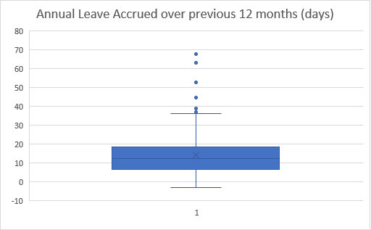

14 days

Average Sick Leave Taken (public sector average = 8 days)

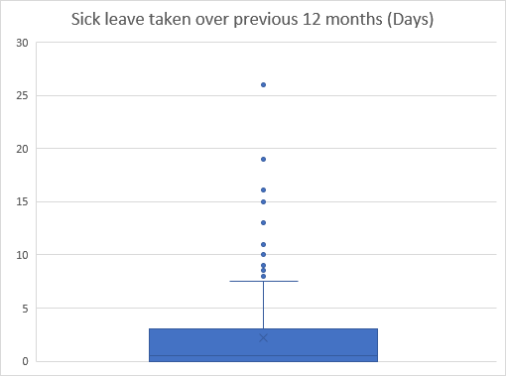

Average of 2 days

**Employee Demographics**

Age bands

**Official Correspondence**

Requests under the Official Information Act 1982 for the three months ended 31 December 2016

|  |  |  |  |  |  |  |
| --- | --- | --- | --- | --- | --- | --- |
| **On hand\*** | **Requests**  **received** | **Responded to in 20 working days** | **Responded to after 20 working days** | **Average time to respond**  **(working days)** | **Transferred** | **Declined** |
| 3 | 7 | 5 | 2 | 18 | - | - |

*‘On hand’ refers to OIA requests received and underway at the Quarter commencement date.