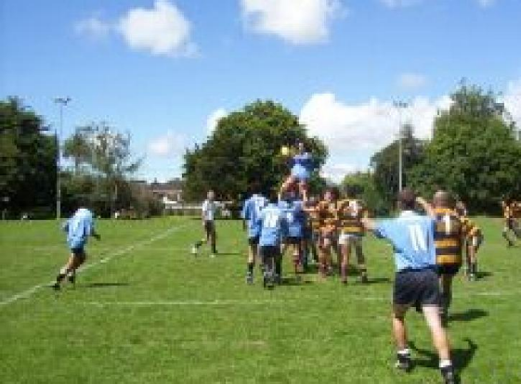

Sports Field Model
Data Entry User Guide


The Sports Field Model – Data Entry User Guide
This user guide has been written to help you understand the process of data entry that is required for the Sports Field Model.

Before you start

The Sports Field Model (SFM) has been developed to work alongside Sports Field Strategy Guidelines. Before you begin to complete this model you will need the following:

- To have identified the area of study and sub divided this into Analysis Areas (as described on page 6 of the guide in Stage 1 Defining the Scope of the Study

- Identified the number of clubs and teams within the area of study and allocated the teams across the analysis areas as appropriate (as described on page 14 of the guide in Stage 2 Identification of Teams).

- Identified any centralised modules and allocated the field demand hours across the analysis areas as appropriate (as described on page 14 of the guide in Stage 2 Identification of Teams and page 21 in Stage 3 Determining Current Field Demand)

- Local information on the assumptions used in the model including ratio of home games, temporal split of games across the weekend, game length, training units required by teams (as described on page 19 of the guide in Stage 3 Determining Current Field Demand) and future growth projections (as described on page 32 of the guide in Stage 7 Identification of Future Surpluses and Shortfalls).
- the number, type and capacity (in hours) of fields available per Analysis Area broken down into training (midweek) and competition (weekend) (as described on page 23 of the guide in Stage 3 Determining Current Field Demand).
- current population breakdown and future population projection for the study area at an Analysis Area level (as described on page 8 of the guide in Stage 1 Defining the Scope of the Study).

Description of the model

The model is an Excel spreadsheet containing 17 tabulated sheets. The model is designed so that information entered into the nine data input sheets:

<Analysis Areas>
<Input Data>
<Population Data>
<Field Summary – Competition>
<Field Summary – Training>
<Team Summary – Competition>
<Team Summary – Training>
<Module Summary – Competition>
<Module Summary – Training>

Data entered into these sheets is automatically copied into all other relevant areas of the spreadsheet, thus avoiding the need to retype data.

It is important when completing the model to only enter the information as directed in this guidance. The data entry cells have been highlighted in pale yellow with the remainder of the model locked down to prevent accidental overwriting the models. This model contains many complex formulas and several of the sheets contain ‘hidden cells’. These cells contain the detailed calculation of the SFM and have only been hidden to improve the layout of the spreadsheet and make it easier to read.

The spreadsheet is designed to analyse the data on up to 25 Analysis Areas and 16 Community Board areas. If the study area has more than 25 Analysis Areas it will be necessary to create two files and combine the results.

How to enter data

Data Input Task 1: Analysis Area Information
Open the Excel spreadsheet and ensure the <Analysis Area> sheet is displayed.
If not, click the <Analysis Area> tab at the bottom of the screen. You should see a screen similar to the one shown below:

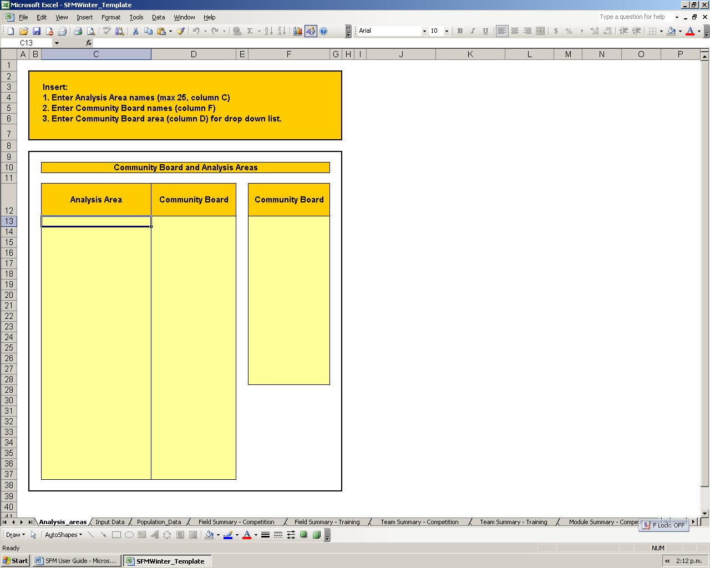

Step 1: Enter the names of the Analysis areas identified for the study in column C

Step 2: Enter the Community Board names for the study area in column F.

Step 3: Allocate the Analysis Area to a Community Board by selecting the Community Board name from the drop down menu in Column D – note it is important to use the drop down lists and not retype the names as any typographical errors will result in the model not recognising the cell. The drop down list will be generated when you complete Step 2

The <Analysis Area> data tab is now complete. Next click on the <Input Data> tab to review some of the Sports Field Model Assumptions.

Data Input Task 2: Input Data

It is possible to amend the assumptions within the model to change a number of factors including:

- Ratio of home games (A)
- Temporal demand across the weekend (B)
- Competition game length (C)
- Field space and amount of time required for training (D)
- Future growth assumptions (in addition to projected population growth). (E)

You will see that ratio of home games, temporal demand and game length assumptions have already been entered into the spreadsheet.

You should input the figures for your local conditions.

Two tables are shown for Competition Growth and Training Growth to further quantify future pressures and demand for sports fields and predict the number of sports teams.
Training unit and growth assumptions should be calculated to reflect the local situation. (See page 20 of the guide in Stage 3 Determining Current Field Demand for more information on training units and page 32 of the guide in Stage 7 Identification of Future Surpluses and Shortfalls for growth assumptions).

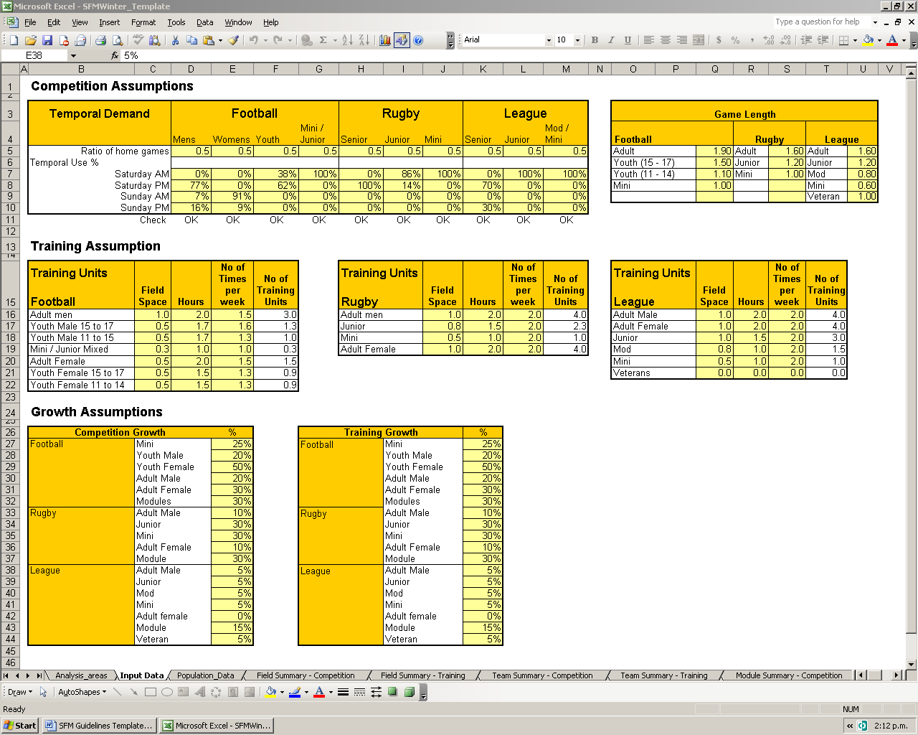
A
E
C
D
B

The <Input Data> data tab is now complete. Once the model has been completed these assumptions can be reviewed at any time to test various projected growth scenarios and the impact on the future supply and demand analysis.

Next click on the <Population Data> tab to enter current and projected population numbers.

Data Input Task 3: Population Data

The next stage is to enter the current and future population data Type in the population in the study area.

Step 1: Insert the current population (2006 Census Estimate data adjusted for increases to the current time) for each Analysis Area in column C.

Step 2: Insert projected population for the Analysis Area in column D.

Step 3: Insert a breakdown of the current population, by age and sex, into column G and H.

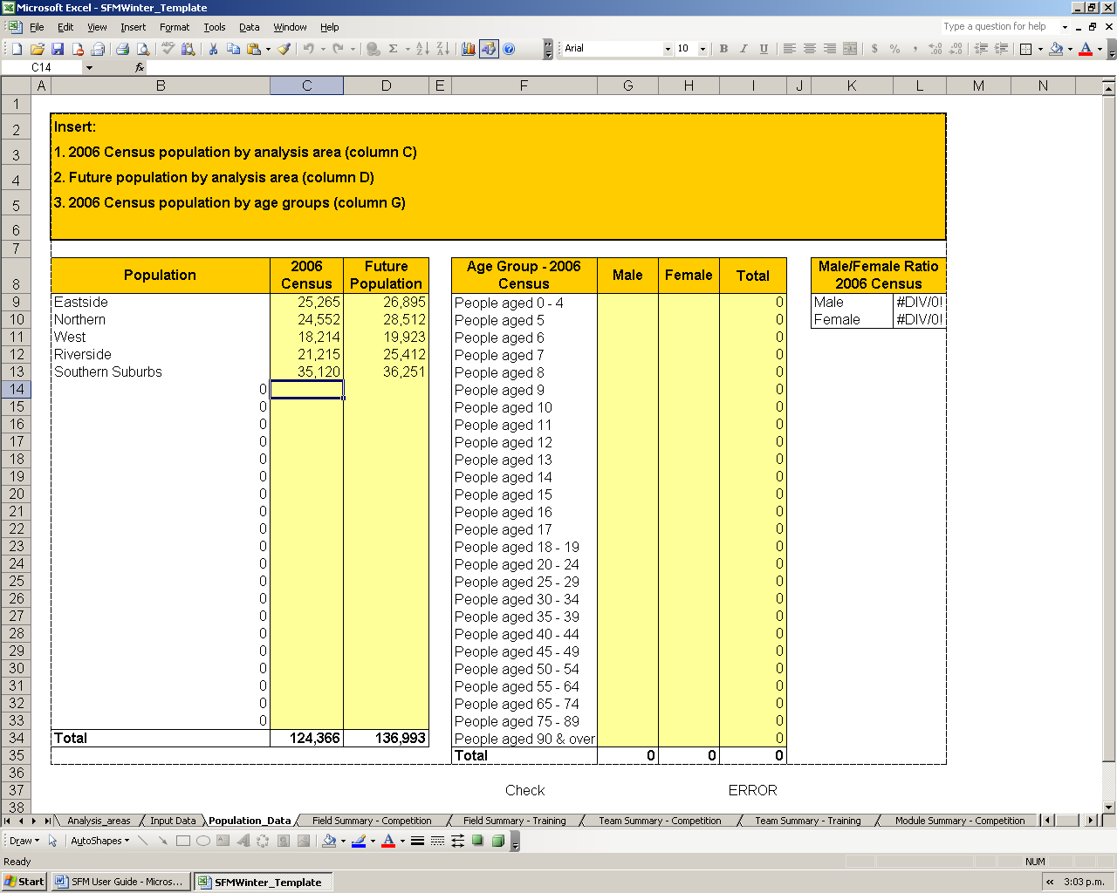
For example:
If the current population in the Southern Suburbs Analysis Area is 35,120, insert 35,120 in the cell
A breakdown of the current population by age and sex should be inserted into columns G and H
Once all population data has been inputted this cell will read “OK”

Once all current and projected population data has been entered this tab is complete.

Next click on the <Field Summary – Competition> tab to enter details of the current sports fields within the study areas.

Data Input Task 4: Field Summary Information

The next stage is to enter the number, type and carrying capacity in hours of all the fields identified within the analysis area. You will see that the names of the Analysis Area and Community Board have been carried forward from before.

(See page 23 of the guide in Stage 3 Determining Current Field Demand for further details).

Step 1: Identify the total number of Full size Football fields within the Analysis area and enter into the spreadsheet. (Point A), completing details for each Analysis Area.

Step 2: Identify the total capacity (for competition) of all full size football fields in hours within each Analysis Area. This should be separated out between hours available on Saturday and hours available on a Sunday. Enter the details into the spreadsheet (Point B). {Note: This is predominantly weekend capacity}

Step 3: Repeat Steps 1 and 2 for mini football, full size and mini rugby, full size and mini league fields until all the data on the capacity for weekend competition has been entered.

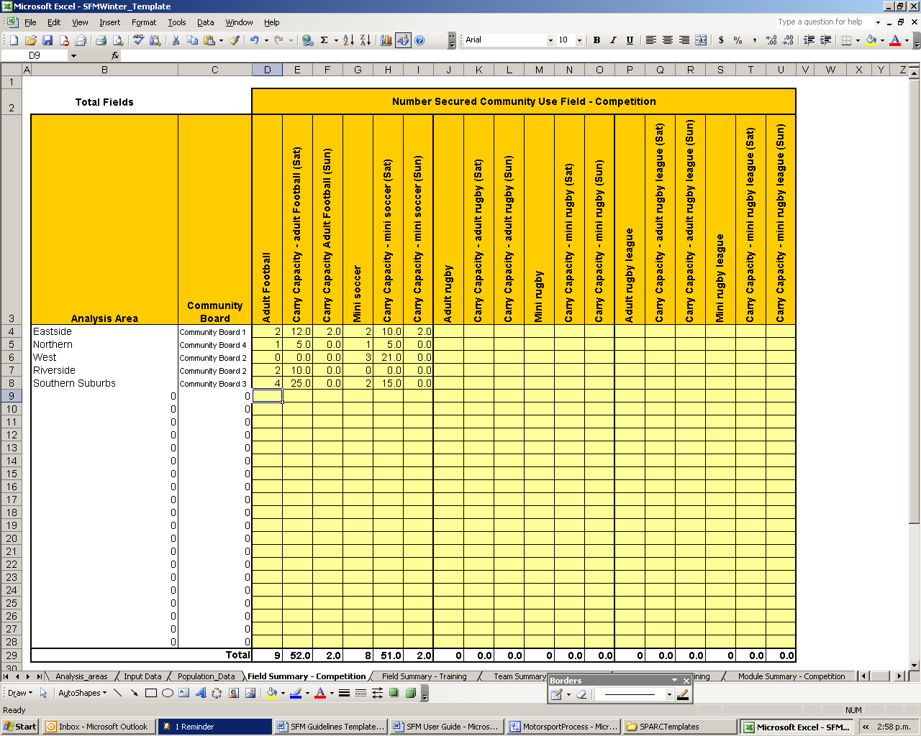

A

BB

Step 4: The <Field Summary - Competition> data tab is now complete. Next click on the <Field Summary – Training> tab to enter details of the number and carrying capacity of the current sports fields within the study areas for training.

Step 5: Repeat Steps 1 to 3 and compete details on the number and capacity of full sized football fields within each Analysis Area for training. (Note: This is predominantly mid week capacity).

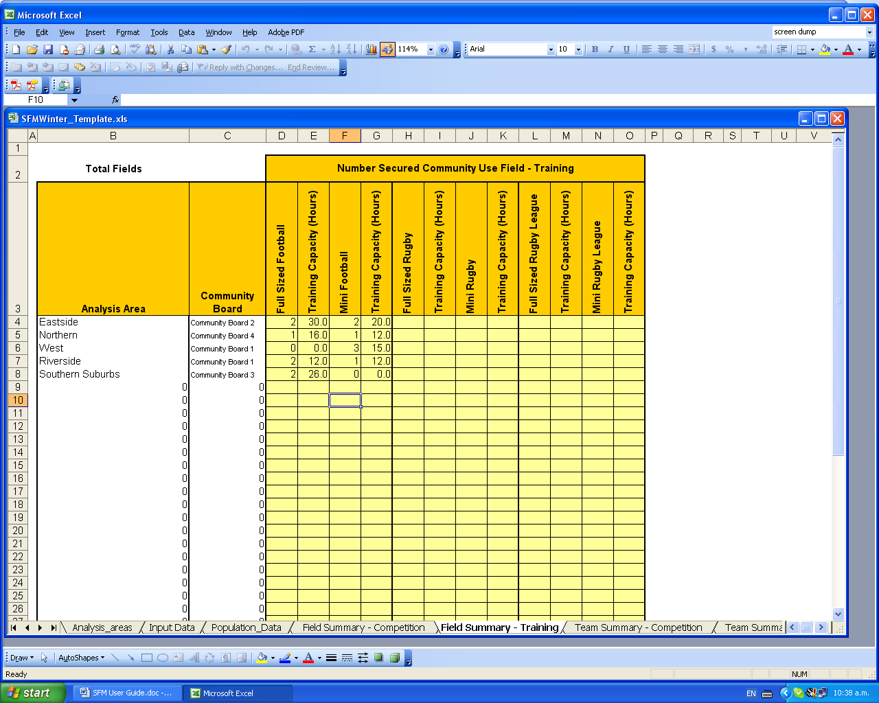
Insert the total capacity in hours
In this example only 2 of the 4 fields identified for competition are available for training

Step 6: Repeat the above for mini football, full sized and mini rugby, full sized and mini league fields until all the data on the capacity for midweek training has been entered.

All information of the number and capacity of fields has now been entered. Now click on the <Team Summary – Competition> tab to enter the team data.

Data Input Task 5: Team Summary Information

The next stage is to insert data on the team numbers within each Analysis Area. This has been separated out into four separate data entry sheets to take account of different patterns of play. These include:

<Team Summary – Competition> Input team numbers for all teams participating in competition (home and away) on a weekend within each Analysis Area

<Team Summary – Training> Input team numbers for all teams participating in training during the week.

<Module Summary – Competition> Input the module field hours and team numbers for all teams participating in competition (module based) on a weekend within each Analysis Area

<Module Summary – Training> Input the module field hours and team numbers for all teams participating in module based play during the week within each Analysis Area.

Step 1: Identify all adult male football teams within each Analysis Area and enter the number into the spreadsheet.

Step 2: Repeat the process for adult women, youth male (15 – 17), youth male (11 – 14), youth girls (15 – 17), youth girls (11 – 14) and mini (mixed) until details of all football teams have been entered.

Step 3: Repeat the above for rugby and league until details of all competitive, weekend teams playing in home and away competitions have been entered in the spreadsheet.

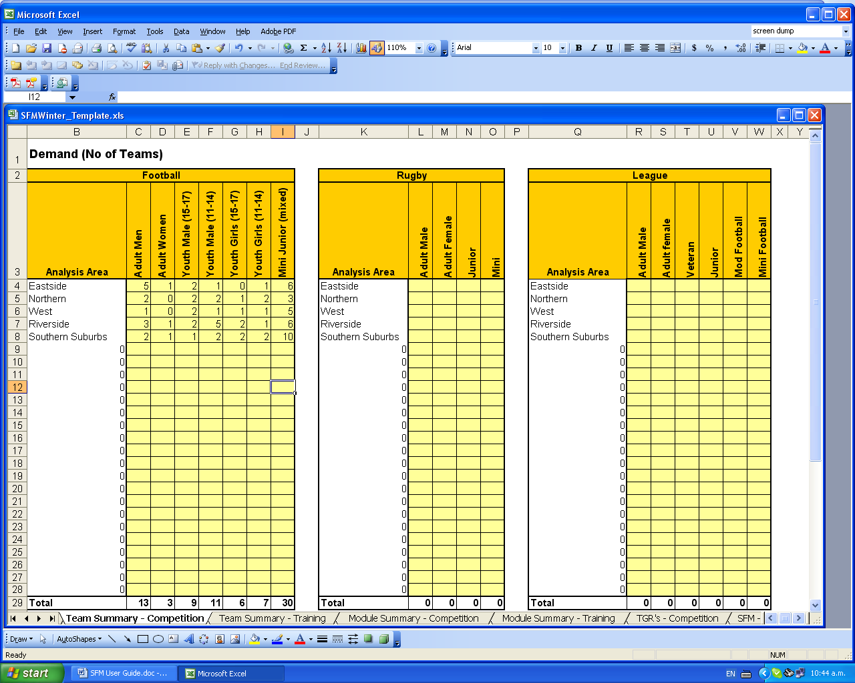
Complete details for all rugby and league teams in the study area
In this example we are showing that Eastside (for competition football) has:
5 adult male teams
1 adult women’s team
2 Youth male (15 – 17 team)
1 Youth male (11 – 14 team)
No Youth girls (15 – 17 team)
1 Youth girls (11 – 14 team)
6 Mini Junior (mixed) teams

Complete details for all rugby and league teams in the study area

Step 4: Once the <Team Summary – Competition> has been completed click the <Team Summary – Training> tab to complete details of all mid week training.

Step 5: Next click on the <Module Summary – Competition> tab to complete details of the module based play on a weekend.

Step 6: Calculate the total hours used (of full sized fields or mini fields) by football modules (or other use on football fields) played in each Analysis Area on a weekend and enter the number in the spreadsheet based on the size of field used and the time of day.

Step 7: Repeat Step 6 for rugby and league modules played in each Analysis Area on the weekend.

It is not always possible to identify all the teams playing within modules as demand is usually identified in terms of hours of play on numbers of fields. Where possible the number of teams identified should be included in Columns N to T.

Step 8: Click the <Module Summary – Training> tab then calculate the total hours used (of full sized fields or full sized field equivalents) by football modules (or other uses of football fields) played in each Analysis Area during the week and enter the number in the spreadsheet based on the size of field used and the time of day.

Step 9: Repeat Step 8 for rugby and league modules played in each Analysis Area during the week.

Once all four tabs are completed all the team data within the study area has been entered.

Analysing the Data

All the necessary data should now have been entered into the spreadsheet. It is now possible to interpret and analyse the data using the final eight tabs of the spreadsheet. You do not need to enter any data into these sheets:

<TGR’s – Competition> This table calculates the Team Generation Rates for the study area as a whole. (See page 31 of the guide in Stage 7 Identification of Future Surpluses and Shortfalls for further detail)

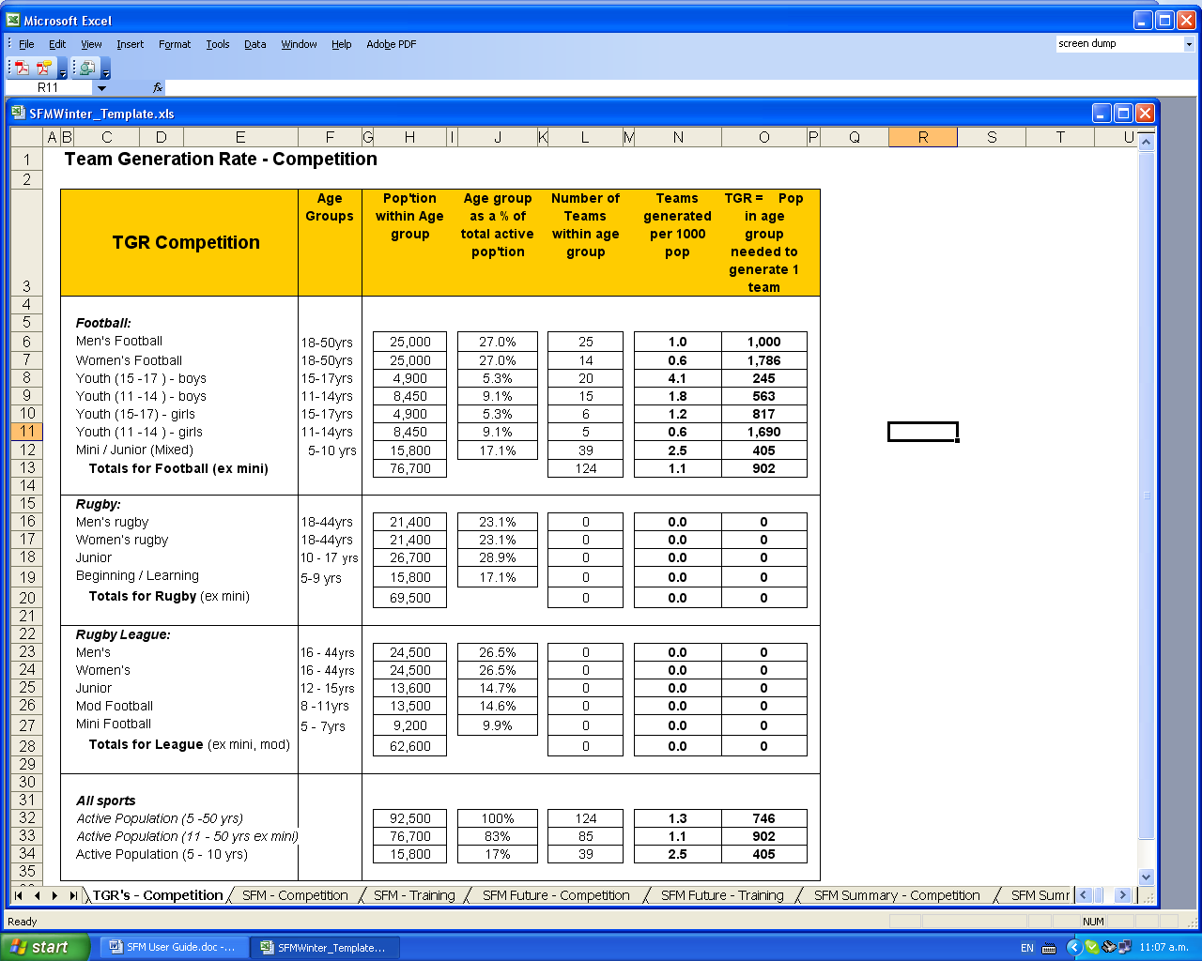
This example indicates that in the study area 2.5 mini-soccer teams are generated per 1,000 population which is equivalent to 1 team per 405 people aged between 5 to 10 within the population of the study areas.

If ‘#DIV/0!’ is displayed in any of the cells, this indicates that no teams in that age group have been identified in the study area and it is therefore not possible to calculate a TGR. This does not affect other TGRs generated or any of the calculations contained in the model.

<SFM – Competition> This tab calculates the current capacity (surplus / shortfall) for weekend competition play.

You should now see a screen similar to the one shown below. This sheet provides the summary analysis of the SFM of the current supply and demand, identifying surpluses and shortfalls in sports field provision. This sheet has been generated automatically and applies the all stages of the sports field model to the data entered.

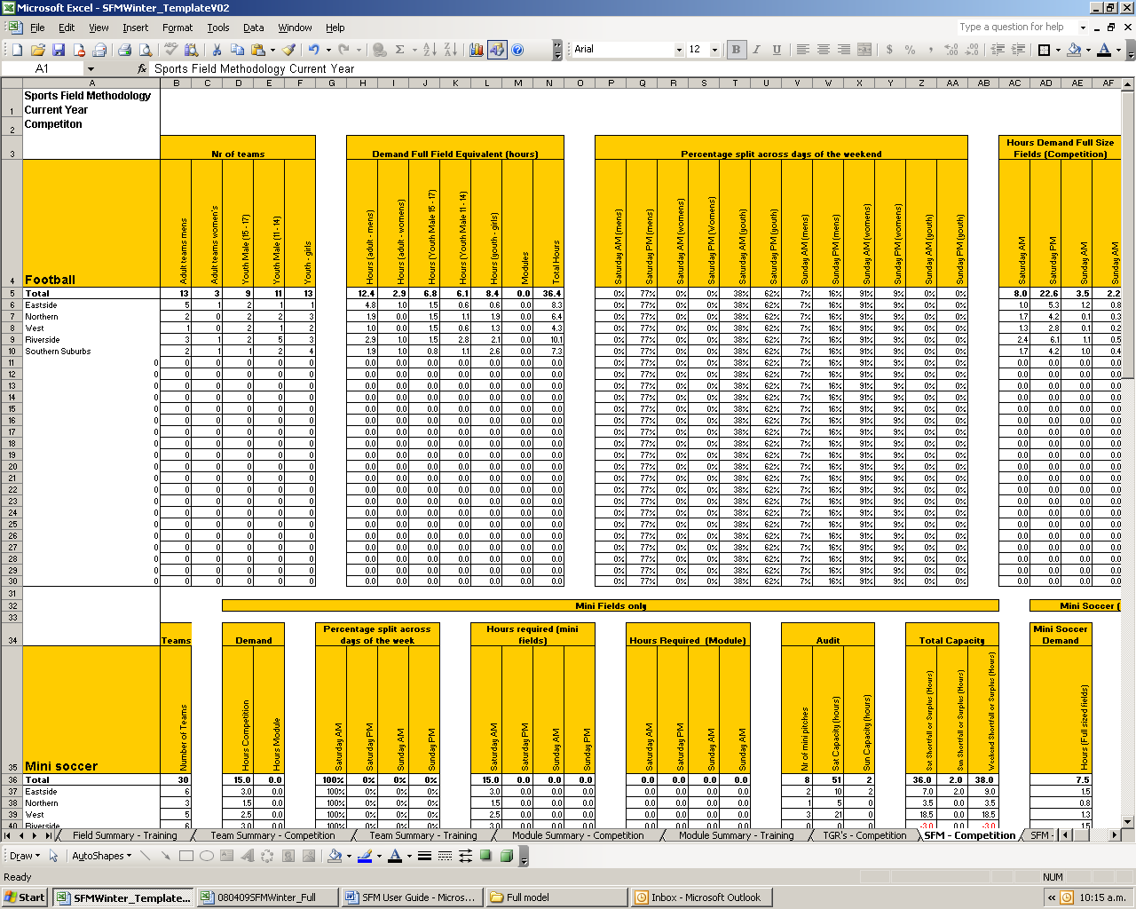

BB

AB

CB

(A) Is the number of teams in each category in the study area from the information inputted to the <Team Summary - Competition> tab.

(B) Identifies the demand for full field equivalents in hours based on the games length assumptions per team from the <Data Input> tab.

(C) Is the percentage split of games across the weekend based on the temporal demand assumptions from the <Data Input> tab.

To see the full model scroll to the right.
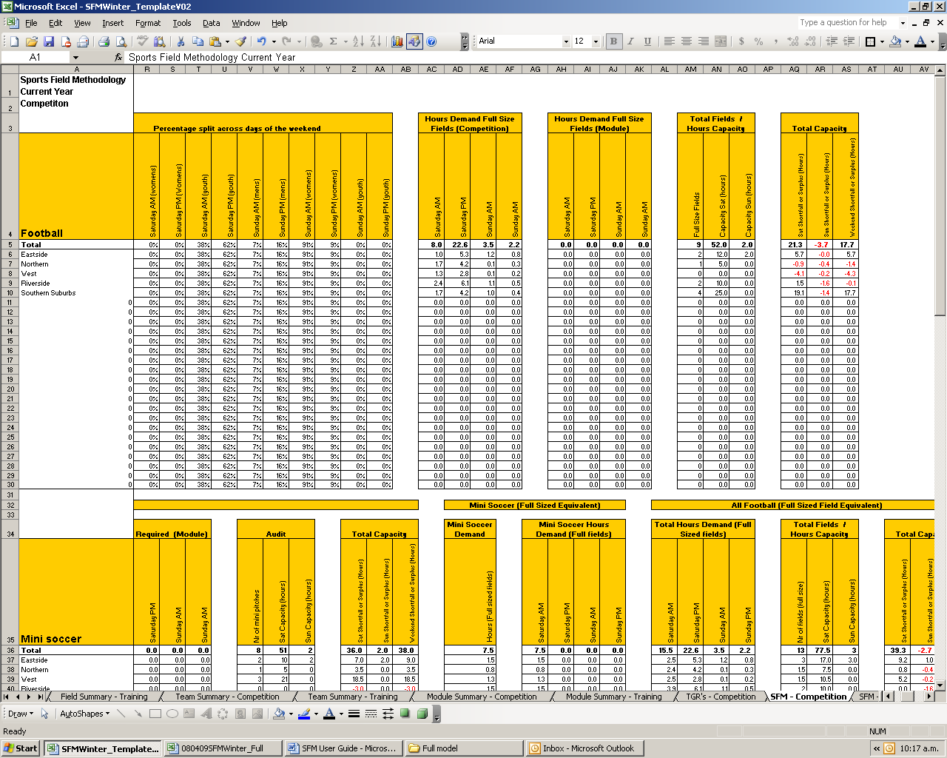

EB

DB

FB

GB

CB

(D) Identifies competition demand for fields (in hours) across the weekend

(E) Identifies module demand for fields (in hours) across the weekend

(F) Identifies the total number of fields and capacity in hours from the information inputted to the <Field Summary – Competition> tab.

(G) Highlights any shortfall or surplus (in hours) for each Analysis Area and the study area as a whole. Figures in red indicate a shortfall.

Scroll down the model to see results for mini soccer, rugby and league.
<SFM Current – Training> This tab calculates the current capacity (surplus / shortfall) for midweek training.

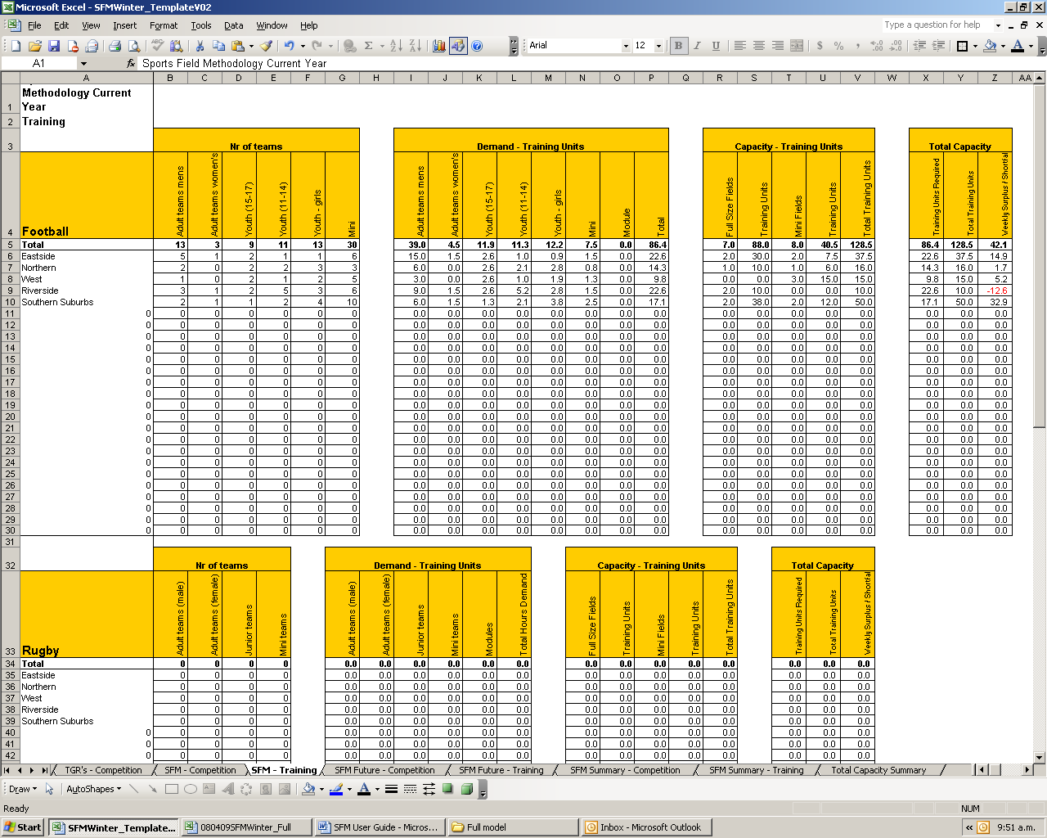

AB

BB

CB

DB

(A) Is the number of teams in each category in the study area from the information inputted to the <Team Summary – Training> tab.

(B) Identifies the demand for training units in hours based on the training unit assumptions per team from the <Data Input> tab.

(C) Identifies the capacity (in training units) based on the field type within each Analysis Area.

(D) Highlights any shortfall or surplus (in hours) for each Analysis Area and the study area as a whole. Figures in red indicate a shortfall.

<SFM Future – Competition> This tab calculates the future capacity (surplus / shortfall) for weekend competition play and the <SFM Future – Training> tab calculates the future capacity (surplus / shortfall) for midweek training. These should be reviewed as above.

<SFM Summary – Competition>, <SFM Summary – Training> and <Total Capacity Summary> tab summarise the data into an easy to use format to enable the summary results for the study area to be analysed for competition, training and overall field capacity (surplus / shortfall).

