Not-for-profit Guidance

Revenues and Consolidation

Tiers 1 and 2

Contents

Executive Summary 3
Revenues for PBEs Tiers 1 and 2 4
Examples for Revenue exchange and non-exchange transactions 5
Consolidation 7
Examples of Consolidation 8

Executive Summary

Following recent changes to the financial reporting framework, “Old NZ GAAP” and “NZ IFRS Differential Reporting” have been withdrawn from having authoritative support. The previous financial reporting framework has been replaced with the following new framework:

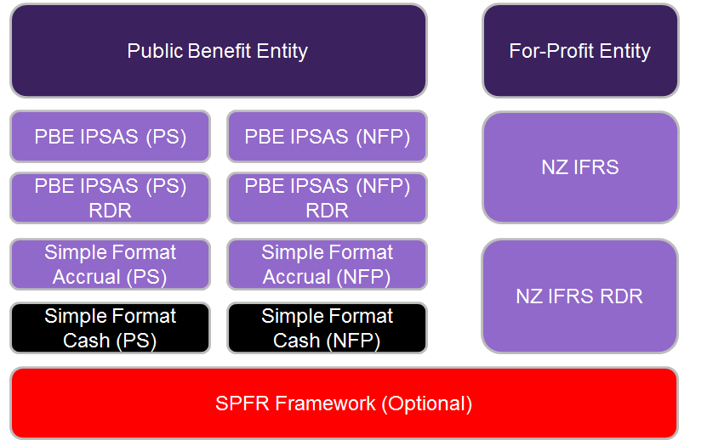

The new financial reporting framework provides for eleven potential framework options, with all new frameworks containing significant recognition and measurement differences to those contained within their predecessor frameworks.

PBEs that are required to comply with Tiers 1 and 2 may find significant changes around the treatment of certain balances. Accounting for revenue and the requirement to prepare consolidated financial statements are two common areas of significant change.

This document provides a summary of these two key changes, and examples of treatments under the new financial reporting framework.

Revenues for PBEs Tiers 1 and 2

The determination as to how revenue should be accounted for is dependent on whether revenue is classified as “revenue arising from an exchange transaction” or “revenue arising from a non-exchange transaction”. The following diagram works through the different treatments available under PBE IPSAS 9 – Revenue from Exchange Transactions and PBE IPSAS 23 – Revenues from Non-Exchange Transactions.

Non-exchange

Are there any stipulations?

Is the stipulation a restriction or a condition?
Income

Exchange
Record revenue as soon as the right to receive the revenue is met.
(Refer to example 2)
Recognise revenue over the period to which it relates.
(Refer to example 1)
Revenue is recognised when the conditions attached to the revenue has been complied with
(Refer to example 3)
Record revenue as soon as the right to receive the revenue is met. (Refer to example 4)
Yes ☐
Condition ☐
No ☐
Restriction ☐
Yes ☐

Definitions (PBE IPSAS 23.7):
Exchange transactions are transactions in which one entity receives assets or services, or has liabilities extinguished, and directly gives approximately equal value (primarily in the form of cash, goods, services, or use of assets) to another entity in exchange.

Non-exchange transactions are transactions that are not exchange transactions. In a non-exchange transaction, an entity either receives value from another entity without directly giving approximately equal value in exchange, or gives value to another entity without directly receiving approximately equal value in exchange.

Stipulations on transferred assets are terms in laws or regulation, or a binding arrangement, imposed upon the use of a transferred asset by entities external to the reporting entity.

Conditions on transferred assets are stipulations that specify that the future economic benefits or service potential embodied in the asset is required to be consumed by the recipient as specified or future economic benefits or service potential must be returned to the transferor.

Restrictions on transferred assets are stipulations that limit or direct the purposes for which a transferred asset may be used, but do not specify that future economic benefits or service potential is required to be returned to the transferor if not deployed as specified.

Examples for Revenue exchange and non-exchange transactions

Example 1 – Exchange Transactions
XYZ Sports Inc. (XYZ) is a regional sports association in Wellington. XYZ has 1,000 members and a financial year ending 30 June 2016.

For the fee year ending 30 September 2016, court fees have been set at $120 per member.

Court fee revenue is an exchange transaction as members are receiving the right to play on the courts for the year in exchange for the fees paid.

The court fee revenue should be initially recognised by XYZ with the following journal entry posted (assuming all income received on 1 October 2015):

 | Dr | Cash | $120,000
 | Cr | Income in advance |  | $120,000
(Being journal to record cash received)

The court fees revenue should be released to the statement of comprehensive revenue and expenses in XYZ and the liability unwound over the period to which the in fees relate. The following journal entry should be posted each month to 30 September 2016:

 | Dr | Income in advance | $10,000
 | Cr | Revenue |  | $10,000
(Being journal to release revenue to the statement of comprehensive revenue and expenses)
At 30 June 2016, three months of income in advance should be in the Statement of Financial Position relating to court fees revenue i.e. ($30,000).

Example 2 – Non-Exchange Transactions (no stipulation)
On 1 July 2015, XYZ Sports Inc. (XYZ) who provide sport facilities for use by the community received $50,000 from a local community group. The community group does not stipulate how the funds have been provided should be spent, but XYZ intend to use the funds to build a new sports area for use by the community.

As there are no stipulations within the grant agreement, the $50,000 should be recognised in the statement of comprehensive revenue and expense when received.

The revenue should be recognised in XYZ at 1 July 2015 with the following journal entry posted:

 | Dr | Cash | $50,000
 | Cr | Grant Revenues |  | $50,000
(Being journal to record cash received)

Example 3 – Non-Exchange Transactions (stipulation with condition)
On 15 May 2015, XYZ Sports Inc. (XYZ) received $125,000 grant income from a local government agency to assist with XYZ’s provision of training courses for sports coaches throughout New Zealand in the next two years.

The contract stipulates that XYZ must provide training to 500 coaches, being $250 for each coach. XYZ must report to the grant provider at each reporting date, and at the end of the two year period any unspent monies must be returned.

At 30 June 2015, 100 coaches have attended training courses funded by the grant. At 30 June 2016 a further 250 coaches have attended training courses funded by the grant, with 150 courses remaining to be utilised. By 15 May 2017, all 500 coaches training placements have been utilised.

In this case the grant contract specifically states there is an obligation for unspent monies to be repaid and therefore grant income is recognised on the balance sheet until it is applied to the intended purpose.

XYZ will recognise the grant at 15 May 2015 with the following journal entry:

 | Dr | Cash | $125,000
 | Cr | Income in advance |  | $125,000
(Being journal to record cash received)

At 30 June 2015, the following adjustment would be posted to recognise the applicable portion of revenue:

 | Dr | Income in advance | $25,000
 | Cr | Grant Revenues |  | $25,000
(Being journal to release revenue to the statement of comprehensive revenue and expenses for 100 coaches @$250 each)

At 30 June 2016, the following adjustment would be posted to recognise the applicable portion of revenue:

 | Dr | Income in advance | $62,500
 | Cr | Grant Revenues |  | $62,500
(Being journal to release revenue to the statement of comprehensive revenue and expenses for 250 coaches @$250 each)

At 30 June 2017, the following adjustment would be posted to recognise the applicable portion of revenue:

 | Dr | Income in advance | $37,500
 | Cr | Grant Revenues |  | $37,500
(Being journal to release revenue to the statement of comprehensive revenue and expenses for 150 coaches @$250 each)

Example 4 – Non-Exchange Transactions (stipulation with restriction)
On 15 May 2015, XYZ Sports Inc. (XYZ) received $125,000 grant income from a local government agency to assist with XYZ’s provision of training courses for sports coaches throughout New Zealand in the next two years.

The contract stipulates that XYZ must use the funding to provide training to 500 coaches, being $250 for each coach. XYZ must report to the grant provider at each reporting date. There is no “use or return” condition.

Given the grant contract does not include an obligation for unspent monies to be repaid, the full amount of revenue is recognised on receipt. This is despite the fact that costs in respect to delivering the courses will be incurred over the next two years. The expenses relating to the provision of training will be recognised as incurred.

XYZ will recognise the grant at 15 May 2015 with the following journal entry:
 | Dr | Cash | $125,000
 | Cr | Grant Income |  | $125,000
(Being journal to record cash received)

Consolidation

Determining Whether Control Exists for Financial Reporting Purposes
The definition of control under PBE IPSAS 6 Consolidated and Separate Financial Statements requires, subject to two limited exceptions, that there be both a “power element” and a “benefit element”. The circumstances listed below are broad criteria that can be applied in establishing if control exists:
- There is ownership of the majority of a voting interest in an entity.
- There is an ability to obtain the majority of a voting interest through ownership of rights that are currently exercisable.
- The board has the power to appoint or remove a majority of the members of the governing body of an entity.
- The board has the power, through any form of mechanism, to set or modify the financing and operating policies that guide the activities of an entity.
- The board has the power to extract distributions from an entity, or the board can direct the entity to perform tasks that meet the objectives of the controlling entity.
- The board has the power to dissolve an entity and obtain a significant level of the residual economic benefits.
When one or more of the circumstances listed in the paragraph above does not exist, other indicators may still be sufficient to establish the existence of control. Refer to PBE IPSAS 6 for a list of other indicators.
The following examples show situations where control exists or does not exist under PBE IPSAS 6 Consolidated and Separate Financial Statements.
Note: When consolidating financial statements from a different tier (e.g. where a tier 2 entity consolidates a tier 3 entity into its financial statements), accounting policy differences are adjusted such that the entity being consolidated aligns its accounting policies with the consolidating entity (e.g. a tier 3 entity adjusts its financial statement balances on consolidation to align its accounting policies with that of a tier 2 entity).

Examples of Consolidation

Example 1 – Control exists
Overview
XYZ Sports Trust is a registered charity with operations spread across the Wellington, Wairarapa and Manawatu region. The organisation has a regional head office based in Wellington, and 15 branches spread throughout the region. The regional head office is responsible for obtaining government funding through contracts held at a national level. The regional head office then distributes the funding to its branches as deemed appropriate in order to achieve its contracted objectives with the government.

The regional head office is also responsible for all aspects of managing the brand and any fundraising activity that takes place at a regional level.

For each branch we note the following:
• | each individual branch is a separate legal entity;
• | each individual branch is responsible for electing its own board members, a process that cannot be influenced by head office;
• | each branch has its own governing body that is responsible for determining its own operating and financing policies (although the constitution requires the branch to fulfil the overriding objectives of the regional head office); and
• | 95% of all funding is received through the regional head office.
The regional head office has the power to dissolve a branch should the need arise.

On wind up, the residual net assets of a branch must be distributed back to head office.

Assessment of control
Whilst there are several factors that would indicate the regional head office might not control the branches, being:
• | each individual branch has its own governing body responsible for determining the operating and financing policies of the branch; and
• | the regional head office does not have the power to appoint the members to the governing body.

In this instance the regional head office does control the branches as the head office has the ability to force the branch to wind up, and to then receive the residual net assets on wind up.

Example 2 - Control does not exist
Overview
XYZ Sports Trust is a registered charity with operations spread across the Wellington, Wairarapa and Manawatu region. The organisation has a regional head office based in Wellington, and 15 branches spread throughout the region. The regional head office is responsible for obtaining government funding through contracts held at a national level. The regional head office then distributes the funding to its branches as deemed appropriate in order to achieve its contracted objectives with the government.

The regional head office is also responsible for all aspects of managing the brand and any fundraising activity that takes place at a regional level.

For each branch we note the following:
• | each individual branch is a separate legal entity;
• | each individual branch is responsible for electing its own board members, a process that cannot be influenced by head office;
• | each branch has its own governing body that is responsible for determining its own operating and financing policies (although the constitution requires the branch to fulfil the overriding objectives of the regional head office); and
• | 95% of all funding is received through the regional head office.
The regional head office does not have the power to appoint members to the governing body, but given the brand association, it does have the power to dissolve a branch should the need arise.

The regional head office uses its “control” of the funding allocation as a means of ensuring the individual branches operate in accordance with the overriding objectives of the regional head office.

On wind up, the residual net assets of a branch must be distributed to another registered charity that undertakes similar activities. This may or may not be the regional head office or another of the individual branches.

Assessment of control
Whilst there are several factors that would indicate the regional head office might control the branches, being:
• | the regional head office can use its control of the funding allocation as a means of gaining leverage over the branches; and
• | the head office has the ability to force the branch to wind up.
In this instance the regional head office does not have control over the branches. The basis for this is as follows:
• | the regional head office does not have the power to appoint the members to the governing body;
• | each individual branch has its own governing body responsible for determining the operating and financing policies of the branch, and while the regional head office controls the supply of funding to the branch, donative control alone is not sufficient in order to establish ownership control (i.e. the ability to set the operating and financing policies of the branch) as ultimately the governing body has the option to reject the funding and seek alternative sources; and lastly
• | While the head office has the power to wind the branch up, it does not have the power to direct how any residual net assets are distributed.

