Wellington Region
Spaces and Places Plan
2019

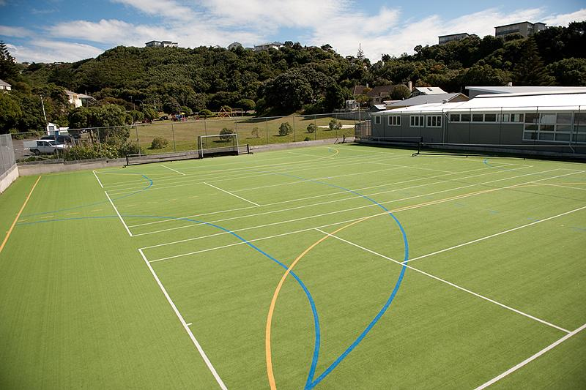

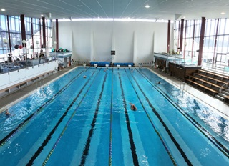

OVERVIEW
PURPOSE
The purpose of this plan is to provide a high-level strategic framework for future regional sports facility planning and optimisation of the current network. The plan emphasises a one-region approach to planning for international, national, regional and sub-regional facilities and provides context for local planning and decision-making about local facilities.
INTRODUCTION
The plan responds to the findings of the Wellington Region Spaces and Places project which provides a stocktake of current assets that make up the regional network of facilities. The project also includes analysis of existing national and regional facility strategies and available participation and population data sourced predominantly from councils, schools and regional sport organisations.
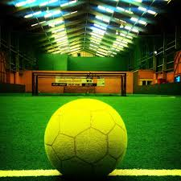
The context for this work is provided by the region’s active recreation and sport strategy – Living Well – and the facilities approach taken by Sport NZ. The New Zealand Sporting Facilities Framework identified that nationally we have:
• gaps and duplications in facility provision
• facilities that are not fit-for-purpose
• facilities that we cannot afford
• many facilities due for replacement.
In response, Sport NZ has been working to ensure that more New Zealanders have access to better places to participate in sport and active recreation by supporting better planning and design of sports facilities around New Zealand, and by encouraging organisations to plan and to share resources and facilities where that reduces costs and provides better services for participants.
Sport and active recreation facilities are key elements of community infrastructure and are highly valued by people in the Wellington region. Investment in facilities supports participation in sport and active recreation and contributes to improved physical activity levels, with subsequent health and wellbeing benefits; social and community benefits through supporting communities to come together around shared interests; and economic development in terms of volunteer services, employment and event revenue.
While the need for a regional plan has been driven by the national direction set by Sport NZ and was identified as a priority project to implement Living Well, the Wellington Region Sport and Active Recreation Strategy, we need to ensure that we have sufficient facilities and the right mix of infrastructure to meet the diverse needs of our expanding and diversifying population to deliver optimal benefits to all.
KEY CONCEPTS

FACILITY HIERARCHY  The facility hierarchy allows us to distinguish the different types and levels of activity that can be run within facilities. The hierarchy distinguishes between:  - International  - National  - Regional  - Sub-regional  - City/District  - Local  (See Appendix 2 for an explanation of the facility hierarchy) | FACILITY PLANNING PRINCIPLES  The facility planning principles used in this plan are aligned with the New Zealand National Sporting Facilities Framework and underpin the approach we want to take when considering any facility development including new builds, upgrades, re-purposing or rationalising. The principles are:  - Meeting an identified need  - Sustainability  - Partnering and collaboration  - Integration and multi-use  - Flexibility  - Inclusive and equitable access
REGIONAL COLLABORATION  This plan advocates for greater regional collaboration around planning and investment for higher-level facilities i.e. those that sit at regional or higher on the facility hierarchy. Across the wider network there are around 50 higher-level facilities.  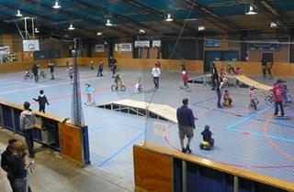 | REGIONAL FACILITY NETWORK  The wider facility network comprises around 1300 facilities of differing types. Most spaces and places have a designation of district/city or local and therefore come under the consideration of individual councils. What we are advocating for is local spaces and places decision-making to be considered in the context of the wider network.
CURRENT STATE
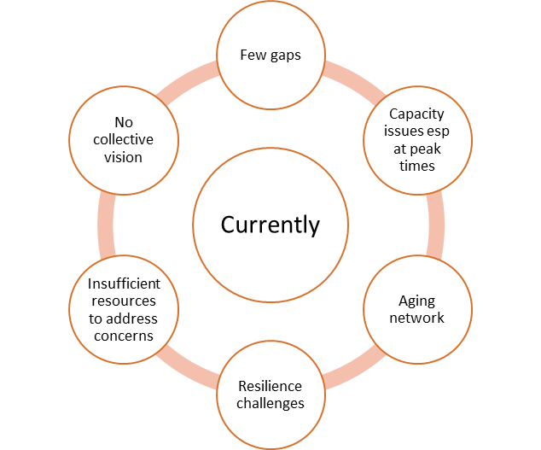
The regional network of facilities (as identified through the regional spaces and places project) comprises around 1300 facility entries. Of these just over 50 have a minimum designation of regional. From a regional investment and decision-making perspective only regional, national, and international spaces and places are considered. However, we would hope that individual councils’ planning and decision-making at a sub-regional, district/city or local level considers the wider network and applies the principles for facility investment and decision-making.
What we know about our current network
Analysis of the current state of the network identifies the following:
- In general, the region does not have many facility gaps. However, it does have capacity issues in key locations, at peak times, and for certain facility types such as indoor court spaces and specialised indoor venues such as those used for gym sports (amongst others). For some sports experiencing declining numbers there is an over-provision of facilities e.g. tennis, bowls and golf.
- Often demand pressures are most acute outside weekday working hours when the use of facilities is at its highest. Partnerships with schools may assist with meeting peak time demand, especially for indoor court facilities.
- The region has an aging network of facilities across all facility types, particularly club facilities such as clubrooms and courts. Many of these are likely to become increasingly unsustainable as they age and face growing maintenance costs which may well be beyond the means of the codes and clubs that own and use them.
- The region has several characteristics that make it susceptible to different types of natural disasters. This, together with the age and location of many of our key assets means the facility network has potential resilience challenges.
- The scale of the required optimisation of the facility network far outstrips the region’s current funding resources. This is most relevant to sports club facilities where the necessary interventions (such as rationalisation, repurposing of assets, and facility development) are currently being constrained.
- The region lacks a collective vision, approach and means for evaluating facility investments and other facility decisions. This hampers the formation of partnerships and makes decisions for third party funders more difficult.

CURRENT CHALLENGES

- Population growth, distribution, and changing demographics  Regionally projected population growth will be localised and relatively uneven leading to the emergence of different facility needs. Irrespective of overall growth, projections indicate the population will also be aging in all districts, with the most relative age group growth projected to be among those aged over 65 years.  The location and types of sport and recreation facilities and services offered, therefore need to adapt in the future, so they are not mismatched with community needs. | - Maintaining Assets, Facility Sustainability and Service Levels:  Maintaining aging assets, current service levels and facility sustainability are likely to become increasingly difficult in some locations. In certain instances, complying with building code requirements, meeting earthquake standards and avoiding functional obsolescence will also be very real challenges. Duplication and underutilisation of sport and recreational facilities will become increasingly unaffordable over time. This will necessitate some hard decisions regarding rationalisation, repurposing, amalgamating and developing new assets. | - Changing Sport Participation Preferences:  Sport participation preferences are constantly changing (as illustrated by the rise of ‘pay-for-play’ sport and changing code preferences). Participation in organised sport is declining with an increasing trend towards informal, individual physical activity. As community needs change our facility network will need to adapt to change and be more flexible.
- Improving Collaborative Approaches:  Historical decision making in respect of new or replacement facilities has often been undertaken on an ad-hoc basis. As demands on capital funding budgets grow, it will become increasingly important for all stakeholders to work collaboratively in order to improve delivery and sustainability of sport and recreational facilities. The introduction of the facility investment decision making process, and a regional funding approach will greatly assist collaboration. | - Network Resilience  The opportunity exists to improve the networks resilience so that we are well placed to cope with the unexpected. This can be done by rationalising or improving existing assets or developing appropriate new facilities. | - Supporting a Regional Investment Approach  Taking a regional approach to planning for sporting facilities is gaining momentum, however, the challenge remains as to how these facilities can be funded regionally. An opportunity exists for the region’s territorial authorities to explore a collaborative investment framework for higher-level facilities.
STRATEGY
OUTCOME:
The outcome we are looking for is a one-region approach to providing an accessible, fit-for-purpose regional network of quality spaces and places that support and encourage physical activity (play, active recreation, sport).
OBJECTIVES and ACTIONS:
For higher-level facilities (regional and above on the facility hierarchy)
OBJECTIVE | PROGRAMMES OF WORK
Cross-boundary collaboration, planning and investment for regional, national, and international level facilities | Create a mechanism that allows the region to collectively approach planning for higher-level facilities including high performance centres and meeting the sporting franchise needs for stadia beyond current provision.
 | Develop an appropriate regional facility investment decision-making model to ensure that higher-status facility developments are robustly assessed
 | Develop a regional facility funding model that considers a range of funding options for regional facilities including regional rate setting amongst others.
For the regional network
OBJECTIVE | PROGRAMMES OF WORK
Optimise and future-proof the current network of facilities | Investigate partnering opportunities, with schools and private providers.
 | Consistently apply the core facility planning and provision principles to facility decisions.
 | Rationalise and/or re-purpose existing under-utilised and unsustainable facilities.
 | Address the resilience challenges of our network through a programme of upgrades and/or renewals where a proven need exists, and a cost-benefit analysis indicates this is warranted.
SHORT-TERM PROJECT OPPORTUNITIES
While there are no individual facility projects arising from the work completed to date, some immediate project opportunities have been identified that will add to the current body of knowledge and contribute to the programmes of work for both higher-level facilities and the regional network.
PROJECTS (1-3 YEARS)
Project 4:
Regional Sportsfield Review
Undertake a review of the Regional Sportsfield Strategy (originally developed in 2013) to determine whether there are changes required to the approach and to consider the recommendations from this project including: maximising use of existing fields through improved field quality, creating an appropriate facility hierarchy (including rationalisation of lower quality fields where appropriate), additional sharing arrangements and potential re-allocations between codes.
Project 3:
Regional Indoor Facility study
Taking a deeper dive into likely future demand for indoor facility spaces given the growth expected across the region in terms of population, geographic spread, and participation trends of sports that have historically used indoor court spaces. Purpose would be to create a hierarchy of indoor facilities and develop options for managing demand beyond just new builds.
Project 2:
Sport sector priorities and processes
Work with sports sector to embed a detailed process for developing and evaluating proposals for facility development prior to approaching councils and other funders. This process would align with the Spaces and Places Planning Principles and be compatible with the Concept and Plan stages of the Spaces and Places Facility Development Lifecycle (see Appendix 3).
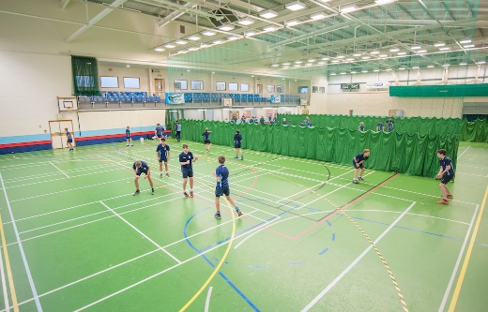

IMPLEMENTATION
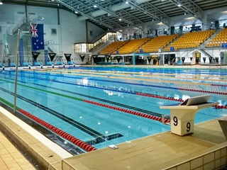
Sport Wellington will lead the implementation of this plan in partnership with key stakeholders - Councils, funders, Sport NZ, and sector groups – through a dedicated Spaces and Places resource.
Sport Wellington’s role will be to:
- Advocate for the use of this plan to guide decision-making
- Identify and agree the responsibilities of partners in the delivery of this plan
- Work with sporting stakeholders to increase the sector’s understanding of the principles applied to decision-making
- Work with the sector to further understand and clarify their facility needs
- Provide ongoing support during the implementation.

Implementation of the plan will be overseen by a Strategy Steering Group which will have responsibility for:
- Promoting the use of the planning principles as a part of the future regional planning approach to facility development
- Monitoring, reviewing and providing regular updates on the progress of implementation activities, including the short-term projects identified
- Providing support and input into the development of mechanisms that will facilitate a collaborative regional planning approach such as
  - Establishment of criteria for determining facility priorities
  - Regional funding approaches
  - Project assessment processes
- Reviewing the strategy.
The steering group will comprise predominantly council representatives but will also reflect other stakeholder interests including funders and sector groups.

SPACES AND PLACES PLANNING PRINCIPLES
The planning principles underpin our desired overall approach to managing the facility network which is about adopting an evidence and needs-based approach to decision-making. These principles can be applied to all facility decision-making processes.
PRINCIPLE | EXPLANATION
MEETING AN IDENTIFIED NEED | Facilities should meet an identified need and be fit-for-purpose. There is often insufficient rigour applied to this fundamental question. The best outcomes are achieved when all the potential facility users are identified, and a deep understanding gained of their range of needs. This will also ensure that there is a community return on investment – measured both socially and economically.
SUSTAINABILITY | Facility sustainability requires consideration of the ongoing operating and maintenance costs of the facility and how these will be funded. The best outcomes are achieved when the ‘whole of life’ costs of the facility are considered at the outset and how it is intended that these costs will be met. Often, upfront investment in, for example, facility features that enable greater energy efficiency, can deliver huge dividends over the life of the facility.
COLLABORATION | Historically sports facilities have tended to be planned and built in isolation. This has led to over-provision and duplication. The best outcomes are achieved when partnerships are developed with education, health, Iwi, and/or the private sector. This increases the likelihood that facilities will be used to their full potential, maximising the return on investment and utilisation.
FLEXIBILITY | No one can predict the future, but what we can predict is that things will change. Facilities should be designed to accommodate changing community profiles and associated sporting trends and needs over time. The best, long-term, outcomes are achieved by designing facilities in ways that enable them to be adapted, developed and extended in response to future demands
INTEGRATION AND MULTI-USE | Facilities need to be fit-for-purpose, and sustainable. The best outcomes are achieved by sharing. Creating multiuse facilities or hubs, or co-locating with other sport and recreation, community, education, or transport facilities and infrastructure is an effective approach
INCLUSIVE AND EQUITABLE ACCESS | Experience shows, that while society is generally more inclusive, barriers remain for many in accessing sport, recreation and physical activity pursuits. To ensure all members of the region’s community have equitable access to and opportunity for participation requires us to consider the needs of a wide range of our community when making decisions. Focus should be given to ethnic, financial and ability barriers including but not limited to age and disability.

Appendix 1: Spaces and Places Facility Development Lifecycle
The New Zealand Sporting Facilities Framework also identifies a six-stage facility development lifecycle that should be applied to any facility project. Adherence to this process will ensure that better facility decisions are made. The end of each stage represents a gateway to the next stage at which a go/no go decision can be made.

CONCEPT

PLAN

DESIGN

BUILD

OPERATE

IMPROVE

Appendix 2: The Facility Hierarchy
The following general facility hierarchy definitions have been used within the Wellington Regional Spaces and Places Facility Plan. The hierarchy allows us to distinguish the different types and levels of activity that can be run within facilities. Note: It is important to understand that a facility at a higher hierarchy level may also meet the needs all the way down to a local level.

APPENDIX 3: Summary of regional, national and international facilities in the Wellington region
Facility type | District/City | Facility Name | Description | Status
Indoor Courts | Hutt City | Walter Nash Centre | 5x basketball courts also marked for 5x netball, 6x volleyball, 2x futsal, 2x floorball, 2x handball, 5x dodgeball, and used for various other indoor sports; 4 meeting rooms, community fitness gym, library, offices and cafe. 1x outdoor basketball half court. | National
 | Porirua | Te Rauparaha Arena (Mana Community Grants Stadium) | Part of Te Rauparaha Arena. 3 courts- full international standard size courts Grandstand seating for 3,000 people, can be split into 3 separate courts or one large space. Caters for conferences, dinners, sporting events, expos. Can combine with NZCT Stadium. | National
 | Porirua | Te Rauparaha Arena (NZCT Stadium) | Part of Te Rauparaha Arena. 1x basketball/netball court (international size). Adjacent to Mana Community Grants Foundation Stadium. | International
 | Wellington | ASB Sports Centre | 12x sprung floor courts, multiple uses (basketball/netball etc). Largest indoor facility, community sport focus, but can host larger tournaments /events. | National
 | Wellington | TSB Arena | Large, flexible facility with a sprung timber sports floor providing 1 x indoor court suitable for regional to international level centre court sport. Retractable tiered seating provided | International
Aquatics | Wellington | Wellington Regional Aquatic Centre | 50 m heated indoor pool, diving pool, toddlers' pool and spray water-play area, hydrotherapy pool, spa, saunas. | International National
 | Hutt City | Naenae Pool and Fitness | Indoor 50m 7 lane pool with moveable bulkhead; learners/toddlers pool; waterslide; diving boards, fitness gym, 3 meeting rooms, offices, changing and toilets. On Walter Mildenhall Park. | Regional
Sportsfields | Porirua | Porirua Park (Trust Park Porirua) | 4x fields. 2 higher grades and 2 lower grade landfill caps (unsuitable for capital development), training areas with lights. #1 field is international standard (sand carpet) with grandstand. | International  Regional
 | Wellington | Newtown Park | 2x football fields, condition grade 1. | Regional
 | Wellington | Westpac Stadium | 1x multi-use field (all codes). Premiere Regional venue. | International
 | Hutt City | Fraser Park | 4 Rugby fields, 7 football fields, 1 artificial diamond (infield), 3 grass diamonds, 3 skin (lime based) diamonds, 4 artificial cricket strips, 3 cricket blocks, 3 lane cricket practice nets. Cricket practice nets owned by club. | Regional
Cricket | Wellington | Basin Reserve (and Indoor) | International standard play/practice facility, Indoor 2 lane training facility used for representative, club and school training (managed by Cricket Wellington). Major outdoor upgrade works underway, including consideration of lighting. | International
 | Wellington | Karori Park | 5x grass wickets and 6x junior wickets, 3 lane nets, clubrooms and café. Considered potential back-up first class venue for Region. | Regional
 | Wellington | Westpac Stadium | Large regional/national event venue used for some games. Also, an indoor training facility with 5 lane nets (managed by Cricket Wellington). | International
Tennis | Wellington | Renouf Tennis Centre | 6x indoor courts, 14x outdoor courts (floodlit). The Renouf Tennis Centre is the most significant tennis facility in the lower North Island. | Regional
Netball courts | Wellington | ASB Sports Centre | Main regional facility for indoor netball competition. 12x sprung wooden floor. Outdoor half court. | Regional
 | Wellington | Hataitai Park | 14x synthetic courts (also used for tennis) open from Labour Weekend until end of March. Hataitai Park is a Community Sports Hub priority site. | Regional
 | Wellington | TSB Arena | Large event hub for premiere games/international. While indoor it is included here for its significance in the netball network. | International
Athletics tracks | Wellington | Newtown Park | This is the only synthetic athletic track in Wellington City and Region (excluding Wairarapa). There is some lobbying from the athletic community for another synthetic athletic track in the Region. | Regional
Golf | Hutt City | Boulcotts Farm Golf | 24-hole private golf course. | Regional
 | Kapiti | Paraparaumu Beach Golf Club | 18-hole premiere links course, clubrooms, bar, restaurant. | National
 | Upper Hutt | Royal Wellington Golf Club | Two courses -18-hole championship Heretaunga Course and 9-hole Terrace Course. World class practice facilities. Swimming pool onsite. | National
Bowls | Hutt City | Naenae Bowls Centre | Includes Naenae and Park Avenue Bowling Clubs, Naenae RSA and Park Avenue Petanque Club. Developing as a regional centre for bowls. 3x outdoor grass and 1x indoor green. No lights. By other sports facilities on Walter Mildenhall Park. | Regional
Squash | Hutt City | Fraser Park Squash Club | 3x squash courts, changing rooms and toilets, lounge. An amalgamation with Mitchell Park Squash Club and development of 6 new courts is planned as part of Sportsville development on Fraser Park. Planned sub-regional/regional facility. | Regional
Bike | Hutt City | Wainuiomata BMX Track | BMX: Full size competitive track with starting ramp on Hugh Sinclair Park. | Regional
 | Hutt City | Waiu Park MTB Park | MTB: MTB park with numerous tracks from beginner to expert, skills course, links to longer tracks. | Regional
 | South Wairarapa | Rimutaka Cycle Trail | PATHS: The approximately 50km section of the Rimutaka Cycle Trail between the Rimutaka Rail Trail Summit and the Wainuiomata Coast Road at Orongorongo. | Regional
 | Wellington | Hataitai Park Velodrome | TRACK: Old concrete outdoor velodrome. Receives regular use by PNP Cycling Club but use is relatively low. Hataitai Park is a Community Sports Hub priority site. Facility may receive higher status if track is upgraded and bike use increases. | Regional
 | Wellington | Makara Peak Mountain Bike Park | Signature Trail in the Regional Trails Framework. MTB: Major MTB Park/network - bike skills, tracks, links to longer tracks. The highest profile MTB park in Region. Often congested at main entries. | National
 | Wellington | Ian Galloway Park BMX Track | BMX: 400m UCI international-level BMX track with start gate and bike skills area. | National
 | Porirua | Rangituhi MTB Park | MTB: Trail network built on Colonial Knob by local biking community. Proposals for further trail-building through a commercial development ('Porirua Adventure Park') which could raise its status. | Regional
Shooting | Upper Hutt | Trentham Rifle Range Reserve | Hub for shooting sports. Cluster of 4 different ranges (including Seddon Range) and nearby clubroom facilities for National Rifle Association NZ, Trentham Rifle Club, Heretaunga Pistol Club, Trentham Archery Club, Karori Rifle Club, Petone Rifle Club. | Regional
Artificial turfs | Hutt City | Fraser Park | Hub facility including 1x Rugby/Football turf with lights, 1.5x hockey turf, 1x softball diamond infield | Regional
 | Hutt City | Memorial Park (Petone) | 1x full size football turf with lights. Owned/managed by Capital Football. | Regional
 | Carterton | Trust House Turfs | 2 x national standard hockey turfs at the Wairarapa A&P Clareville Complex. Hockey Wairarapa based there. Has been used for international games. | National
 | Kapiti | Coastlands Kapiti Sports Turf | Hockey water turf with flood lights and pavilion facility with viewing deck. Used for hockey, football and rugby. Some national hockey events. | Regional
 | Porirua | Ascot Park (Bernie Wood) | 1x full artificial field for rugby/football, full competition and training lights. | Regional
 | Porirua | Elsdon Park | 1x full artificial hockey turf, full competition and training lights. | Regional
 | Upper Hutt | Maidstone Park Hockey | 1x full artificial hockey turf, 1x full football/rugby turf, half turf for warm-up, lights, electronic score board. | Regional
 | Wellington | Alex Moore Park | 1x full artificial field with lighting, used mainly for football and softball. | Regional
 | Wellington | National Hockey Stadium | 3x full size hockey turfs - the 3rd turf opened in 2017. | International
 | Wellington | St Patrick's College | 1x full size field mainly used for football, rugby and junior cricket. | Regional
 | Wellington | Te Whaea | 1x full artificial field mainly used for football and rugby. | Regional
 | Wellington | Wakefield Park | 2x full size artificial fields - mainly used for football and touch. | National
 | Wellington | Wellington College | 1x artificial rugby/football field, also separate artificial multiuse surface with 4x tennis courts, lighting. | Regional
Specialised indoor venues | Wellington | Basin Reserve Indoor Cricket | INDOOR TRAINING: Indoor cricket training facility at international standard cricket venue. | Regional
 | Wellington | Kilbirnie Recreation Centre | ROLLERSPORTS: Large hall dedicated to indoor roller sports, located by the Wellington Aquatic Centre; Toitu Poneke Sports Hub and Kilbirnie Park sports fields. Few dedicated venues in the region, with some hire-use of sports gyms and halls for events. Regional status here due to its uniqueness as dedicated venue. Requires earthquake strengthening. | Regional
 | Wellington | Renouf Tennis Centre | TENNIS: 6x indoor courts, 14x outdoor courts (floodlit). The Renouf Tennis Centre is the most significant tennis facility in the lower North Island. | National
 | Wellington | Westpac Stadium Indoor Cricket | INDOOR TRAINING: Indoor cricket training facility at international event venue. | Regional
Softball | Hutt City | Fraser Park | 1 x artificial, 2x skin, and 3x grass diamonds. | National
 | Wellington | Hataitai Park | 2x skin and 1x grass diamonds, viewing stands, lights as part of community sports hub area. | Regional
Outdoor water sports | Hutt City | Seaview Marina | Marina with 300+ berths, hardstand, boat launching and small craft sailing area. Complementary businesses also co-located. | Regional
 | Wellington | Chaffers Marina | Floating marina in Central City. Deep-water site with large berths and a comprehensive range of facilities and amenities. Adjacent to Clyde Quay Boat Harbour | Regional

