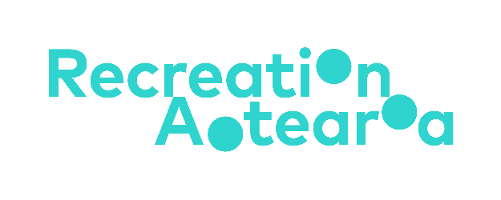

Accessibility and inclusion in outdoor education and recreation: Summary
A guide for outdoor providers and educators
Adapted in 2025 by Accessible Formats Service,
Blind Low Vision NZ, Auckland
Total print pages: [3]
Total large print pages: [4]
Transcriber's Note: At the top of the page, three logos are displayed in a row. On the left is Sport New Zealand Ihi Aotearoa. In the centre is Recreation Aotearoa. On the right is Education Outdoors New Zealand.

Notes for the Large Print Reader
Print page numbers are indicated as:
Page 1
Main text is in Arial typeface, 18 point.
Headings are indicated as:

Heading 1

Heading 2

Page 1

Summary: Accessibility and inclusion in outdoor education and recreation
The full guidance document (PDF) is published here on the Sport NZ website: https://sportnz.org.nz/resources/accessibility-and-inclusion-in-the-outdoors/

Introduction
The Accessibility and Inclusion in Outdoor Education and Recreation guide emphasises the importance of making outdoor education and recreation accessible to all tamariki and rangatahi in Aotearoa New Zealand, regardless of their age, gender, sexuality, location, ethnicity, or ability. It aims to break down barriers for disabled tamariki and rangatahi by providing tools and information for outdoor providers and educators.

Disability in Aotearoa New Zealand
One in four New Zealanders identify as disabled, including 11% of young people under the age of 15. The guide adopts the social model of disability, which focuses on removing barriers in activities rather than viewing impairments as the primary issue.
Page 2

Disability language
This document provides guidance on using respectful and inclusive language when talking about disability. It highlights the importance of using terms like "disabled people" or "people with impairments" and respecting individual language preferences.

Diversity, Equity, and Inclusion (DEI)
This guide discusses the importance of DEI in outdoor education and recreation. It defines diversity as the different characteristics, backgrounds, and perspectives people bring. Equity involves recognising that people start from different places in society and may need extra help to achieve fair outcomes. Inclusion means creating spaces where everyone feels welcome and able to participate fully.

Important considerations for inclusion
This guide emphasises the need to create safe, welcoming environments and value each participant as an individual. It discusses different ways to help participants feel a sense of belonging, such as inclusion, integration, and safe spaces.

Guiding Frameworks and Mindsets
Several frameworks are recommended for being more inclusive of disabled people:
- Te Whare Tapa Whā: A Māori wellbeing model that emphasizes the balance of different aspects of a person's wellbeing.
- Mana Taiohi: A framework of principles that guide positive youth development in Aotearoa New Zealand.
- United Nations Article 30: Advocates for recreation as a human right for disabled people.
- Enabling Good Lives: An equity framework designed to give disabled people more choice and control over their lives.

Organisational policies and inclusion training
This guide advises developing and sharing DEI policies to help everyone in the organisation understand how they can contribute to an inclusive environment. It also recommends providing inclusion training to build staff confidence and ensure DEI policies are meaningfully implemented.

For outdoor providers
The guide provides specific guidance for outdoor recreation providers, including improving website accessibility, creating inclusive marketing materials, and tailoring registration forms to gather the right types of information about participants' needs.
Page 3

For schools and educators
The guide offers guidance for making the outdoor classroom accessible to all, working with ākonga (students) and whānau (families), and advocating for inclusive education outside the classroom.

Resources and case studies
The guide includes a section on resources, case studies, funding, training opportunities, and information about providing inclusive outdoor experiences.

Contact
If you have any questions about this document, please contact: accessible@sportnz.org.nz
End of Accessibility and inclusion in outdoor education and recreation: Summary.

