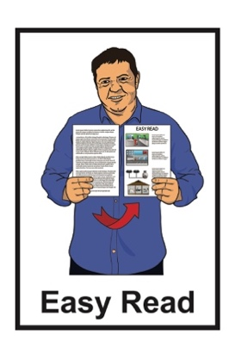


The future of sport and recreation for disabled New Zealanders:

Part 1 – About the report
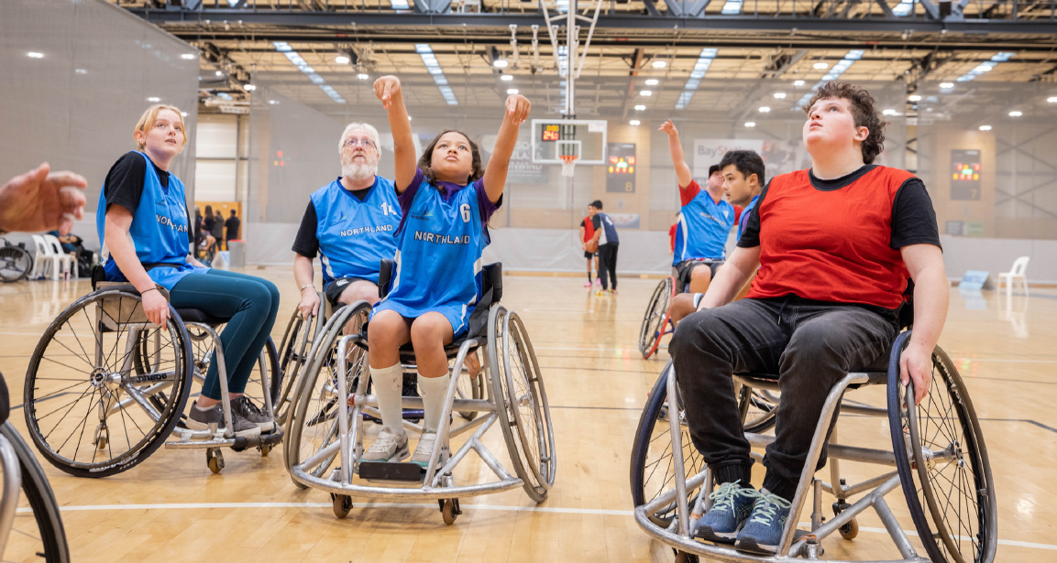

Image source: Parafed Bay of Plenty
Published: July 2025

Before you start

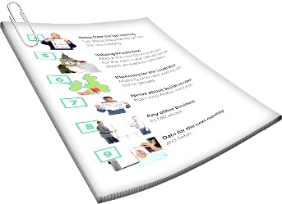
This is a long document.

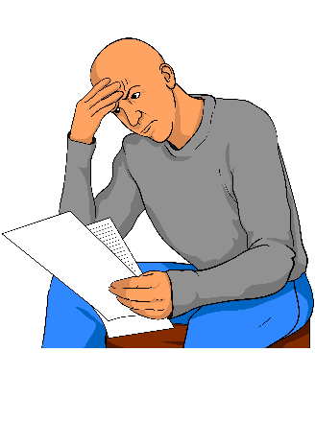
It can be hard for some people to read a document this long.

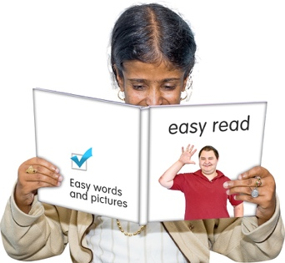
Some things you can do to make it easier are:
read it a few pages at a time
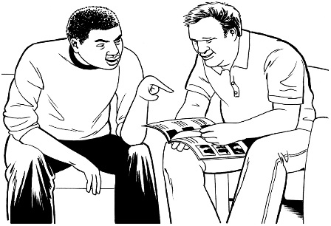
set aside some quiet time to look at it
have someone read it with you to support you to understand it.

What you will find in here

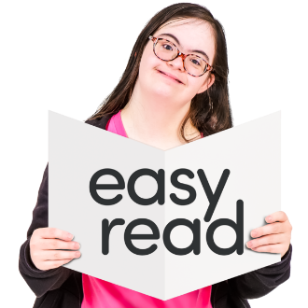
Page number:

About this Easy Read 3

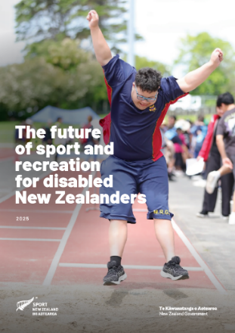
Why did Sport NZ write
this report? 8

What did the report find out? 15
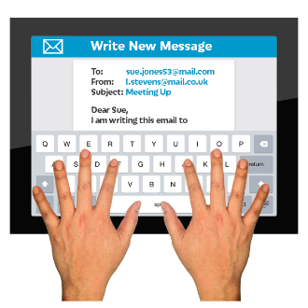

Where to find more information 39

About this Easy Read

This Easy Read is a summary of a longer report.


A summary:
is shorter than the full report
tells you the main ideas.

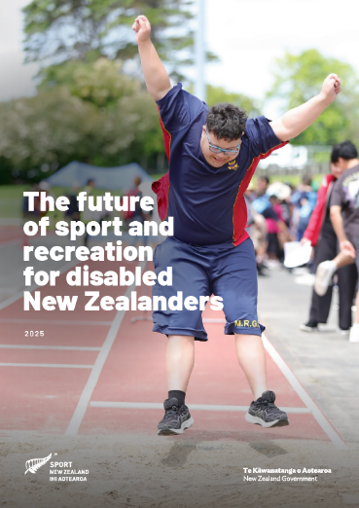
The report is called The future of sport and recreation for disabled New Zealanders.

In this Easy Read we call this report the report for short.


You can read the full report on this website:

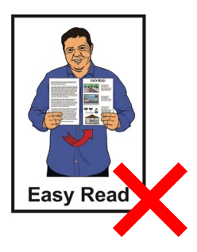
https://tinyurl.com/5a6vu7jk

The full report is not in Easy Read.


The report is by
Sport New Zealand Ihi Aotearoa.

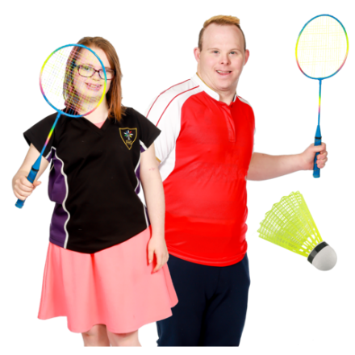
Sport New Zealand Ihi Aotearoa
is the part of the Government in charge of making sure everyone in Aotearoa New Zealand can take part in:
play
sport
active recreation.

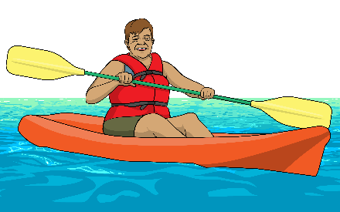
Recreation means things you do for fun.

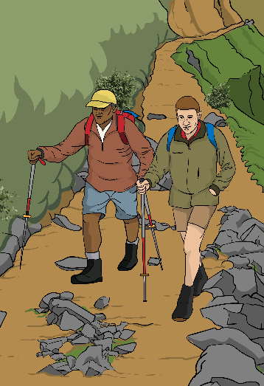
Here active recreation means physical activities like:
walking
running
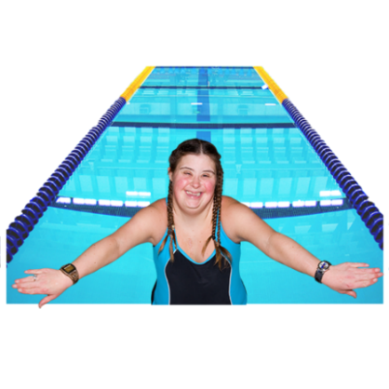
swimming
cycling
fishing
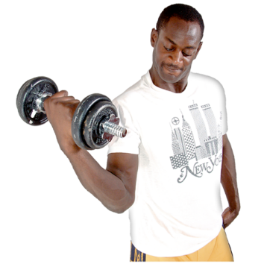
yoga
going to the gym.
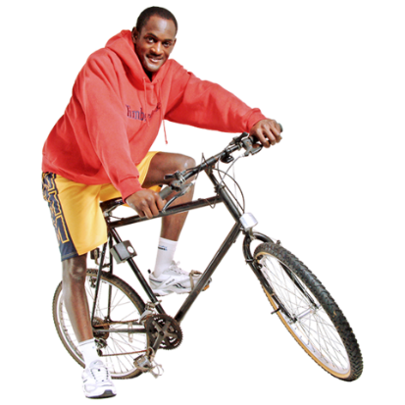

In this Easy Read we call
Sport New Zealand Ihi Aotearoa Sport NZ for short.
In this Easy Read we use the words intellectual disability.

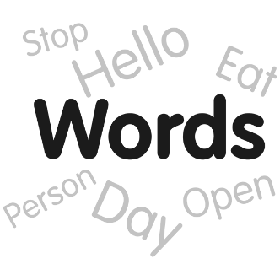
We know some people prefer the words learning disability.

We are using the words intellectual disability because those are the words used in the report written by Sport NZ.

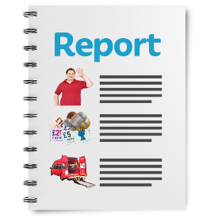
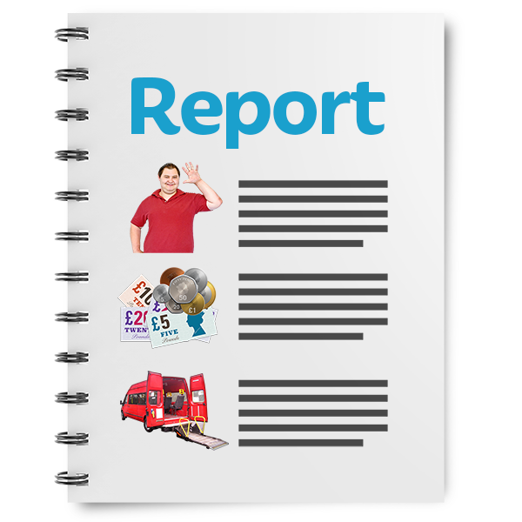
This summary of the report is in 2 parts.

This is part 1.

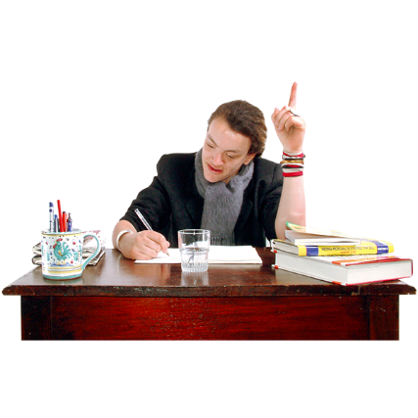
It tells you:
why Sport NZ wrote the report
what the report found out.
Part 2 of the summary tells you:
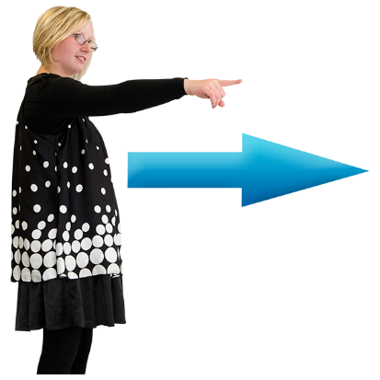
about the history of disability sport and active recreation in Aotearoa New Zealand
what the future might be like for disability sport and active recreation in Aotearoa New Zealand.

You can read part 2 of the summary on this website:

https://tinyurl.com/5a6vu7jk

Why did Sport NZ write this report?
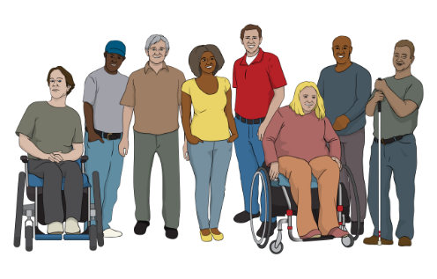

1 out of every 6 people in Aotearoa New Zealand is disabled.

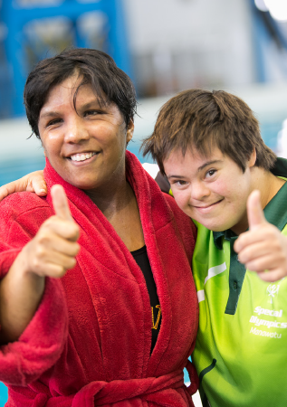
Image source: Sport NZ
Sport NZ thinks it needs to be easier for disabled people to do sport and active recreation.

They wanted to know what:
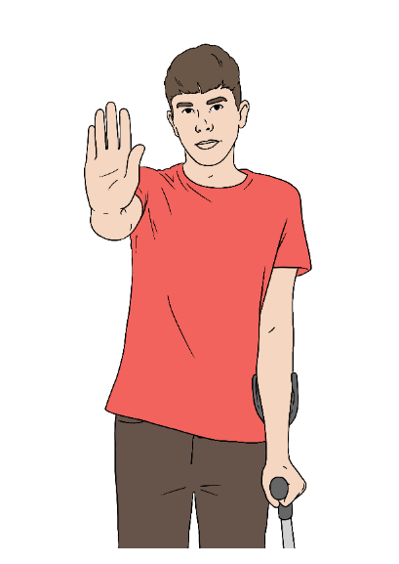
stops disabled people doing sport and active recreation now
might stop disabled people doing sport and active recreation in the future
they can do to make it easier for disabled people to do sport and active recreation.
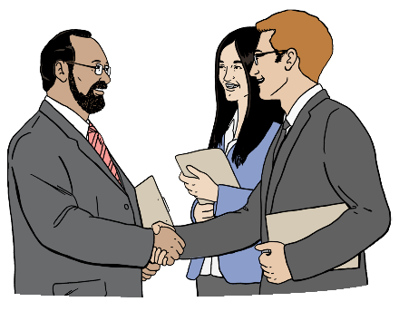
To find out the answers to these questions Sport New Zealand worked with:
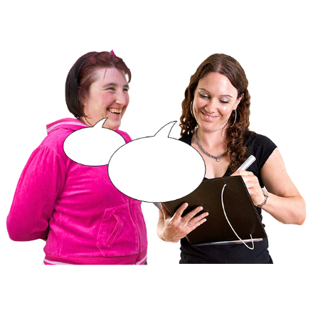
the Halberg Foundation
Paralympics New Zealand
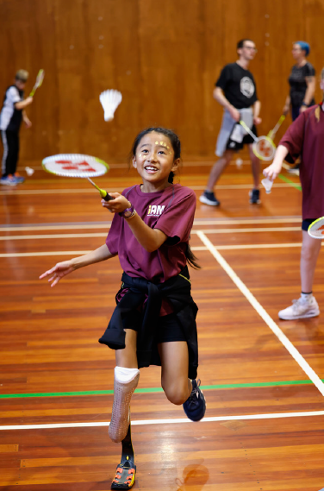
Special Olympics New Zealand.
Image source: Halberg Foundation

The Halberg Foundation supports physically disabled young people
to do sport and active recreation.

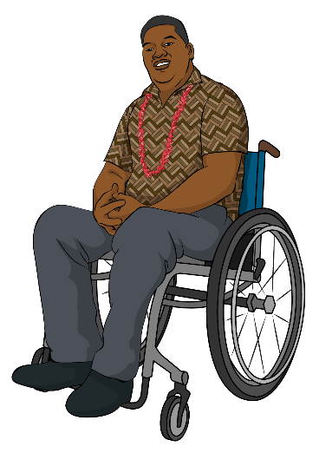
In this Easy Read being physically disabled means your disability makes part of your body work differently like:
being blind
something that means you need to use a wheelchair.
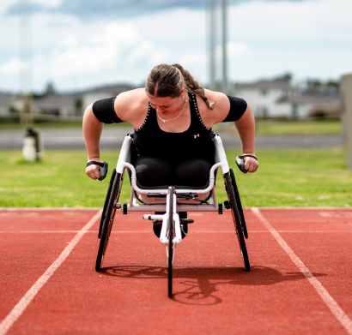
Paralympics New Zealand
supports physically disabled
athletes to be part of big sports competitions around the world.
Image source: Sport NZ

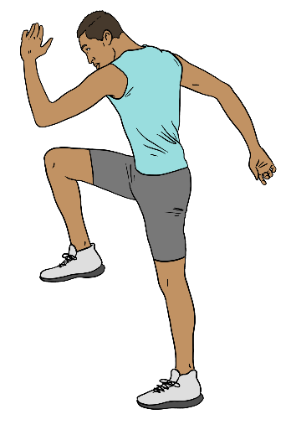
Here athletes means people who
are very good at sport.

Some athletes play sport as their
job.

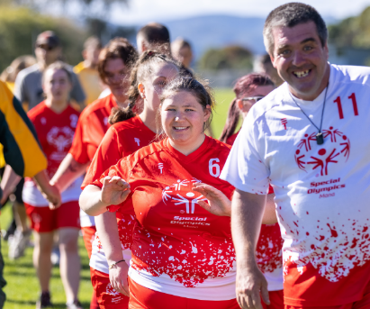
Image source: Special Olympics NZ
Special Olympics New Zealand supports people with intellectual disability to do sport and active recreation.

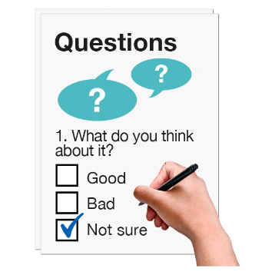
To find out what doing sport and active recreation is like for disabled people in Aotearoa New Zealand Sport NZ:
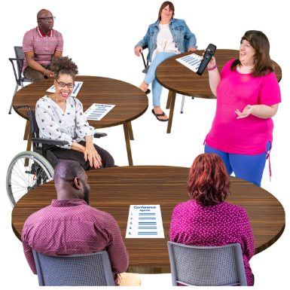
did surveys
held workshops
talked to experts.

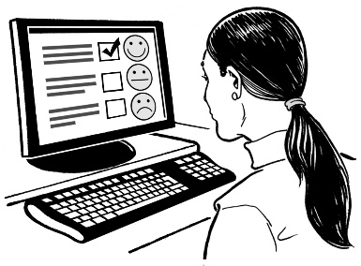
A survey is a set of questions that lots of people answer.

Surveys are used to find out information like what people think about doing sport and active recreation.
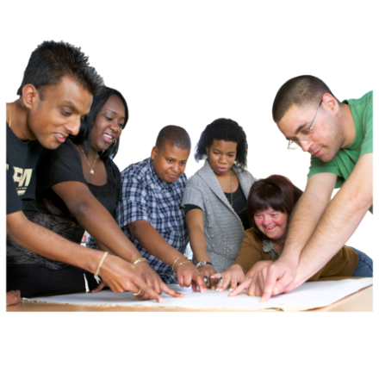

Workshops are when a group of people work together to think of
ways to solve a problem.
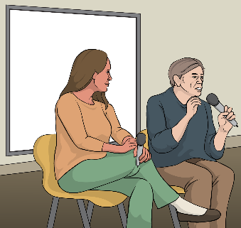
Here experts are people who know
a lot of information about sport and active recreation for disabled people.

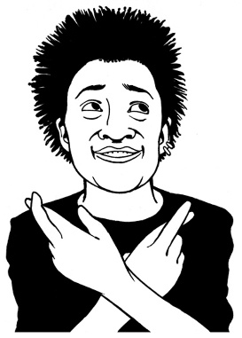
Sport NZ hopes the disability sport and recreation sector will use this report to make it easier for disabled people to do sport and active recreation.

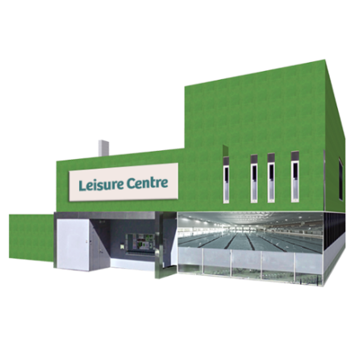
The disability sport and
recreation sector means all the organisations that support disabled people to do sport and active recreation.

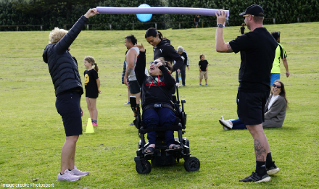
Image source: Photosport
When you see the words the sector in this Easy Read they mean the disability sport and recreation sector.

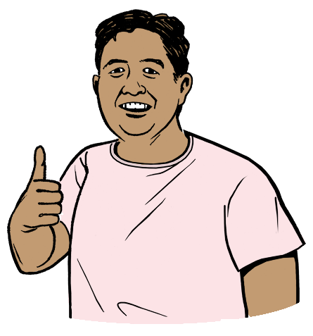
Being able to do sport and active recreation will make life better for disabled people by making them:
healthier
happier.

What did the report find out?

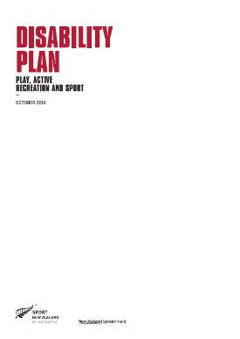
Sport NZ has a Disability Plan from 2019.

The Disability Plan tells Sport NZ how they can make it easier for disabled New Zealanders to do sport and active recreation.

You can read the full Sport NZ Disability Plan on this website:

https://tinyurl.com/yc3j97hv

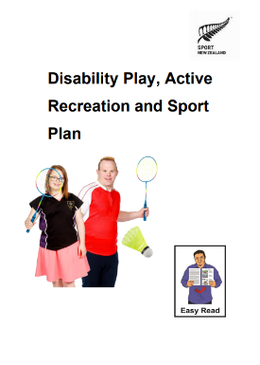
You can read the Sport NZ Disability Plan in Easy Read on this website:

https://tinyurl.com/335uefc3

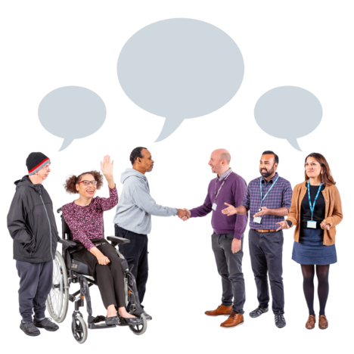
The Disability Plan says Sport NZ needs to focus on:
working together with disabled people
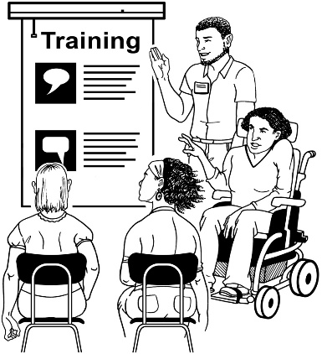
making sure everyone in the sector knows how to support disabled people
including disabled people.

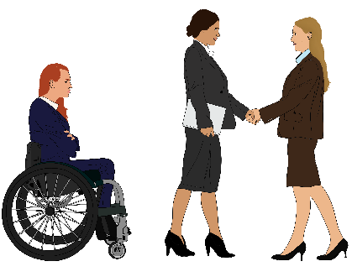
The report says these things are still important.

Some people think it is too hard to include disabled people in sport and active recreation.
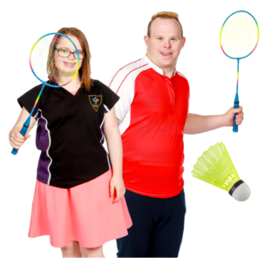


This stops disabled people from doing sport and active recreation.

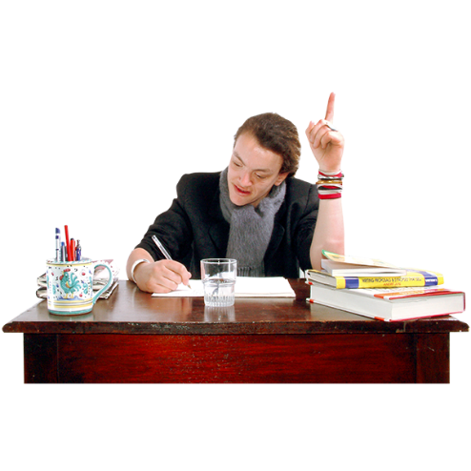
To make it easier for disabled people to do sport and active recreation the sector needs to:
work together
try new things.

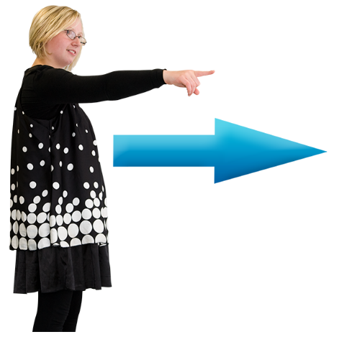
The report says it is hard to know what will happen in the future.

The sector needs to be ready to change if it needs to in the future.


The report found there are 6 main opportunities for disability sport and active recreation.

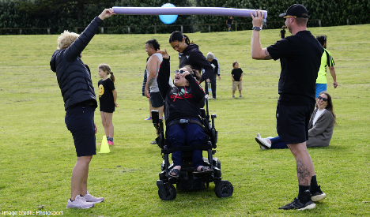
Here opportunities are things the sector can do to make it easier for disabled people to do sport and active recreation.
Image source: Photosport

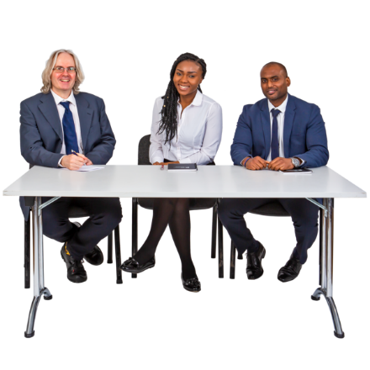
Opportunity 1: Leadership

Leaders in the sector need to change how they think about disability.

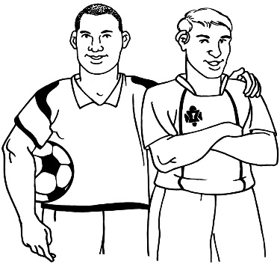
Here leaders are people who run organisations like disability sports organisations.

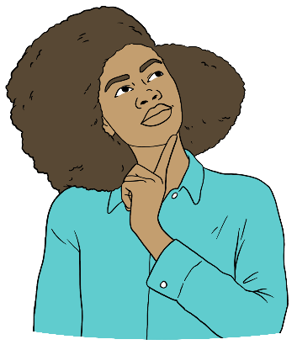
Leaders can change how they think about disability by:
talking to lots of different people
trying new things.
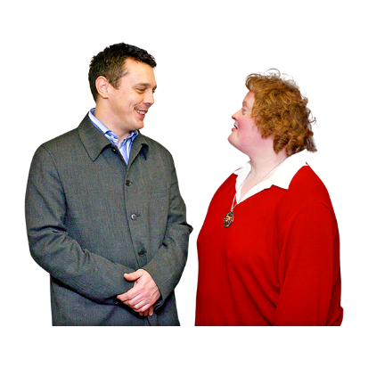
It is important for leaders to learn about things like neurodiversity.

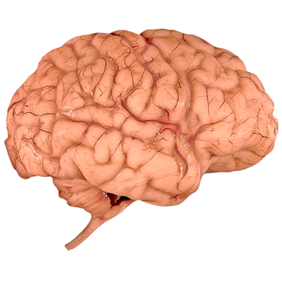
Neurodiversity is the idea that
there are natural differences in how our brains work.

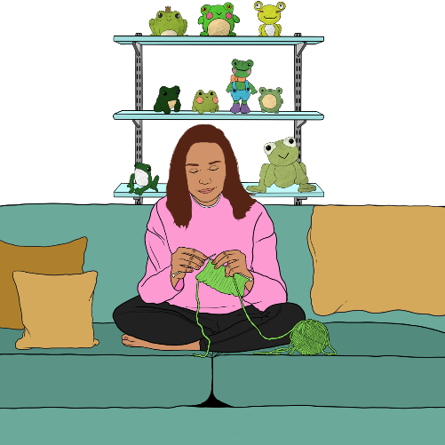
It says no to the idea that some people have brains that work in
ways that:
are wrong
need to be cured / fixed.
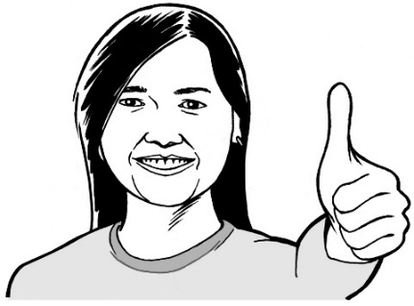

Neurodiversity says the world
should work well for everyone.
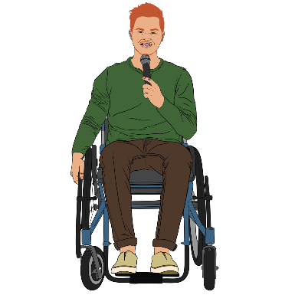

Disabled people should have a say in how disability sport and active recreation is run.
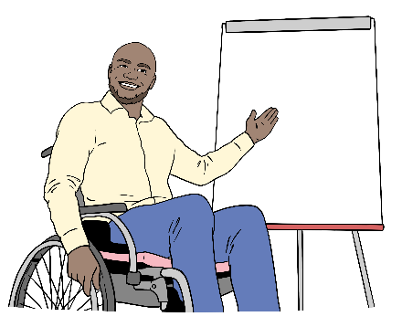
The report says the sector should make sure:
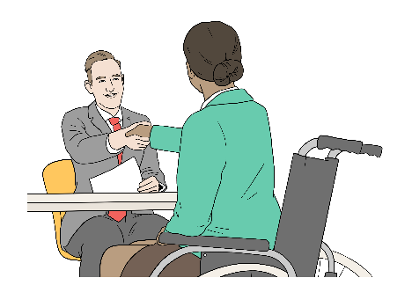
everyone in the sector gets training about disability
more disabled people can work in the sector
disabled young people get to:
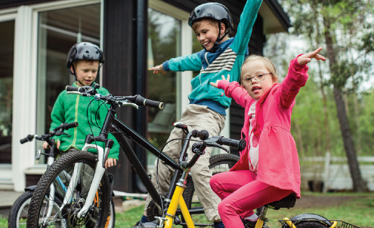
- do sport and active recreation
Image source: Sport NZ
- be leaders in sport and active recreation.

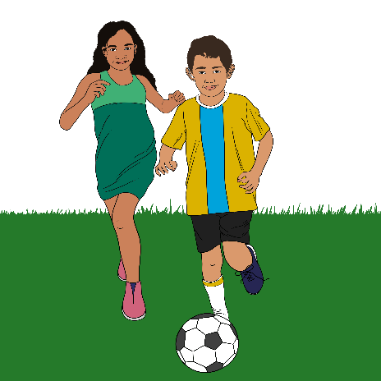
Here leaders are young people who do things like:
speaking up about what doing sport and active recreation is like for them
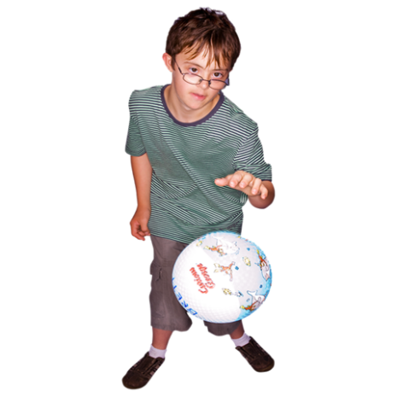
supporting other people to understand what they can do
showing people new ways to
take part in sport and active recreation.

The sector should also keep asking what:
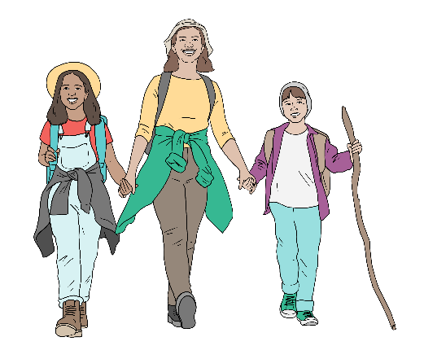
disabled people think about sport and active recreation for them in Aotearoa New Zealand
whānau / families of disabled people think about sport and active recreation for disabled people in Aotearoa New Zealand.

Opportunity 2: Partnering
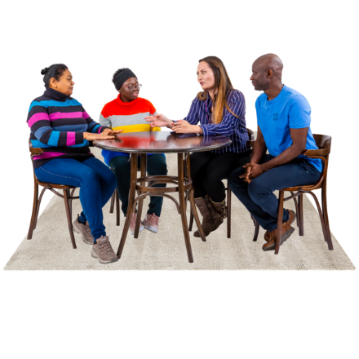
Partnering is about:
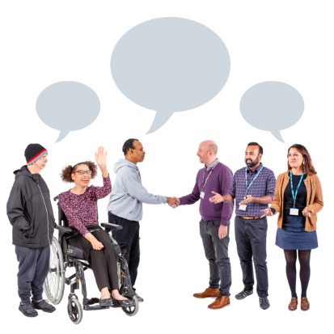
Sport NZ supporting different kinds of organisations including ones that focus on disabled people
different organisations working together to connect with more disabled people.
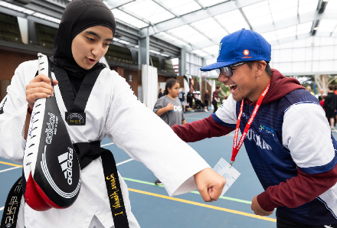
Image source: Halberg Foundation

The sector needs to find ways to pay for more types of disability sport and active recreation.
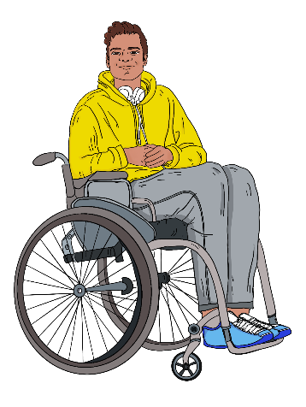

At the moment SportNZ mostly pays for sport and active recreation for physically disabled people.

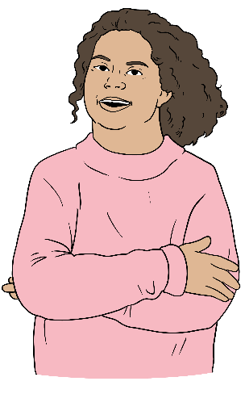
SportNZ should also pay for sport and active recreation for:
people with intellectual disability
people with invisible disabilities.

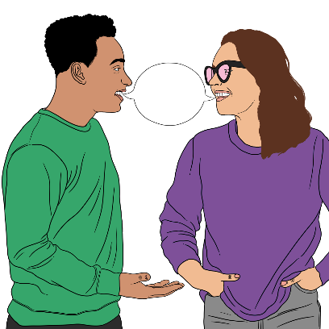
An invisible disability is when you cannot tell someone is disabled by looking at them.

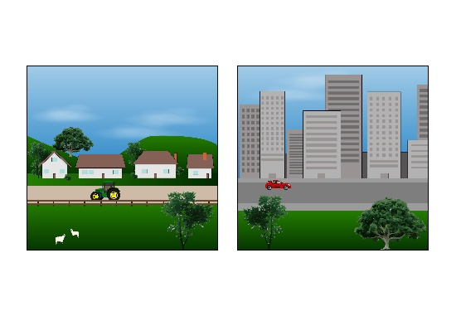
The sector can make it easier for disabled people to do sport and active recreation by working with:
local government
community providers.

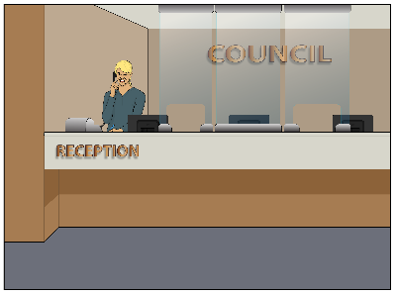
Local government means the councils that run things in each part of Aotearoa New Zealand.
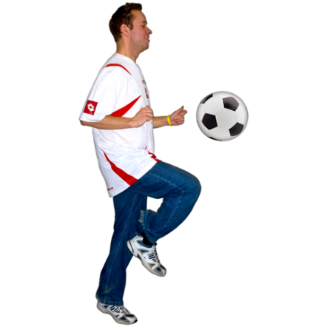
Here community providers means organisations that run services for people in the place where they live like:
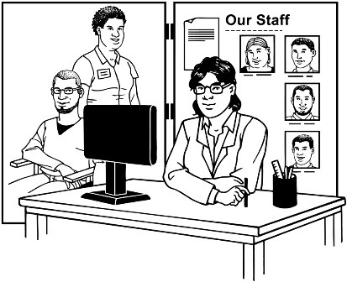
soccer clubs
disability support services.

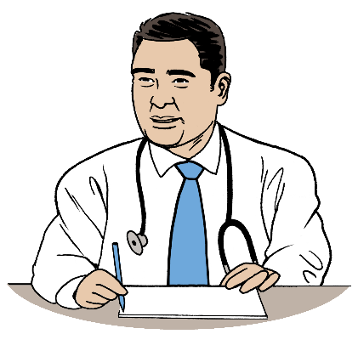
The report says the sector should work with:
healthcare providers like doctors
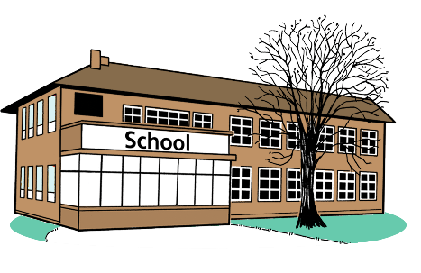
schools
community providers.

The sector should work with disabled people to come up with new ways of paying for disability sport and active recreation.

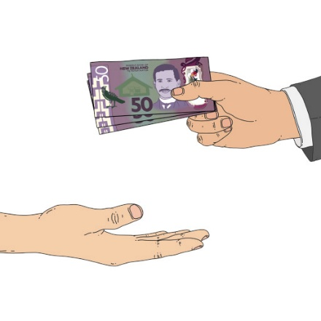
Funding for disability sport and active recreation should be flexible.

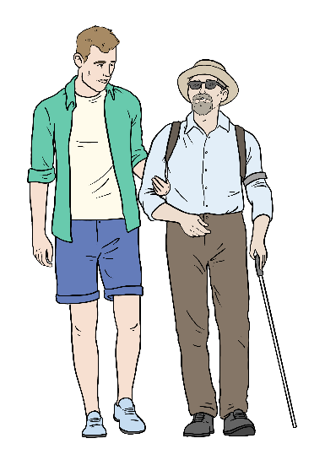
Here funding means the money
that pays for disability sport and active recreation.

Here flexible means the money can be used in different ways to meet
the needs different people have.

Opportunity 3: System capability


The system capability opportunity
is about how the sector can work together to make it easier for disabled people to do sport and active recreation.

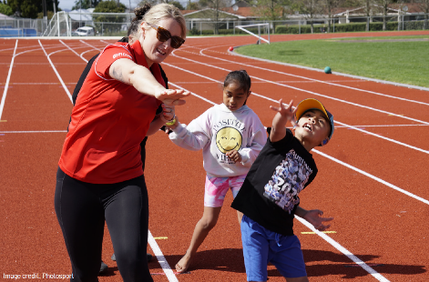
Everyone in the sector should want to include disabled people in sport and active recreation.
Image source: Photosport


Policies should support disabled people to do sport and active recreation.

Here policies are the rules that
sport and active recreation organisations have about including disabled people.

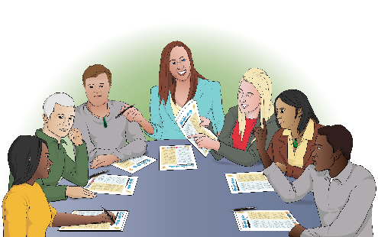
Organisations should share the information they know about including disabled people with each other.

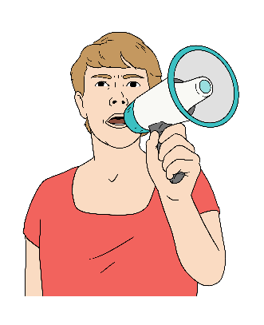
Different parts of Aotearoa New Zealand have organisations that speak up about including disabled people in sport and active recreation.
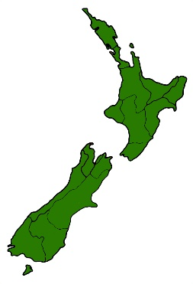

These organisations should be the leaders in making it easier for disabled people to do sport and active recreation in their part of Aotearoa New Zealand.

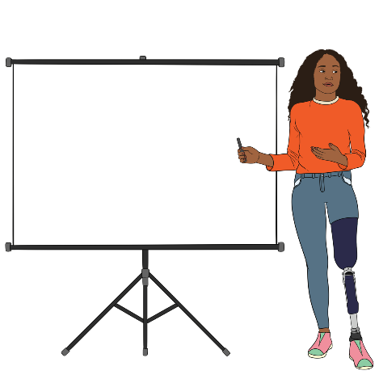
The report says the sector should:
make it easier for organisations to share information about including disabled people
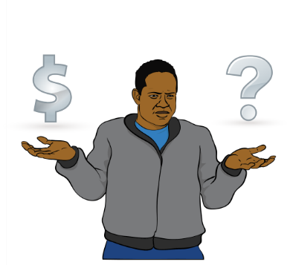
teach all New Zealanders about including disabled people in sport and active recreation
include disabled people when choosing what sport and active recreation to pay for.

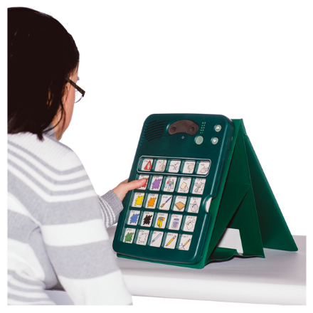
Opportunity 4: Technological and digital access

The technological and digital access opportunity is about using technology to support disabled people to do sport and active recreation.

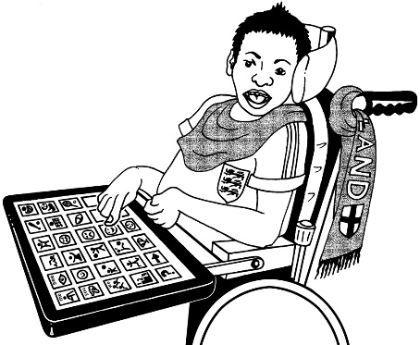
The sector needs to know about:
assistive technology
virtual reality
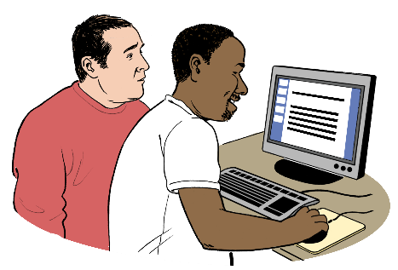
augmented reality
AI-powered systems.

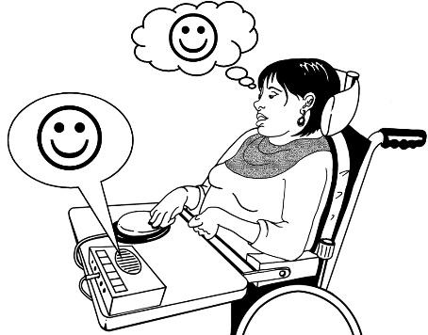
Assistive technology is any technology a disabled person uses
to support them like a:
screen-reader
text-to-speech app.

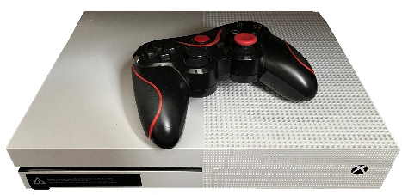
Virtual reality is a type of
technology that uses special goggles so you feel like you are inside a computer game.

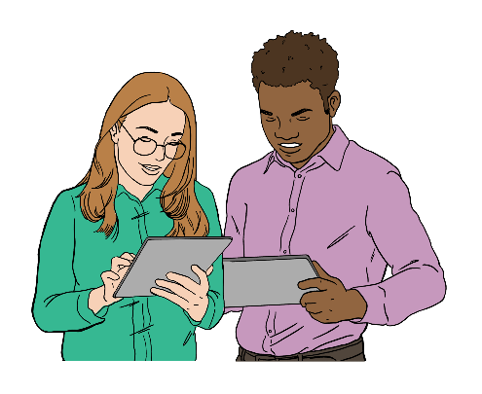
Augmented reality is technology that lets you use digital information
in the real world.
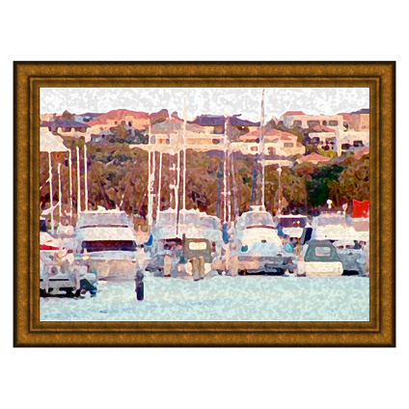

For example you can use
augmented reality to see what a painting will look like in your room.

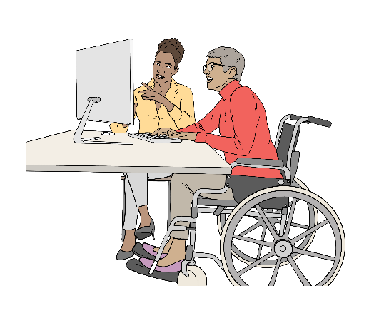
AI is short for artificial intelligence.

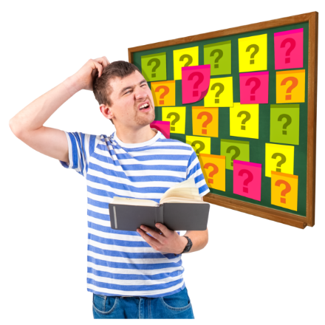
Artificial intelligence means computer programs that can do
some of the things humans can do like:
learning
solving problems.

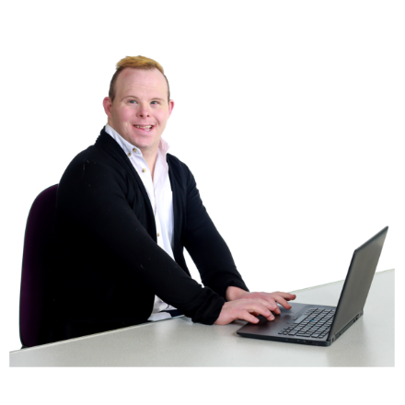
AI-powered systems are computer programs that use AI to solve a problem.


Digital information about disability sport needs to be accessible.


Here digital means anything to do with devices like:
computers
mobile phones.
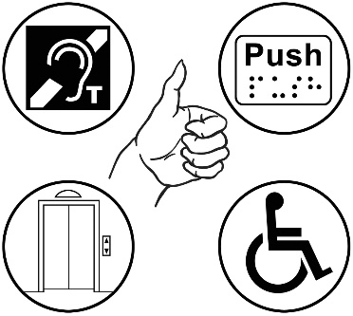

Here accessible means easy for disabled people to use.

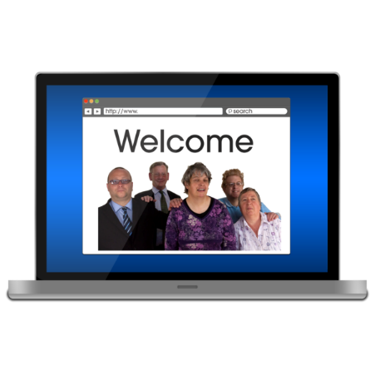
The report says the sector should:
use digital tools to:
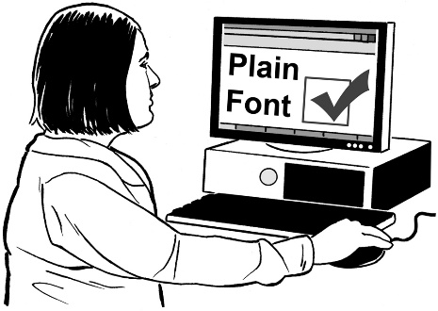
- tell people about disability sport and active recreation
- make it easier for disabled people to do sport and active recreation
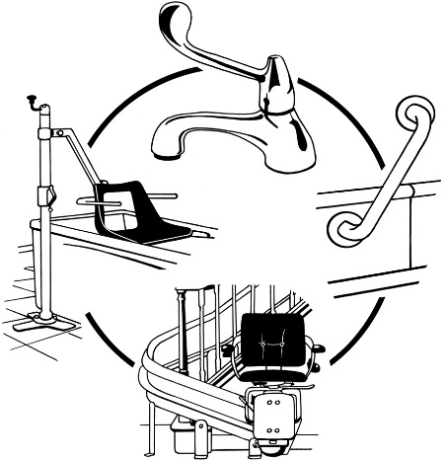
teach sport and active recreation organisations about making digital information accessible
work together with the companies that make adaptive devices.

Adaptive devices are tools that support disabled people to do sport and active recreation like:
Image source: Sport NZ
racing wheelchairs
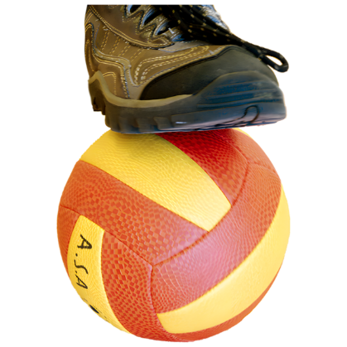
bikes you can use while lying down
balls that make a noise so blind people know where they are.

Opportunity 5: Agility

The agility opportunity is about making sure the sector is ready to change if it needs to in the future.

People keep making new assistive technology.

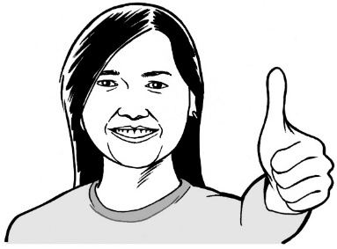
The sector should use this new technology.

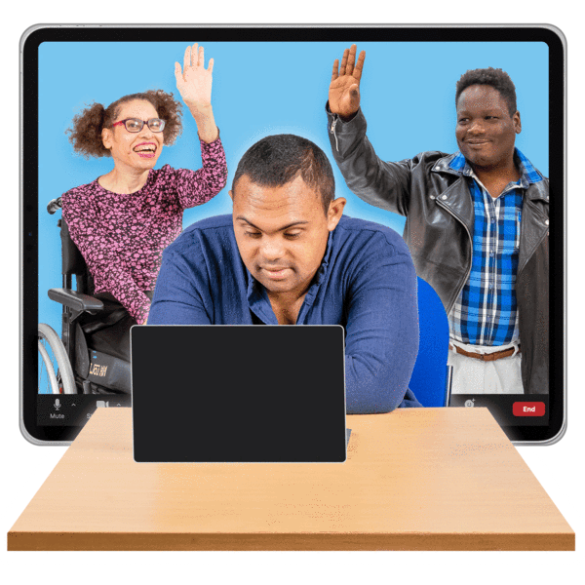
The sector should provide hybrid ways of doing sport and active recreation.

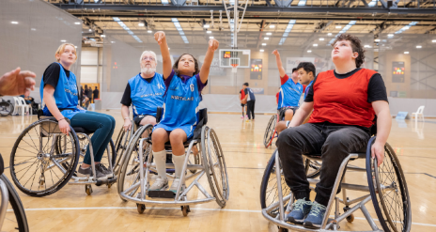
Image source: Parafed Bay of Plenty
Here hybrid means that you can
do sport and active recreation:
in person
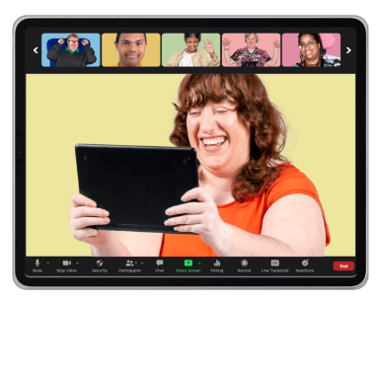
online
using virtual reality.

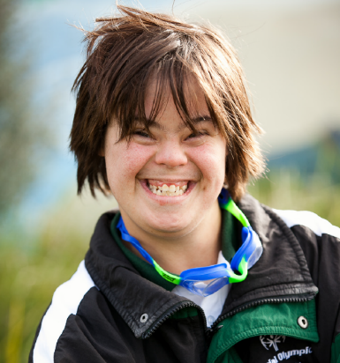
The report says the sector should make sure:
Image source: Sport NZ
sport and active recreation can be run in different ways if they need to be
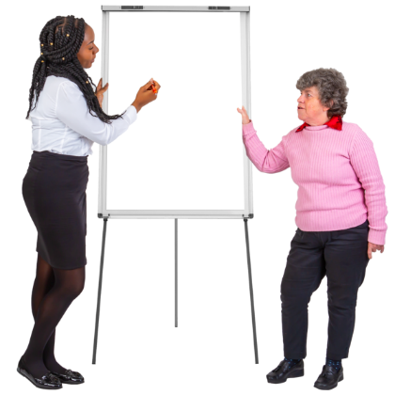
people working in the sector think trying new things is important
people working in the sector think it is important to keep learning.

The sector should run training on:
including disabled people
new technology.

Opportunity 6: Individual and collective focus
The individual and collective
focus opportunity is about making sure all the organisations in the sector know what their job is.

This will:
make it easier for organisations to work together
stop different organisations doing the same thing
Image source: Special Olympics NZ
support different organisations to say the same things about including disabled people in sport and active recreation.

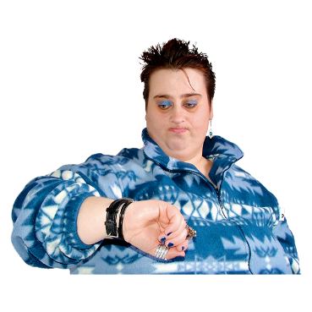
When different organisations do the same thing it is a waste of:
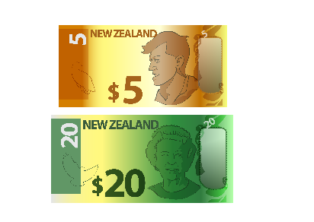
time
money.

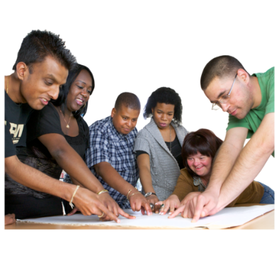
The report says organisations in the sector should:
plan for the future together
meet often
share the things they know about including disabled people in sport with each other.

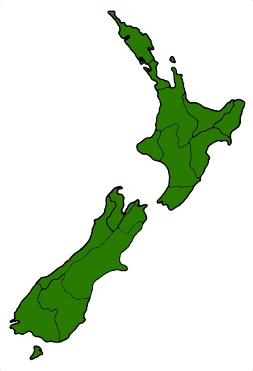
Planning for the future together can happen:
locally – meaning in 1 town or city
regionally – meaning in a bigger part of Aotearoa New Zealand like Waikato.

Where to find more information

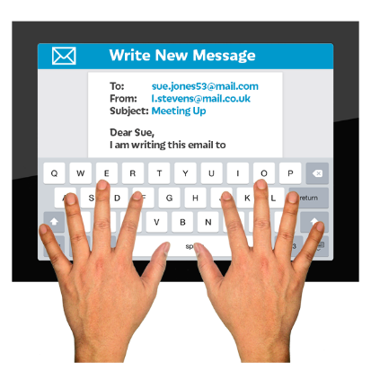
If you have questions about the information in this Easy Read you can email:

accessible@sportnz.org.nz

You can find out more about
Sport NZ on their website at:

https://sportnz.org.nz
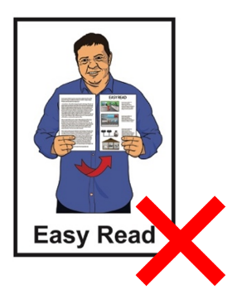

This website is not in Easy Read.


This information has been written by Sport New Zealand Ihi Aotearoa.

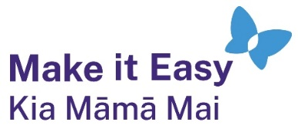
It has been translated into Easy Read by the Make it Easy Kia Māmā Mai service of People First New Zealand Ngā Tāngata Tuatahi.
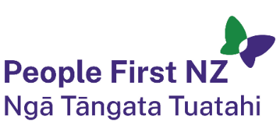
The ideas in this document are not the ideas of People First New Zealand Ngā Tāngata Tuatahi.

All images used in this Easy Read document are subject to copyright rules and cannot be used without permission.


Make it Easy uses images from:

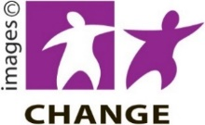
- Photosymbols

- Change Images


- Huriana Kopeke-Te Aho

- SGC Image Works

- T Wood

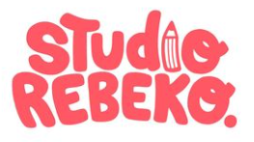
- Studio Rebeko

- Inga Kramer.

