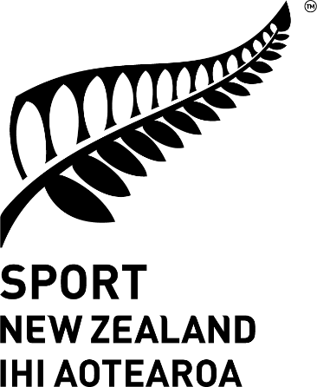
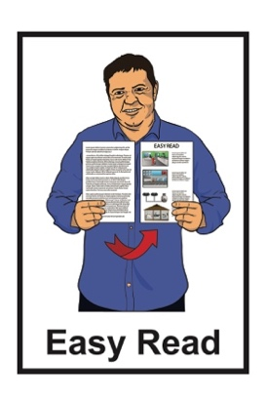

The future of sport and recreation for disabled New Zealanders:

Part 2 – The history and future of disabled sport and recreation
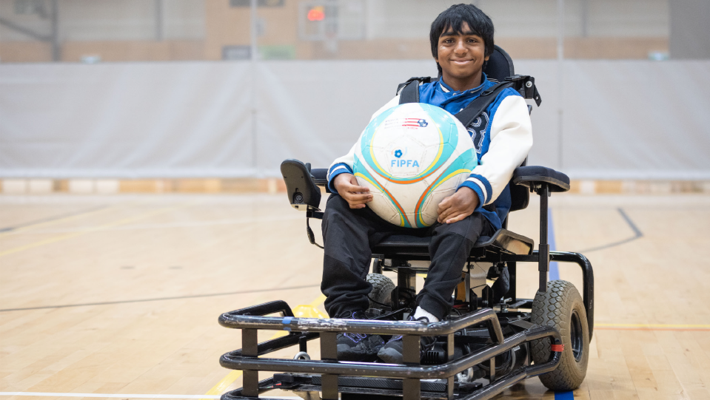

Image source: Parafed Bay of Plenty
Published: July 2025

Before you start

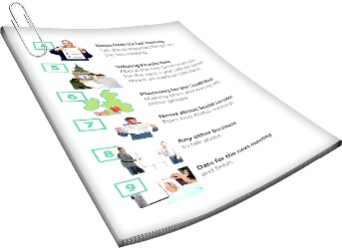
This is a long document.

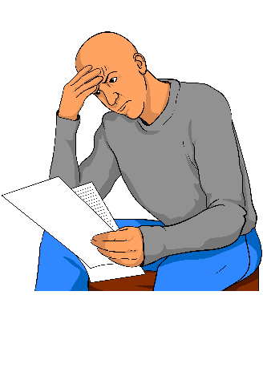
It can be hard for some people to read a document this long.

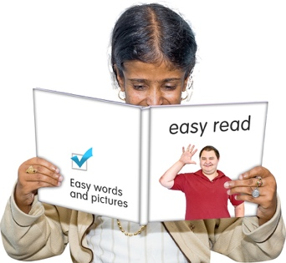
Some things you can do to make it easier are:
read it a few pages at a time
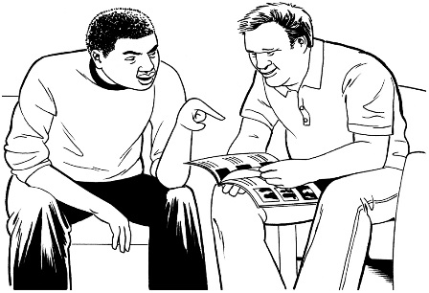
set aside some quiet time to look at it
have someone read it with you to support you to understand it.

What you will find in here

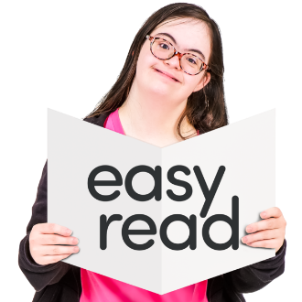
Page number:

About this Easy Read 3

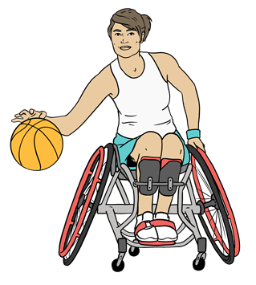
History of disability sport in
Aotearoa New Zealand 8

Current trends and challenges 14
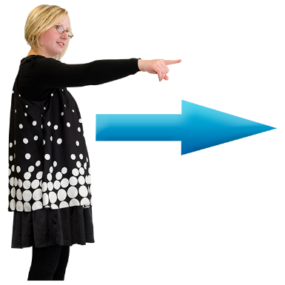

What the disability community
thinks will happen in the future 20

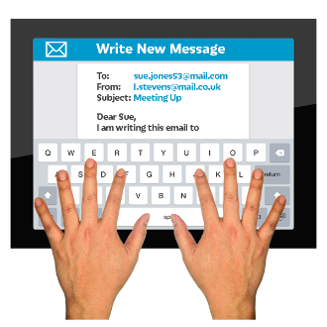
Future scenarios 26

Where to find more information 35

About this Easy Read

This Easy Read is a summary of a longer report.


A summary:
is shorter than the full report
tells you the main ideas.

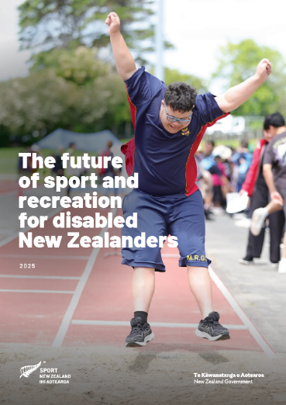
The report is called The future of sport and recreation for disabled New Zealanders.

In this Easy Read we call this report the report for short.


You can read the full report on this website:

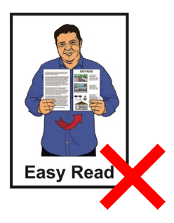
https://tinyurl.com/5a6vu7jk

The full report is not in Easy Read.

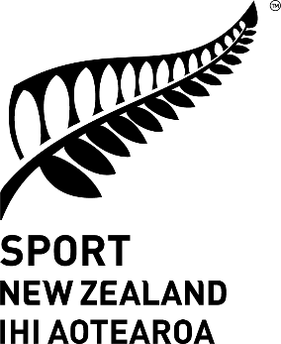
The report is by
Sport New Zealand Ihi Aotearoa.

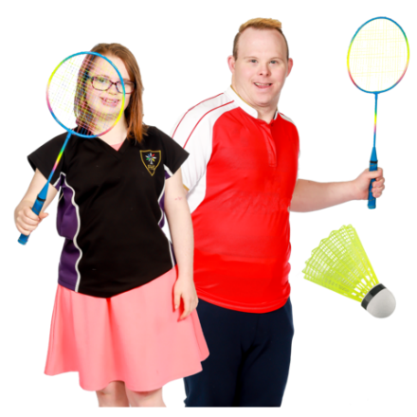
Sport New Zealand Ihi Aotearoa
is the part of the Government in charge of making sure everyone in Aotearoa New Zealand can take part in:
play
sport
active recreation.

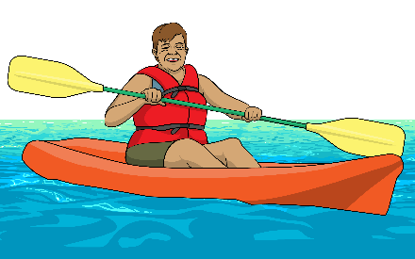
Recreation means things you do for fun.

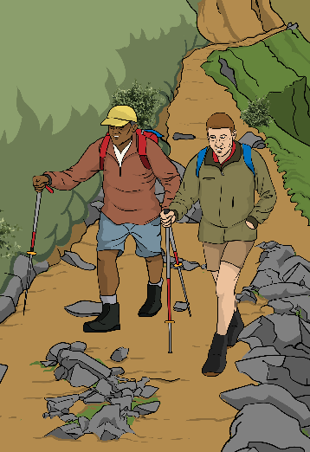
Here active recreation means physical activities like:
walking
running
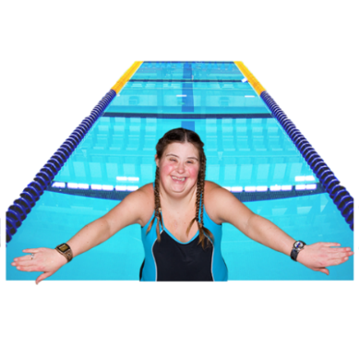
swimming
cycling
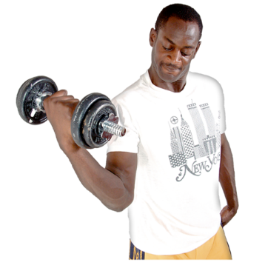
fishing
yoga
exercise where someone uses equipment like lifting weights.
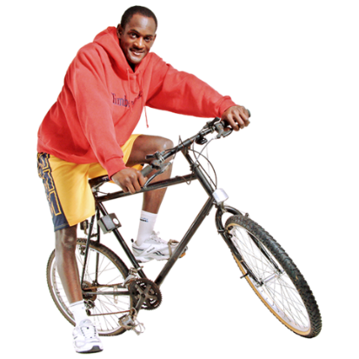

In this Easy Read we call
Sport New Zealand Ihi Aotearoa Sport NZ for short.
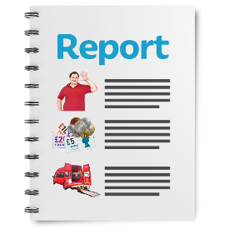
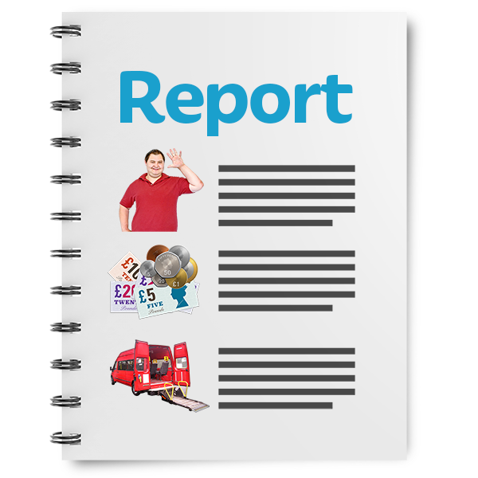
This summary of the report is in 2 parts.

This is part 2.

It tells you:
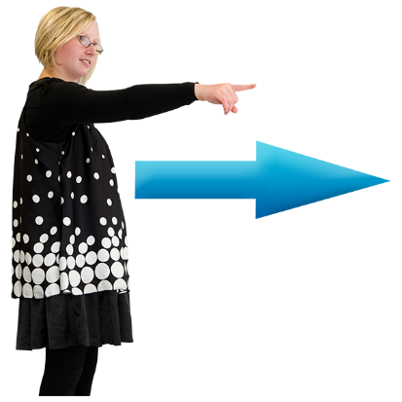
about the history of disability sport and active recreation in Aotearoa New Zealand
what the future might be like for disability sport and active recreation in Aotearoa New Zealand.

Part 1 of the summary tells you:
why Sport NZ wrote the report
what the report found out.

You can read part 1 of the summary on this website:

https://tinyurl.com/5a6vu7jk

History of disability sport in

Aotearoa New Zealand
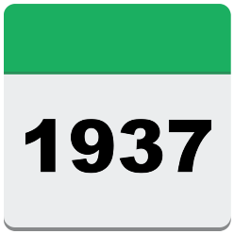

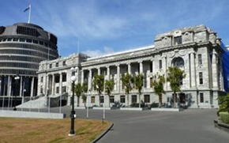
In 1937 the Government first started working on disability sport and active recreation in Aotearoa New Zealand.

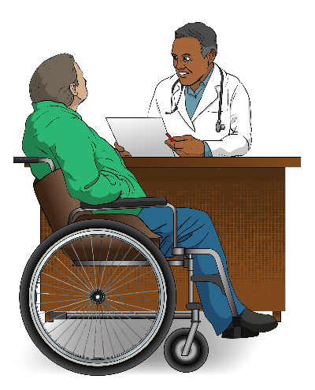
At this time the focus was on the medical model of disability.

The medical model of disability says that disability:
is a problem with the:
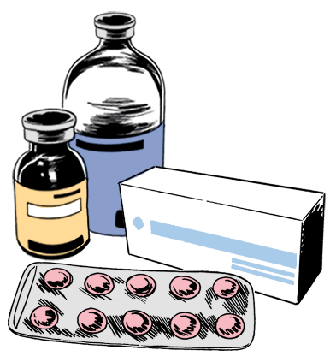
- body of a person
- mind of a person
needs to be fixed.

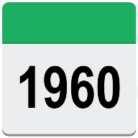
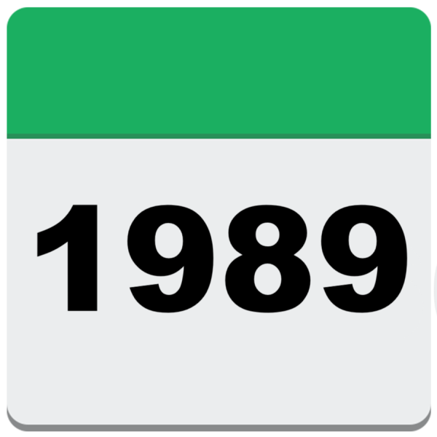
From the 1960s to the 1980s:
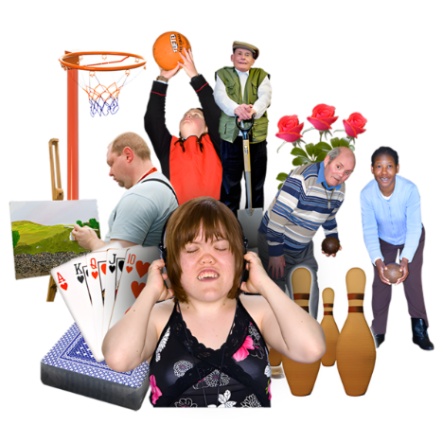
people in the community started running disability sport and active recreation
people started knowing more about disability
it was hard to make changes that lasted.

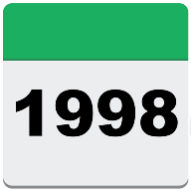

From 1998 to 2005 there were national strategies about including disabled people in sport and active recreation.

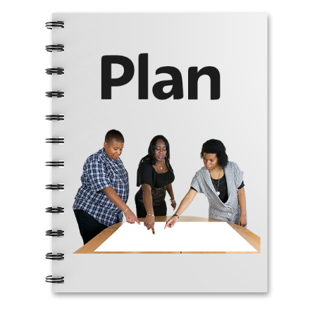
Here national strategies means plans for including disabled people
in sport and active recreation that cover all of Aotearoa New Zealand.

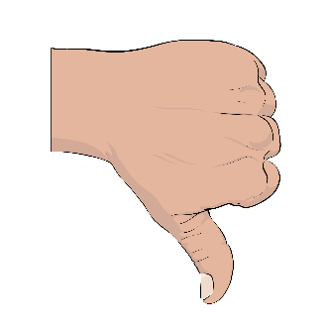
These national strategies did not work very well.

Some of the problems were:
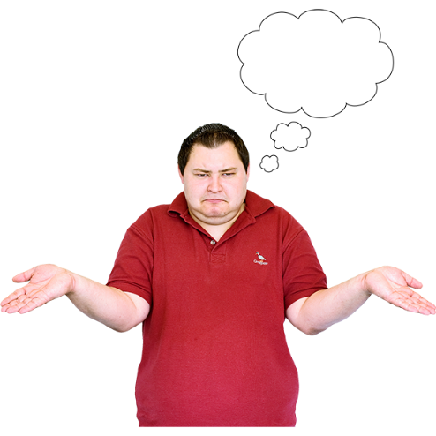
there were not enough resources to make sure disabled people were included in sport and active recreation
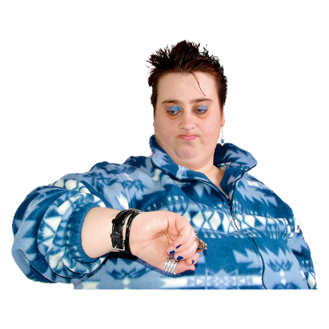
people were not sure whose job it was to make sure disabled people were included in sport and active recreation.

Here resources means things like:
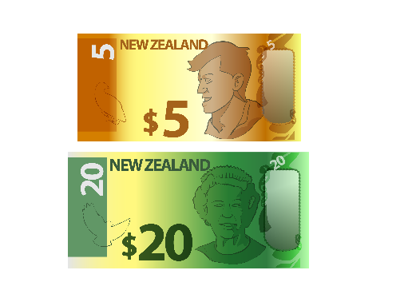
time
money.



From 2016 to 2019 there was more focus on making sure disabled people could do physical activity.

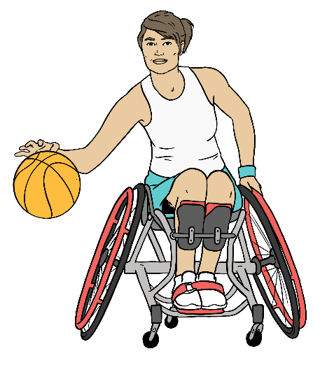
Here physical activity means:
play
sport
active recreation.

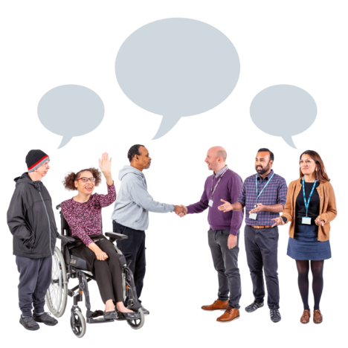
Part of this focus was making sure:
leaders in the sector knew about including disabled people
sport and active recreation organisations knew about including disabled people.

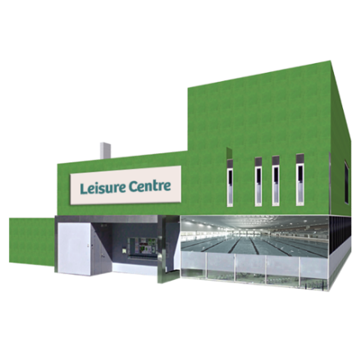
In this Easy Read the sector means all the organisations that support disabled people to do sport and active recreation.

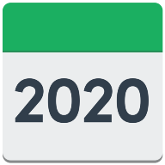
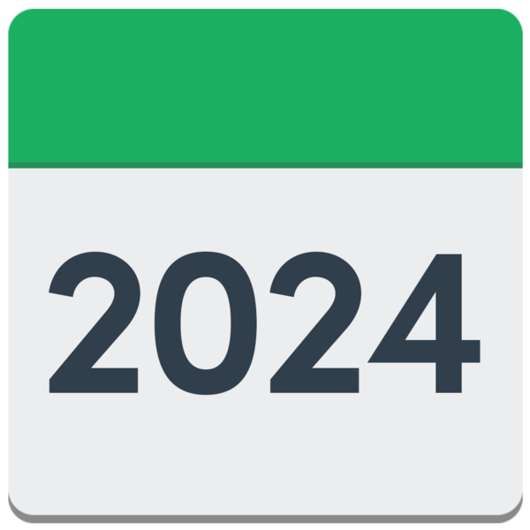
From 2020 to 2024 COVID-19 meant that:
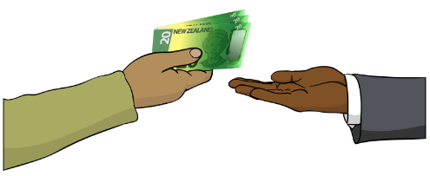
the sector had to change so people could still do sport and active recreation
there was new funding for disability sport and active recreation.
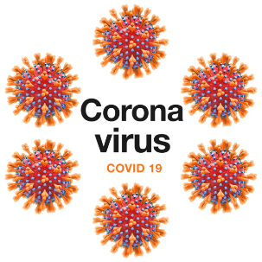

COVID-19 is a virus that can make people very sick.

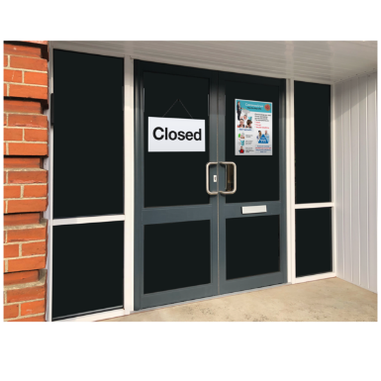
COVID-19 meant we had to do things to stop the virus spreading like:
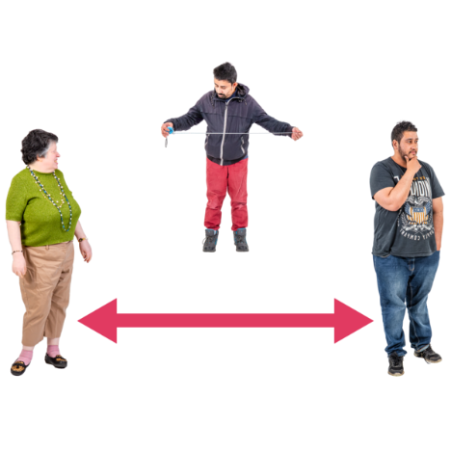
lockdowns
social distancing.

This stopped people from doing sport and active recreation in the usual ways.

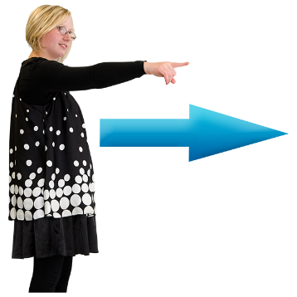
Aotearoa New Zealand is still working to make sure disabled people can do sport and active recreation.

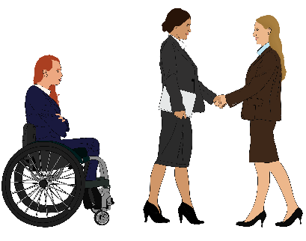
It is still harder for disabled people to do sport and active recreation than it is for non-disabled people.

Current trends and challenges

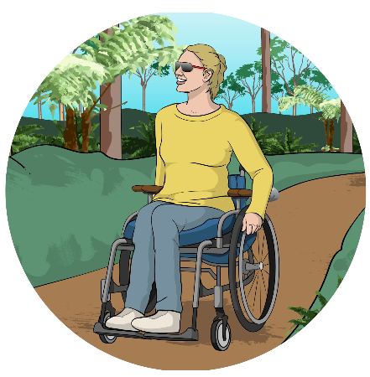
This section of the Easy Read is about:
trends in disability sport and active recreation
challenges in disability sport and active recreation.
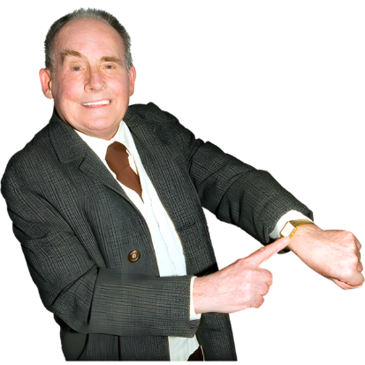

Here trends are things that are happening in disability sport and active recreation at the moment.

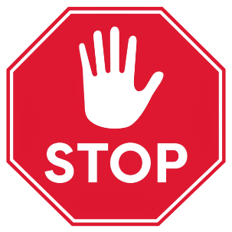
Here challenges are things that make it harder for disabled people
to do sport and active recreation.

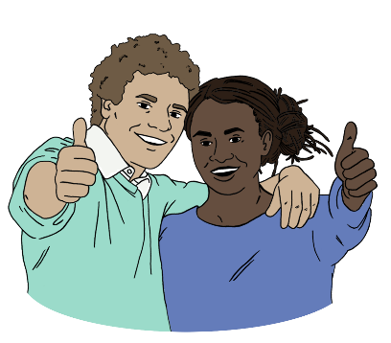
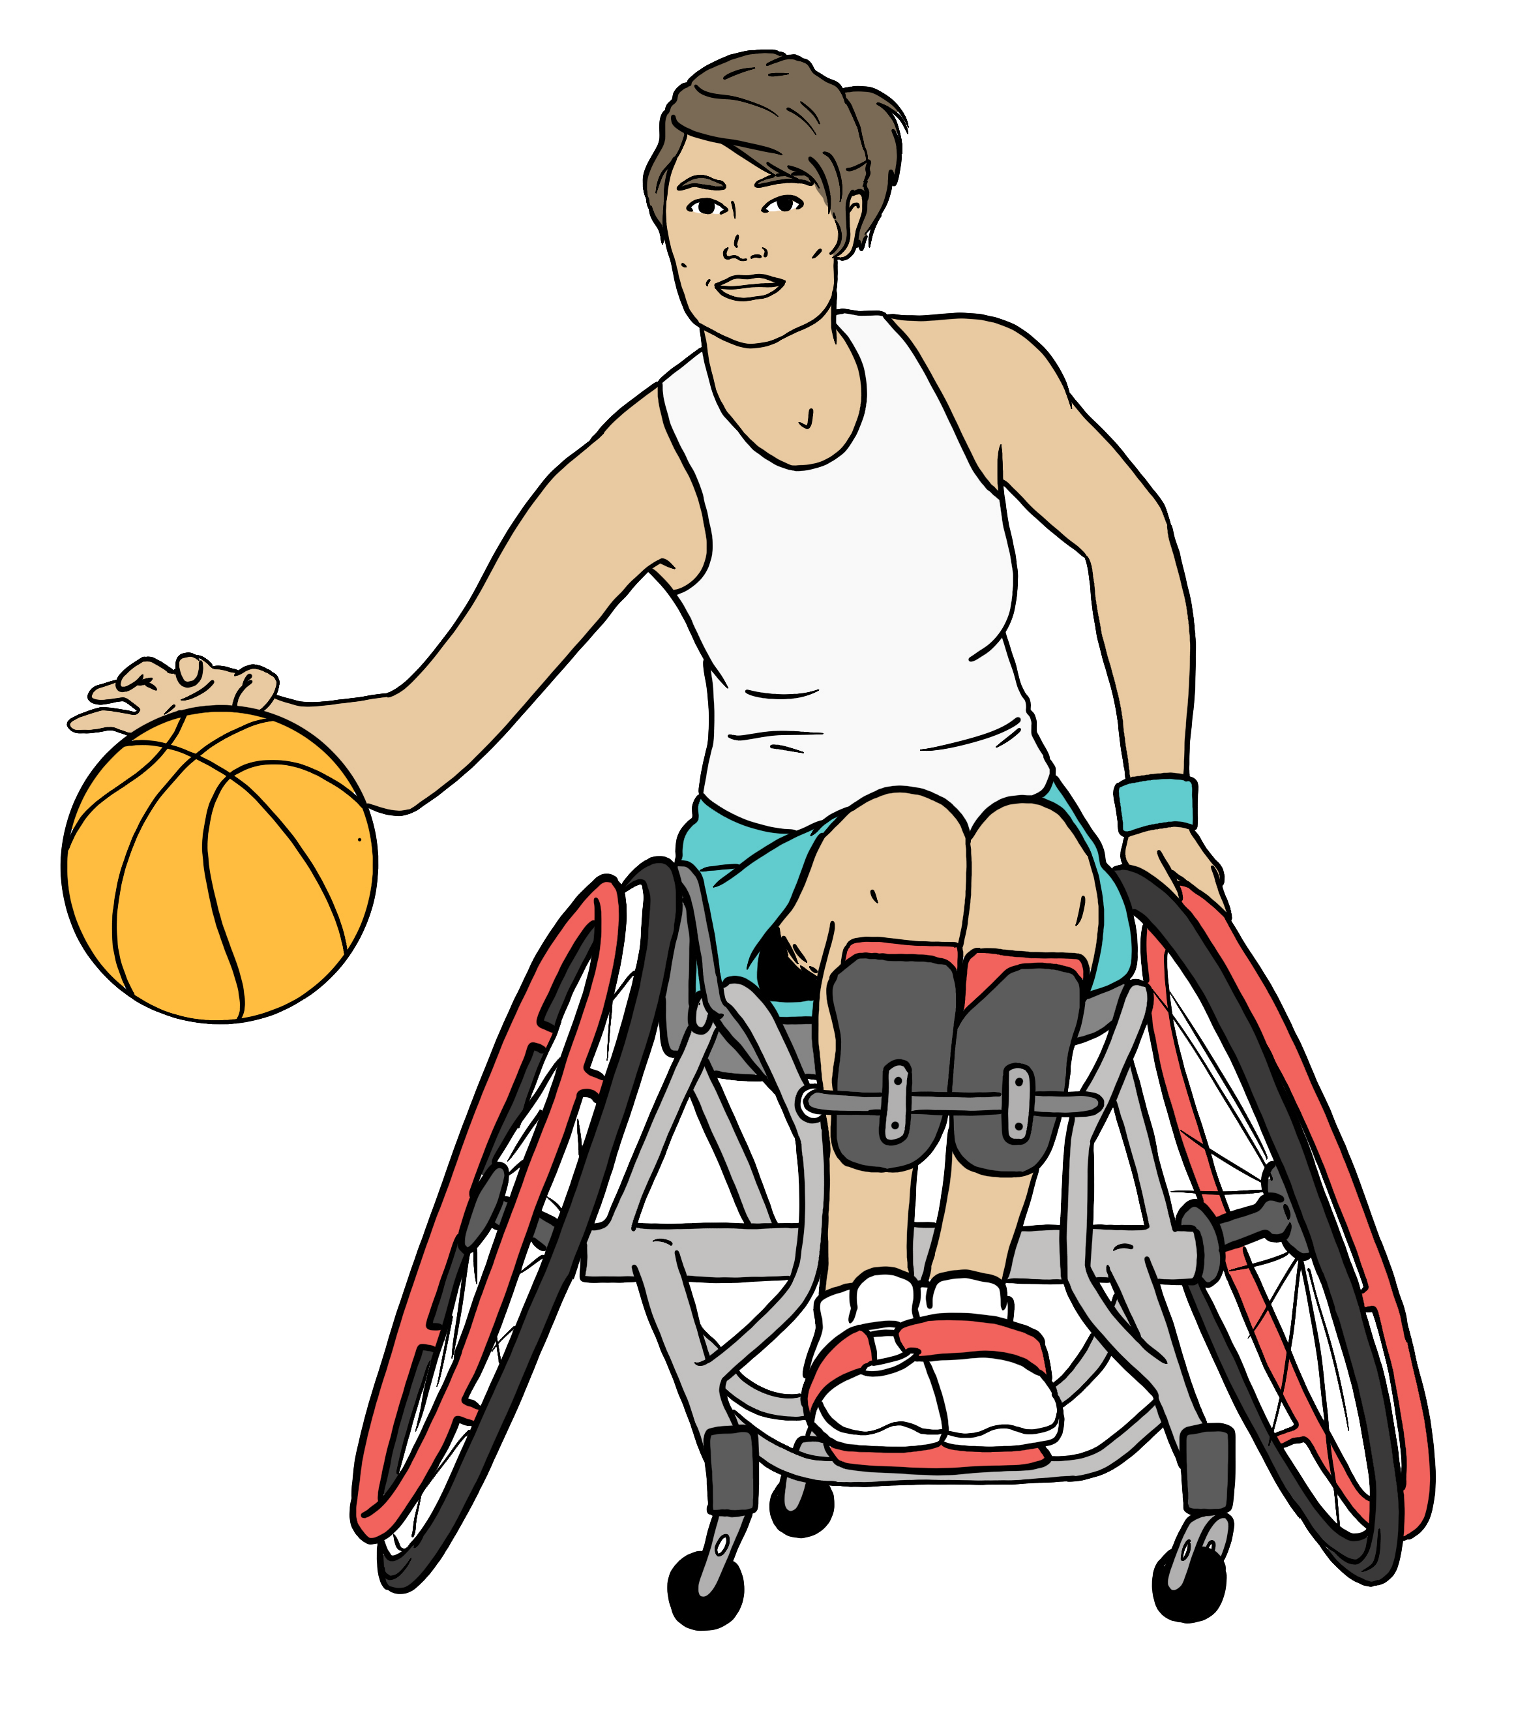
More people:

know about paralympic sport
think paralympic sport is important.

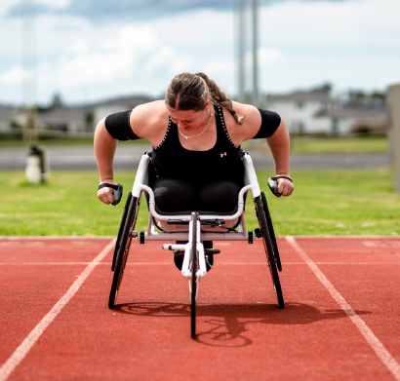
Image source: Sport NZ
Paralympic sport is sport for
physically disabled people.

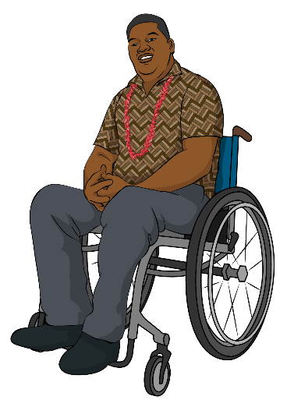
In this Easy Read being physically disabled means your disability makes part of your body work differently like:
being blind
something that means you need to use a wheelchair.

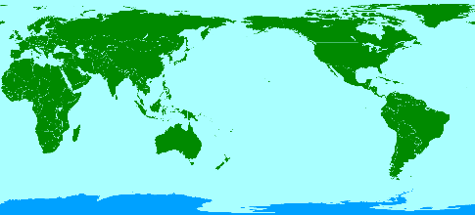
Lots of people around the world are working to get better at including disabled people.

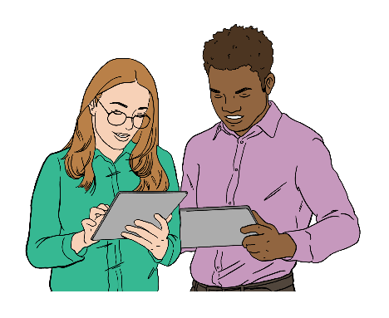
New technology is making sport and active recreation more accessible for disabled people.

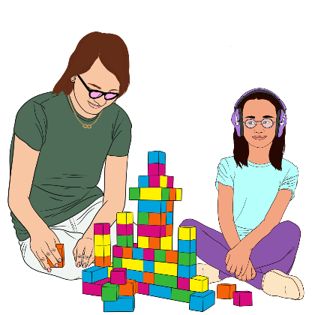
People know more about neurodiversity.

Neurodiversity is the idea that
there are natural differences in how our brains work.
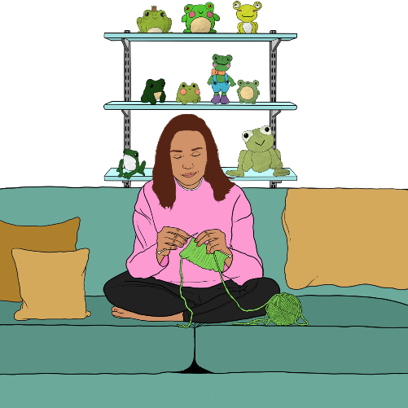

It says no to the idea that some people have brains that work in
ways that:
are wrong
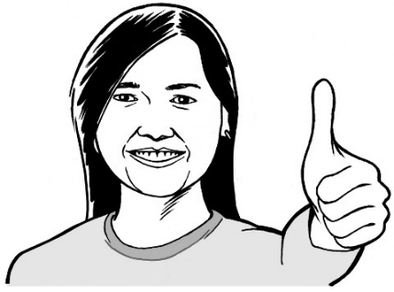
need to be cured / fixed.

Neurodiversity says the world
should work well for everyone.
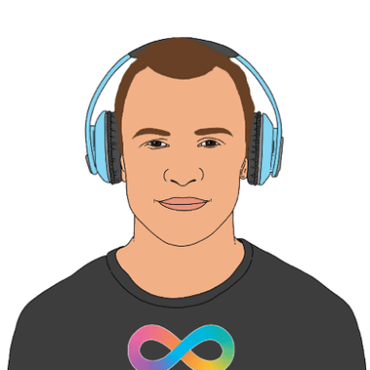

There is still not enough support for neurodivergent people.

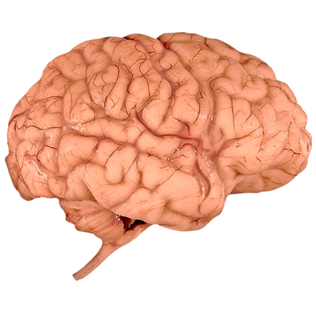
Neurodivergent people have brains that are different to:
how most brains work
what some people think our brains should be like.
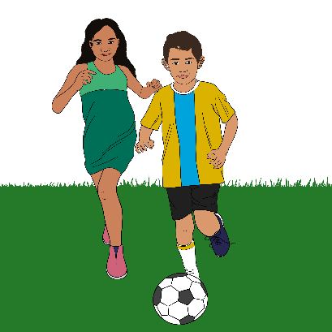

Disabled young people do less physical activity than non-disabled young people.

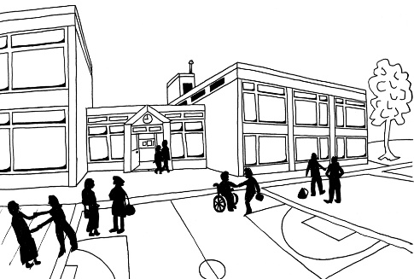
It is hard for disabled young people to do sport and active recreation:
at school
in the community.

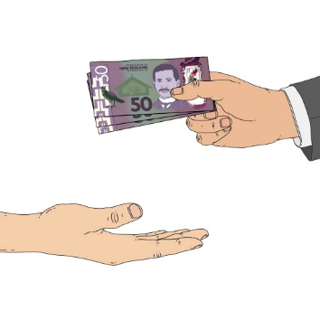
There is more money from the Government to pay for disability sport and active recreation.

There are still not enough resources for disability sport and active recreation.

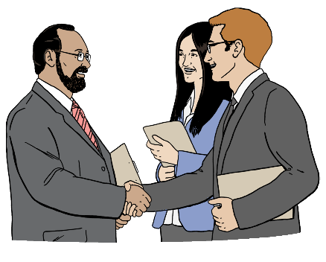
Other things that still make it harder for disabled people to do sport and active recreation are:
ableism
organisations in the sector not working together.

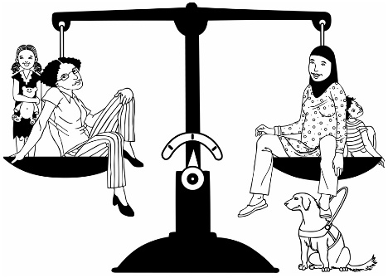
Ableism is believing that:
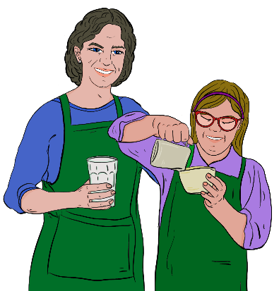
disabled people are less important than non-disabled people
disabled people cannot do the same things as non-disabled people.

What the disability community thinks will happen in the future

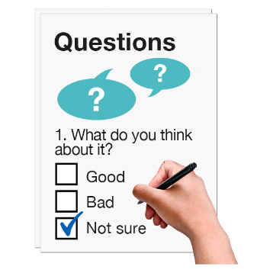
As part of writing the report Sport NZ did a survey.

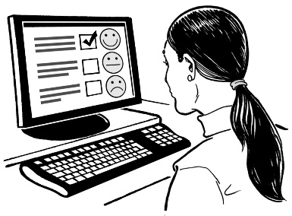
A survey is a set of questions that lots of people answer.

Surveys are used to find out information like what people think about doing sport and active recreation.

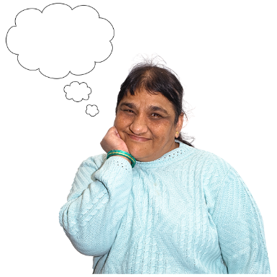
The survey asked the disability sport and active recreation community what they think will happen with disability sport and active recreation in the future.

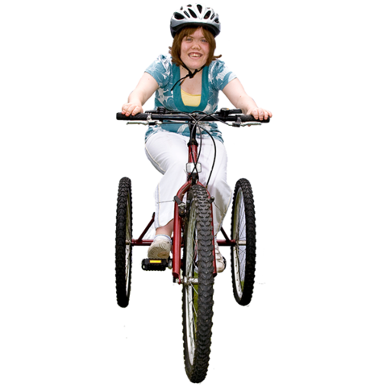
Here the disability sport and
active recreation community means people who:

work for disability sport and active recreation organisations
do disability sport and active recreation.

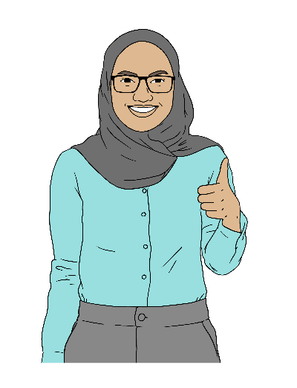
If things are going well in the future the disability sport and active recreation community thinks that:
disabled people will be included in all sport and active recreation
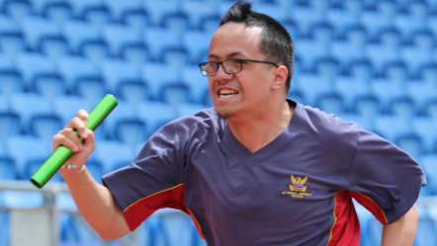
it will be easy to know what people need to do to get better at their sport
Image source: Sport NZ
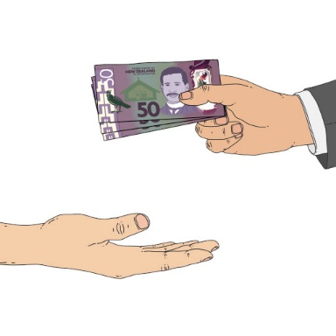
there will be more resources for disability sport and active recreation
the sector will work together better.

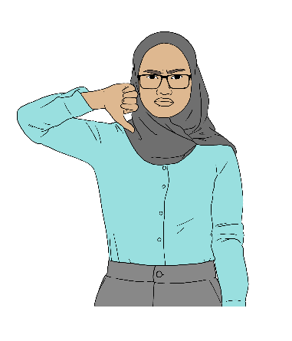
The things that could stop disability sport and active recreation from being better in the future are:
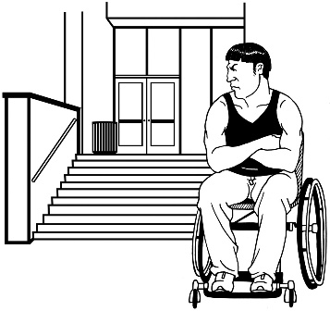
not having enough resources
sport and active recreation not being accessible
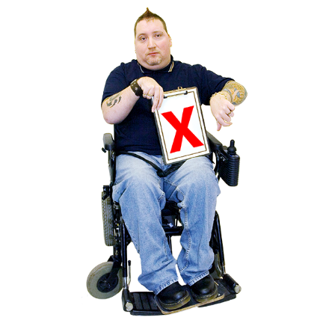
the sector not working together
people thinking that including disabled people in sport and active recreation is:
- too hard
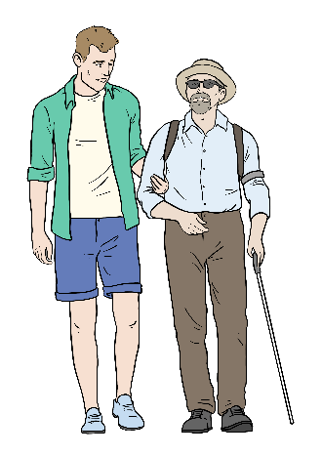
- not important
- there not being enough people who want to work in disability sport and active recreation.

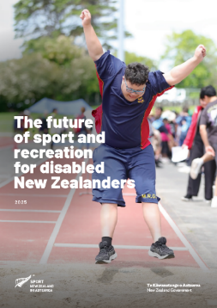
The report talks about some things that might change what will happen with disability sport and active recreation in the future.

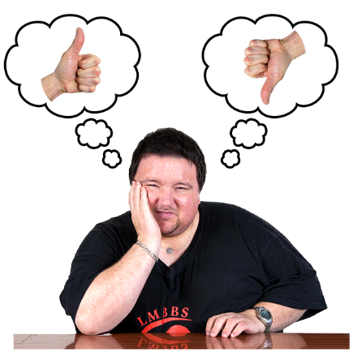
These changes might be:
good
bad.

The report thinks the most important things that could change are:
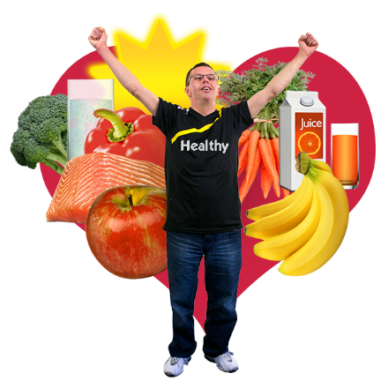
how many people want to work in disability sport and active recreation
what the Government spends money on
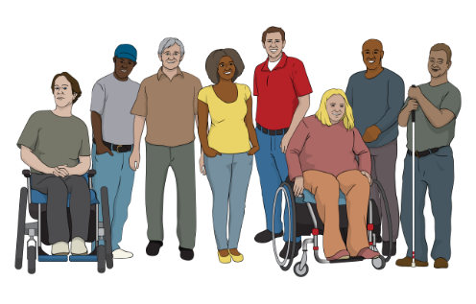
how healthy New Zealanders are
what New Zealanders think about disabled people
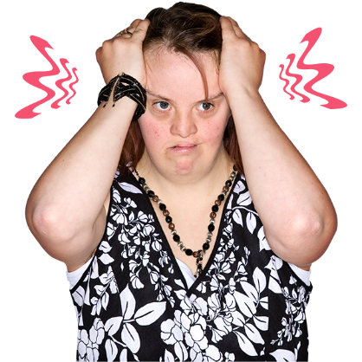
how much money / time New Zealanders can spend on doing sport and active recreation
how people feel about doing sport and active recreation.

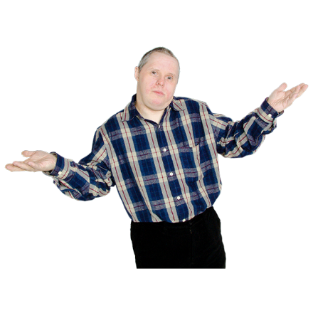
Future scenarios

Sport NZ does not know what will happen in the future.

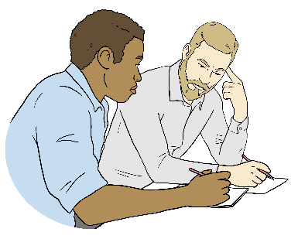
To help them plan for the future they thought about 4 scenarios.


Here scenarios are ideas about
what might happen for disability
sport and active recreation in the future.

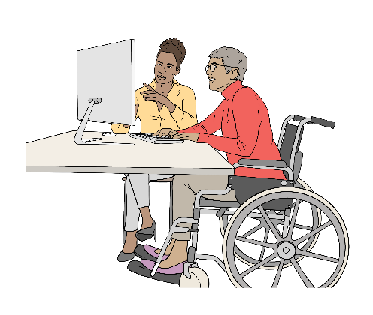
Scenario 1: Growth

In this scenario the sector:
uses new technology well
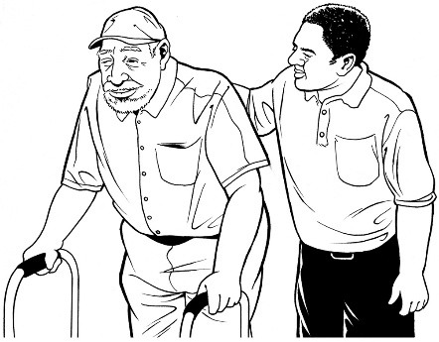
supports people to be active
works together well.


Things that could stop this scenario from happening are:
people not knowing how to use technology
people not having enough money to pay for technology
the Government not spending enough money on disability sport and active recreation.

Scenario 2: Discipline

In this scenario the sector is:
sustainable
eco-friendly.

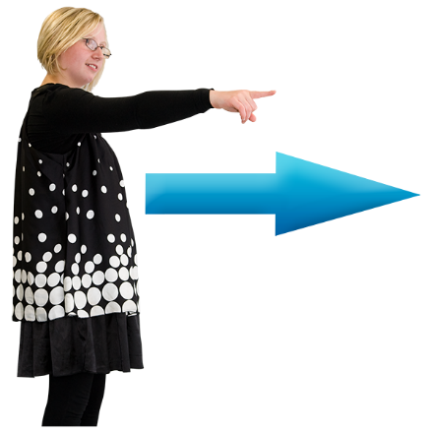
Here sustainable means the sector:
does what it needs to do now
makes sure it can still do the things it needs to do in the
future.

Only paying for things you have enough money for is an example of being sustainable.
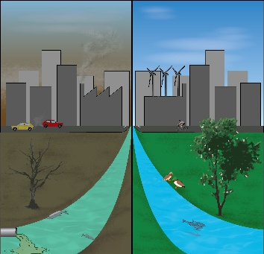

Eco-friendly means doing things
that are good for the natural world.
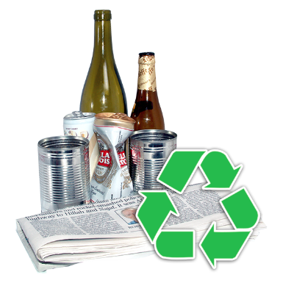
Recycling is an example of being eco-friendly.

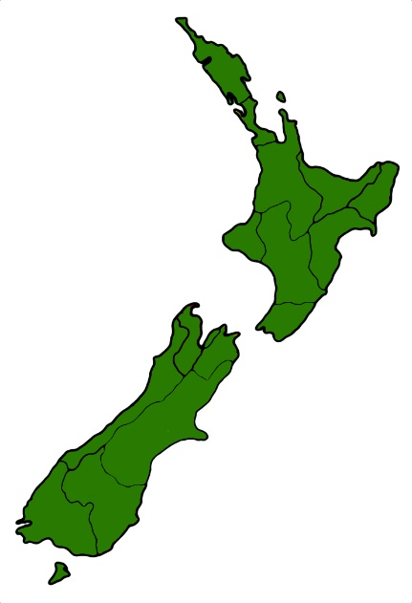
In this scenario organisations in each part of Aotearoa New Zealand would work together.

Organisations would focus on doing things for their local area.

There would be less focus on doing things for all of Aotearoa New Zealand.

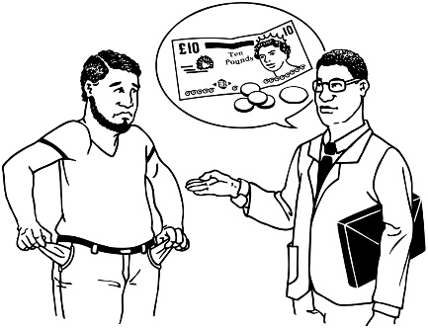
Scenario 3: Collapse

In this scenario there is not much money for disability sport and active recreation.

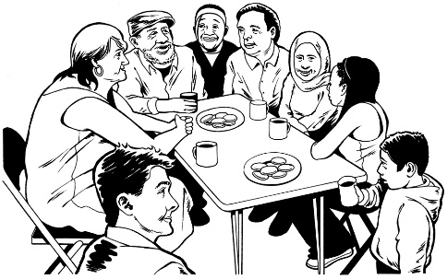
This means the community has to make sure disabled people can do sport and active recreation.

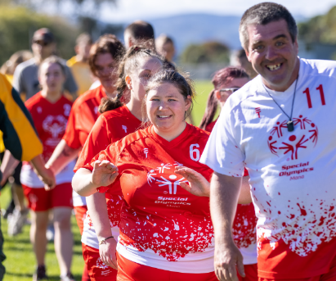
Image source: Special Olympics NZ
Here the community means New Zealanders who care about making sure disabled people can do sport and active recreation.

In this scenario people who work in disability sport and active recreation may not get paid.

Scenario 4: Transformation

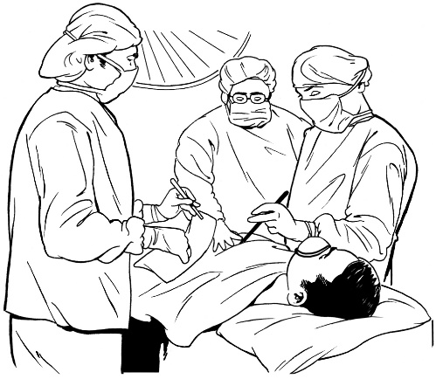
In this scenario there are lots of changes in technology like:
doctors being able to change what bodies can do
AI making sport and active recreation more accessible.

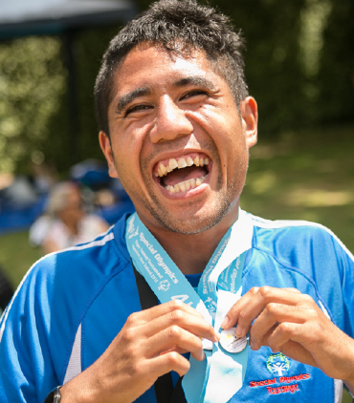
These changes make it easier for disabled people to do sport and active recreation.
Image source: Sport NZ

Some people might have:
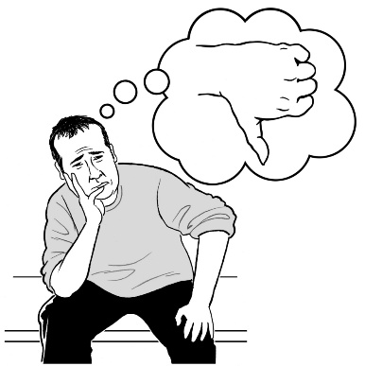
ethical beliefs that say these changes are wrong
cultural beliefs that say these changes are wrong.

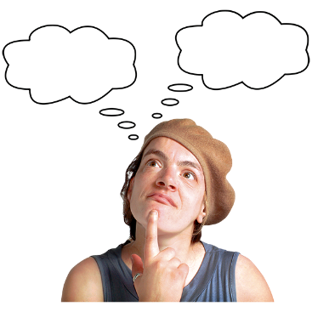
Here ethical beliefs are what
you think about big ideas.

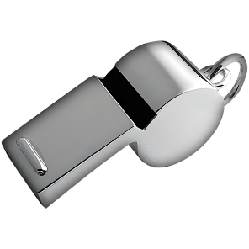
For example you might believe it is not okay to cheat in a game even if you really want to win.

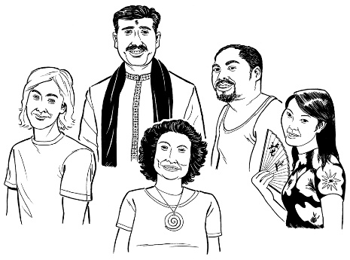
Here cultural beliefs are how your culture changes how you think
about something.

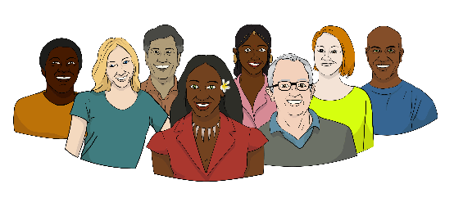
Culture is a way of:
thinking that a group shares
doing things as a group.
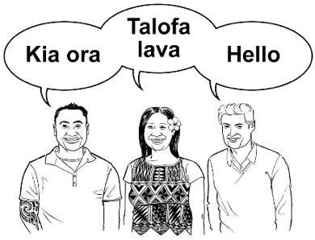

There are many different cultures in
Aotearoa New Zealand.

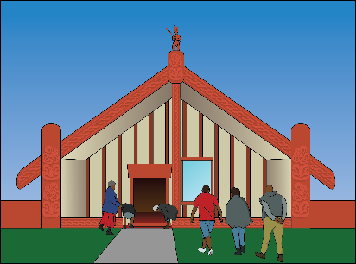
Some examples of the different cultures are:
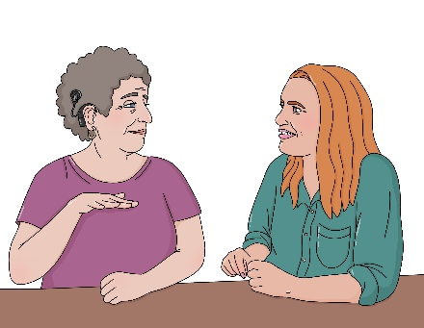
Māori culture
Pacific culture
Deaf culture.

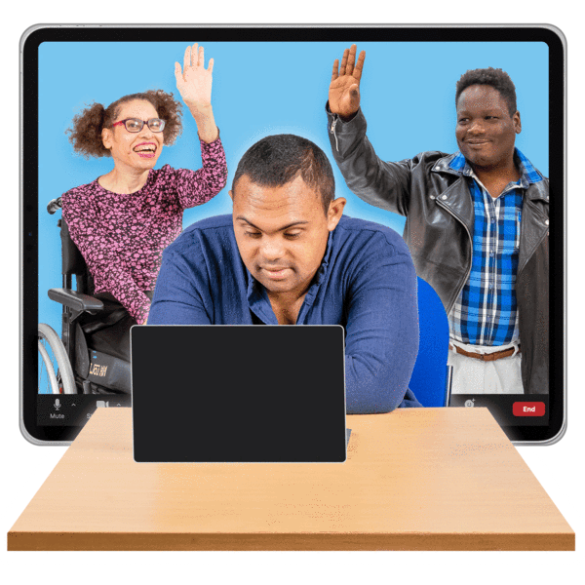
In all of the scenarios the sector will need to:
be ready to change if it needs to
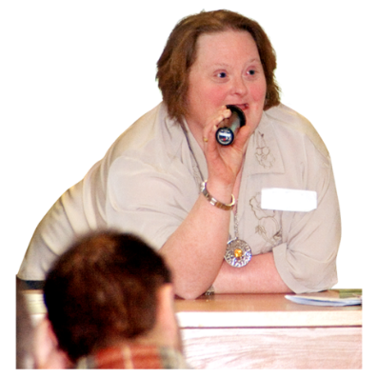
work together
know about new technology
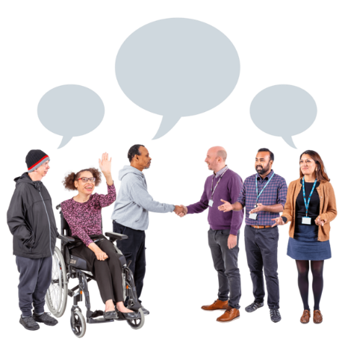
support disabled people to be leaders
work with the community
learn from the community.

Where to find more information

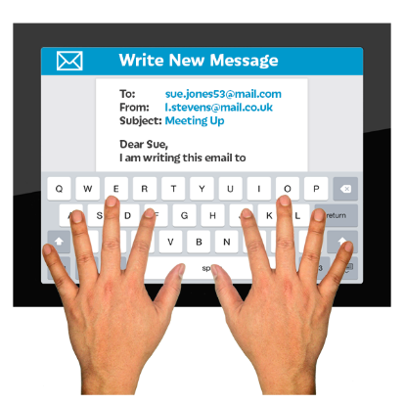
If you have questions about the information in this Easy Read you can email:

accessible@sportnz.org.nz

You can find out more about
Sport NZ on their website at:

https://sportnz.org.nz
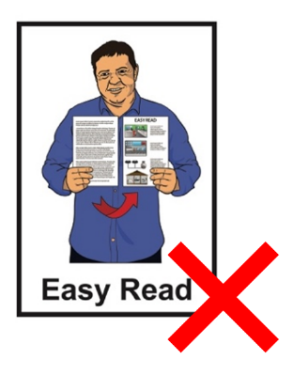

This website is not in Easy Read.

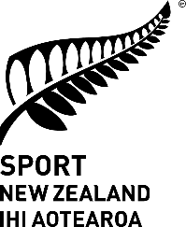
This information has been written by Sport New Zealand Ihi Aotearoa.

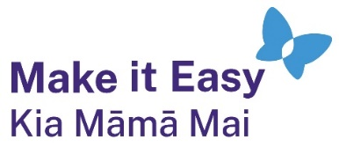
It has been translated into Easy Read by the Make it Easy Kia Māmā Mai service of People First New Zealand Ngā Tāngata Tuatahi.
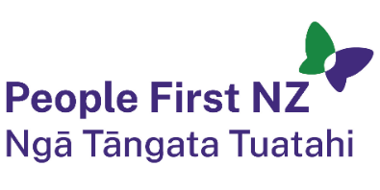
The ideas in this document are not the ideas of People First New Zealand Ngā Tāngata Tuatahi.

All images used in this Easy Read document are subject to copyright rules and cannot be used without permission.


Make it Easy uses images from:

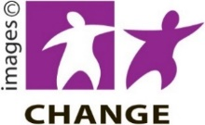
- Photosymbols

- Change Images


- Huriana Kopeke-Te Aho

- SGC Image Works

- T Wood

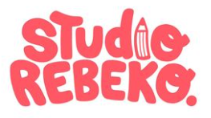
- Studio Rebeko

- Inga Kramer.

