
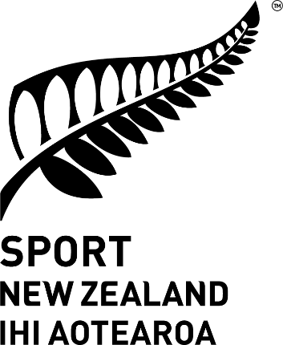
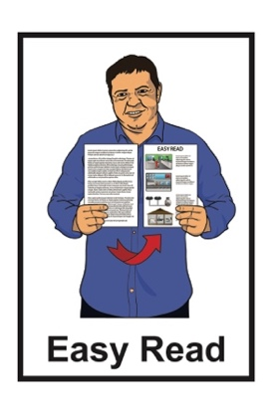

A summary of the
Sport NZ Disability Plan progress report
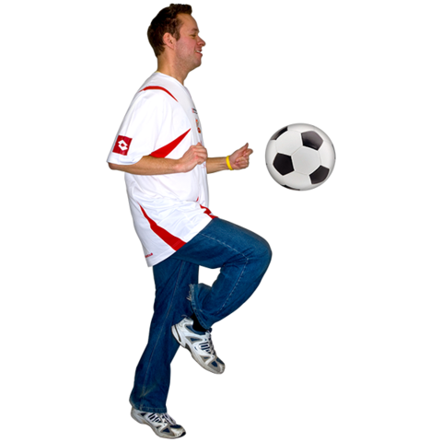
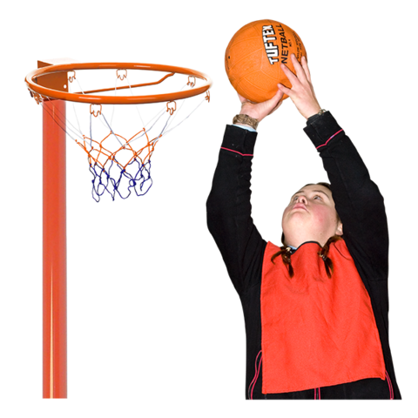

Published: November 2024

Before you start

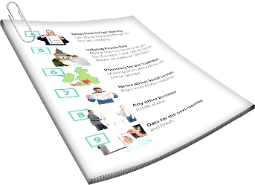
This is a long document.


It can be hard for some people to read a document this long.

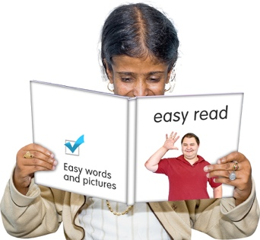
Some things you can do to make it easier are:
read it a few pages at a time
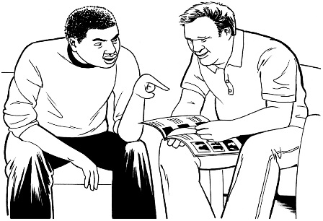
set aside some quiet time to look at it
have someone read it with you to support you to understand it.

What you will find in here
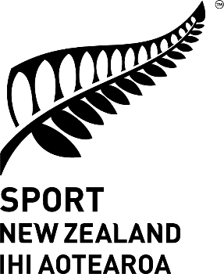
Page number:

About this document 3
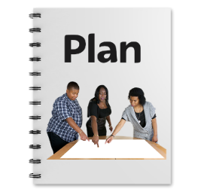


About the Sport NZ Disability Plan 7


About the 3 priorities 11


Outcomes 25

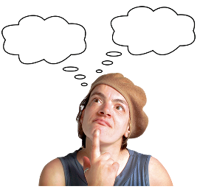
Summing up 36

About this document

This Easy Read document is from Sport NZ.

Sport NZ works to support everyone in New Zealand to look after their wellbeing by being physically active.
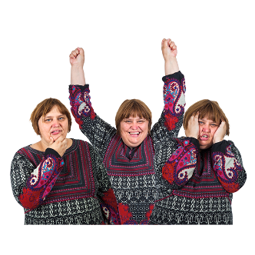

Wellbeing means things like:
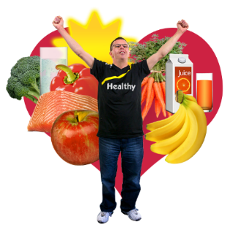
how we feel about ourselves
looking after our bodies with good food / exercise
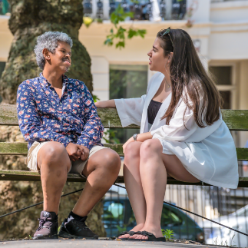
getting support when we are feeling sad / worried.

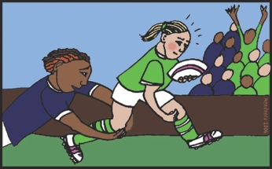
Being physically active means moving your body:
for fun / enjoyment
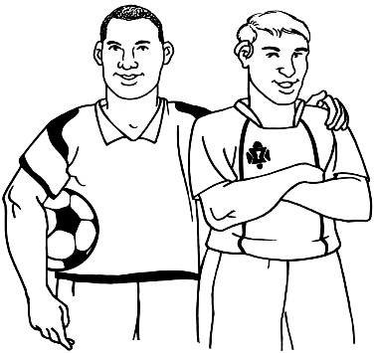
to connect with other people socially
for competition.

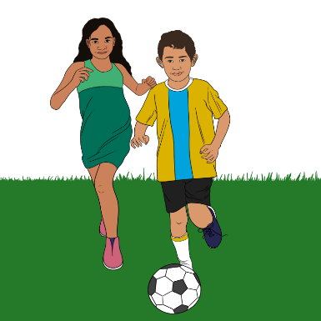
Sport NZ encourages people to take part in physical activities including:
play like playing hopscotch in your neighbourhood
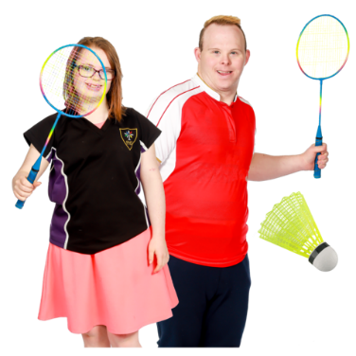
sport like playing badminton at a leisure centre / sport club
active recreation.

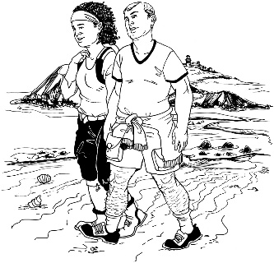
Here active recreation means physical activities like:
walking
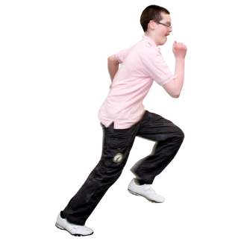
running
swimming
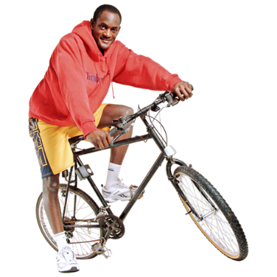
cycling
fishing
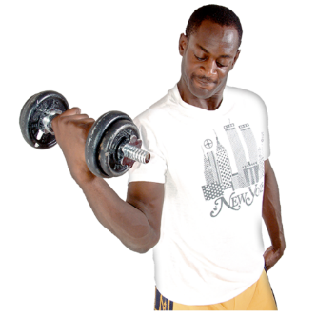
yoga
exercise where someone uses equipment like lifting weights.


This Easy Read document is a summary of a progress report about the Sport NZ Disability Plan.

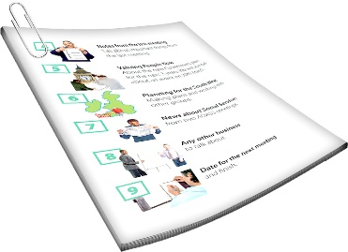
A summary:
is a shorter version of a report
tells you what you need to know.


Progress means seeing if / how
the work that has been done has made things better.

About the Sport NZ Disability Plan
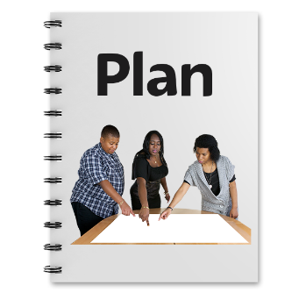

Sport NZ put together the Disability Plan in 2019.

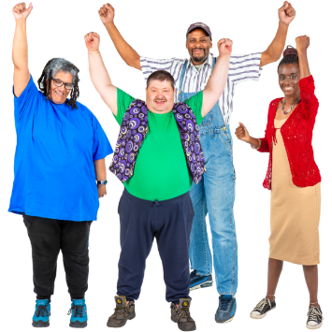
The Disability Plan was put together to support the wellbeing of disabled people in New Zealand.
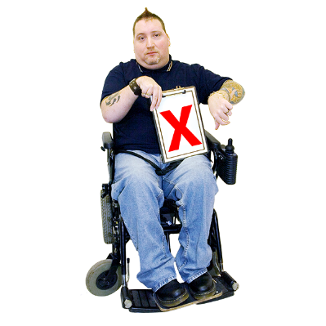

The Disability Plan looked at the inequities disabled people face when taking part in physical activities.

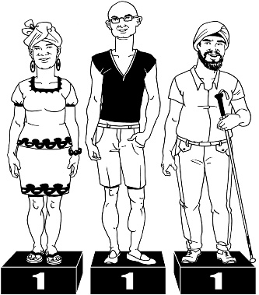

Inequities are ways something is not fair / equal for everyone.

This makes some things harder for some people to do than others.

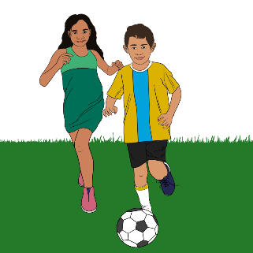
The Disability Plan was put together to improve physical activities for disabled:
tamariki / children
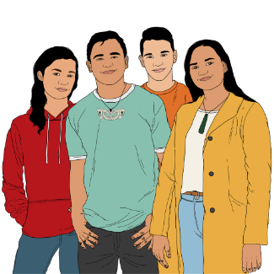
rangatahi / young people up to 25 years old.

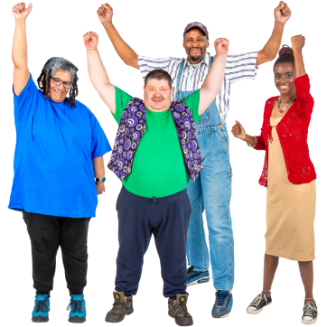
Improve means doing things to
make things better.

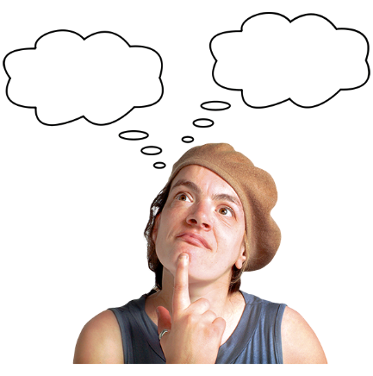
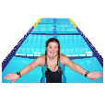
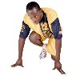

The Disability Plan was put in place to improve:
the choices of activities disabled people have
how good the activities are.

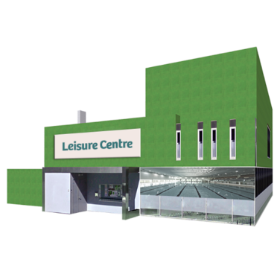
The Disability Plan will improve how sport and recreation organisations:

offer physical activities to everyone
make sure they can keep doing this for a long time.

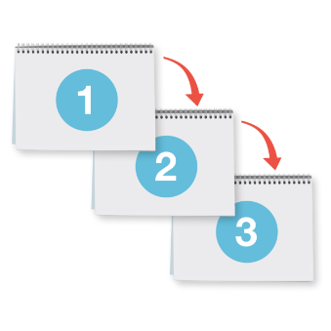
The Disability Plan included 10 commitments from Sport NZ that were based on 3 priorities.
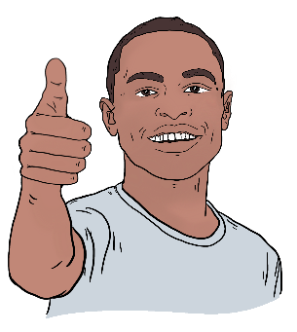

Commitments means a promise something will be done.

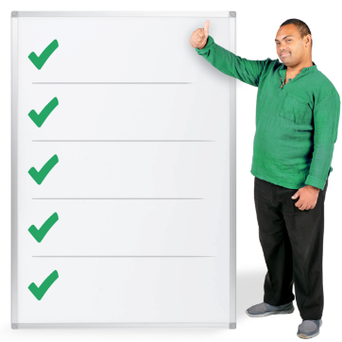
Priorities means things that must be done first.

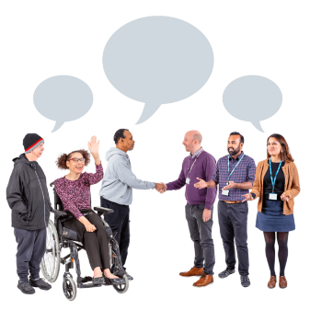
The 3 priorities are:
- partnership which means working with other organisations

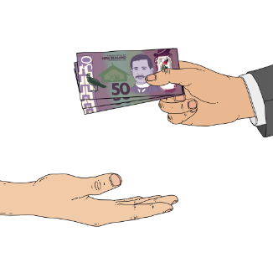
- investment which means giving money to an organisation to support good opportunities
- capability which means being able to make things happen.

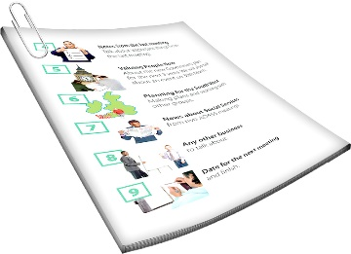
There is more information about the
3 priorities on pages 11 to 24 of this document.


You can read the full Disability Plan Progress Report on the Sport NZ website at:

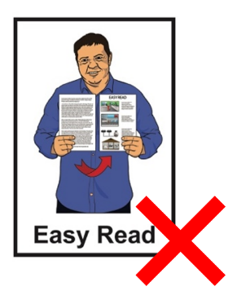
https://tinyurl.com/3yaknn5n

The full report is not in Easy Read.

About the 3 priorities

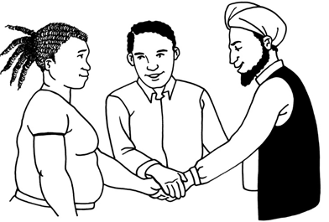
Priority 1: Partnerships

Partnerships means working well with other organisations.

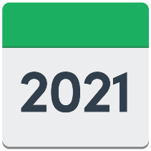
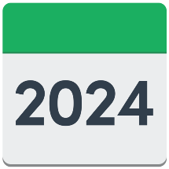

There have been lots of changes over the past 4 years in the active sector.

The active sector includes organisations that offer / support opportunities for:
play
active recreation
sport.

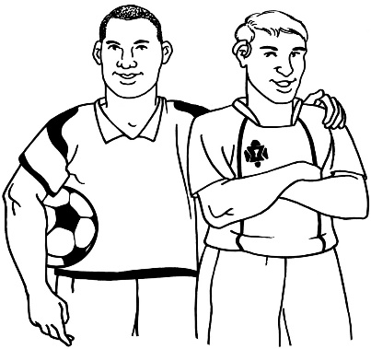
The active sector includes groups
like:
organisations
clubs
leisure centres.

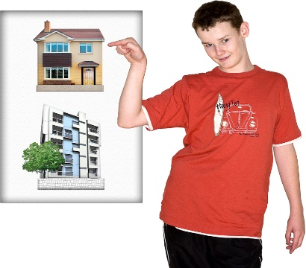
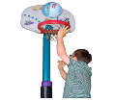
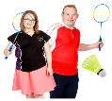

Lots of organisations have provided increased opportunities for disabled tamariki / children and
rangatahi / young people.

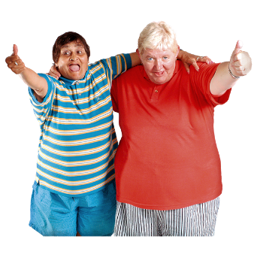
Here provided means something has been offered to someone.

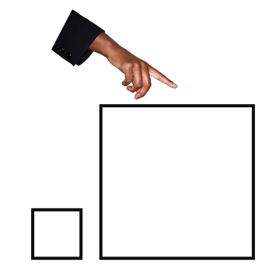
Increased means to make more of something.

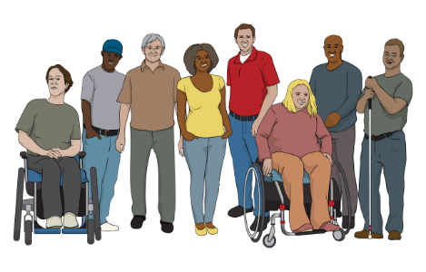
Regional and national organisations in the active sector have increased:
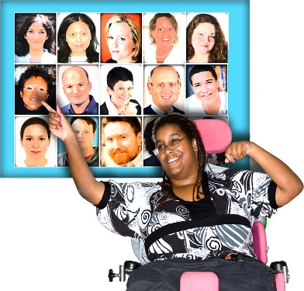
the number of disabled people they support
opportunities that include disabled people.

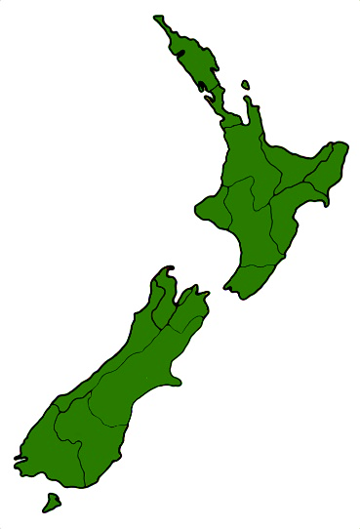
Regional means to do with an area of land called a region.

There are 16 regions in
New Zealand.

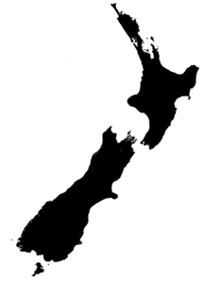
National means the whole of
New Zealand.

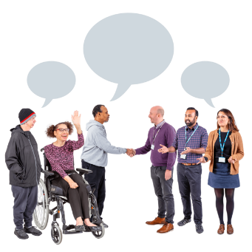
Opportunities have increased because different organisations have worked well together.


From 2021 to 2024 Sport NZ:
worked with
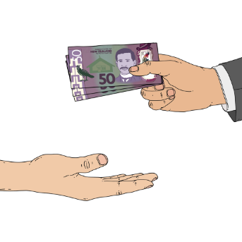
and
gave money to:
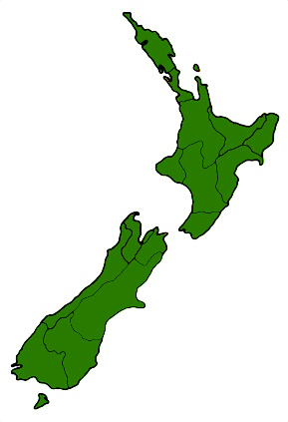
- 15 regional disability organisations
- 7 national disability sport organisations.

From 2021 to 2024 Sport NZ
worked with 16 organisations around New Zealand to put together new opportunities through the
Disability Inclusion Fund.

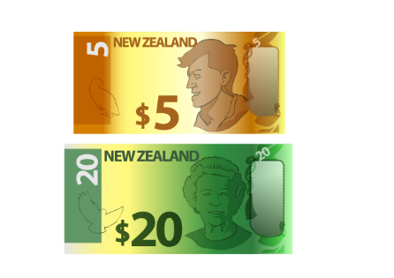
The Disability Inclusion Fund is funding of just over 3 and a half million dollars.

It supports opportunities for disabled tamariki / children and
rangatahi / young people to be
active.


You can find out more about the Disability Inclusion Fund on the
Sport NZ website at:

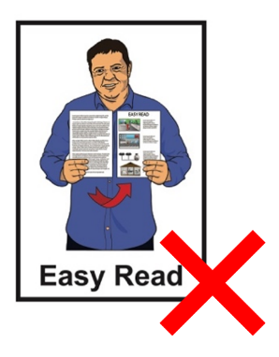
https://tinyurl.com/c8wcpzcp

The website is not in Easy Read.

From 2021 to 2024 Sport NZ:
worked with national disability organisations
and
gave money to national disability organisations.
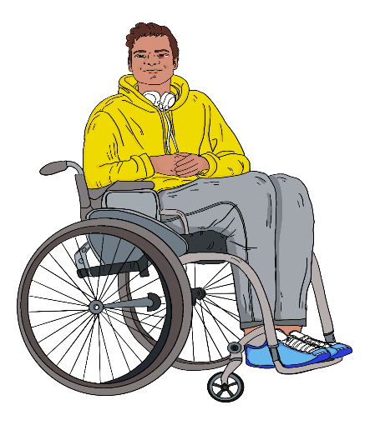

This was to make sure disabled tamariki / children and
rangatahi / young people had opportunities to be active.

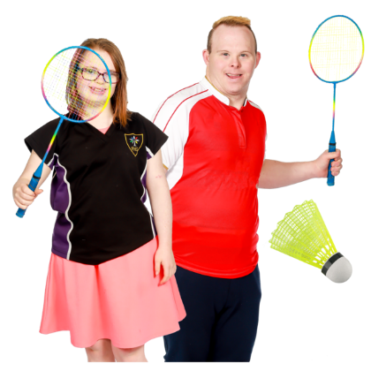
The national disability organisations Sports NZ supported were:
the Halberg Foundation
Special Olympics New Zealand
Paralympics New Zealand.

Priority 2: Investment
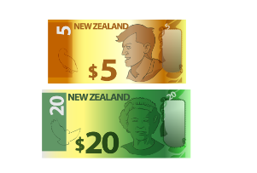
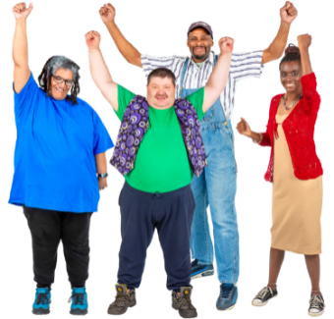
Investment means to give money to an organisation so it can:
provide more opportunities for disabled tamariki / children and
rangatahi / young people
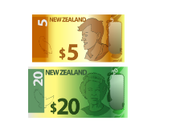
to
make more money to support the work it does in the future.

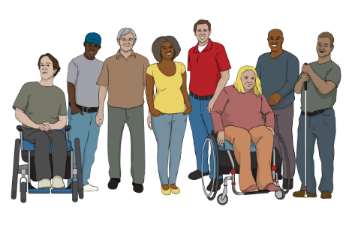
The Disability Plan has meant that money has been put into supporting:
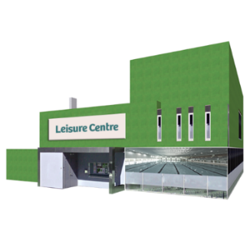
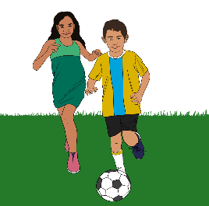
many different disability organisations around New Zealand
sport / active recreation providers.

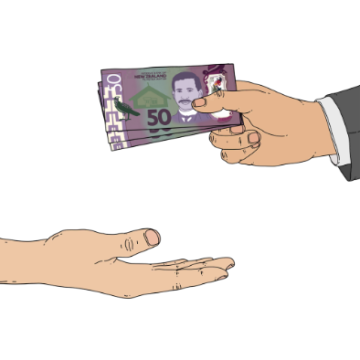
Investment has been made through things like the:
Direct Disability Investment
Disability Inclusion Fund.

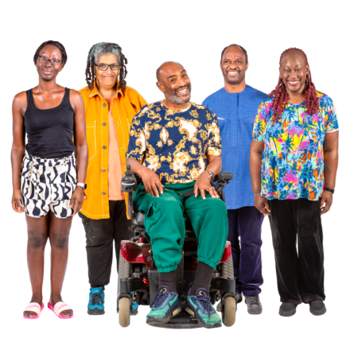
Investment has also been made in other:
programmes
funding opportunities.

These include:
Tū Manawa Active Aotearoa
Strengthen and Adapt
Sport Development Leverage Fund.

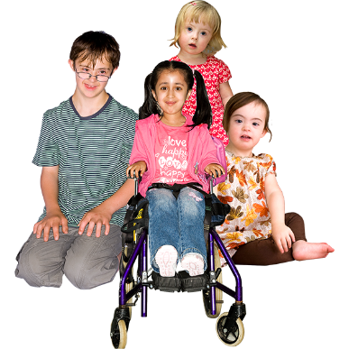
Many organisations have been given investment to support projects for disabled tamariki / children and rangatahi / young people.

From 2021 to 2024 Sport NZ invested:
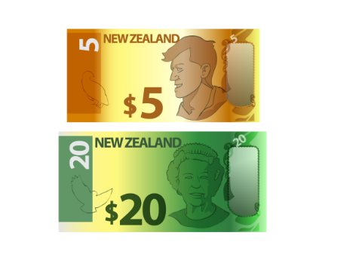
just over 3 and a half million dollars into the sports sector through the Disability Inclusion Fund
just over 2 million dollars into:
- 15 regional disability organisations
- 7 national disability sport organisations.



The Disability Inclusion Fund has supported 16 projects that lasted for 3 years.
From 2021 to 2024 Sport NZ leveraged 20 million dollars from:
Tū Manawa Active Aotearoa,
Strengthen and Adapt
Sport Development Leverage Fund.
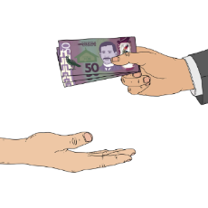

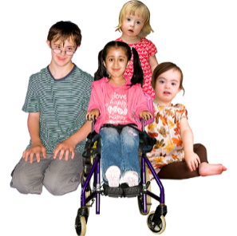

Here leveraged means money was used from other funds to support disabled tamariki / children and rangatahi / young people.

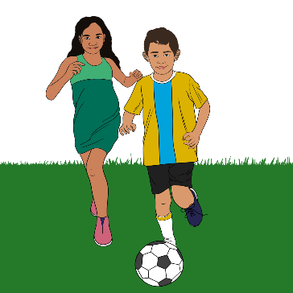
The leveraged money was used to support many different programmes that support disabled people to be active.

Priority 3: Capability
In the past 4 years there have been many different initiatives put together for people in New Zealand led by:
Sport NZ
other organisations in the active sector.
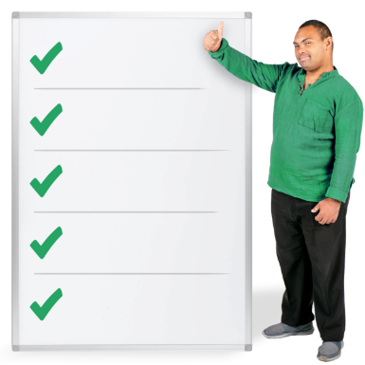

Here initiatives mean things
done / put together to make things better.

The initiatives were put together to improve opportunities in:
play
active recreation
sport.


The initiatives improved things by:
supporting good ways of working
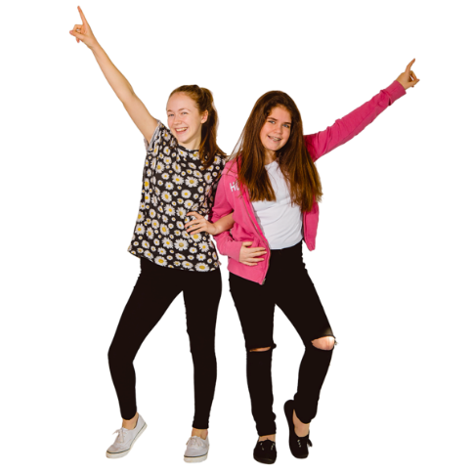
connecting organisations
making sure disabled
tamariki / children and
rangatahi / young people were included in opportunities to be active.

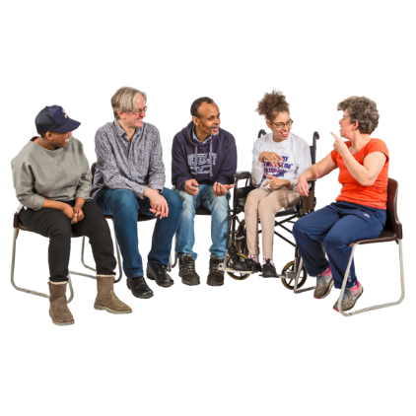
Sport NZ hosted a disability
hui / meeting with hundreds of people
in:
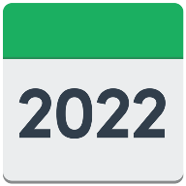
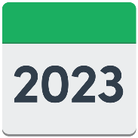
2022
2023.

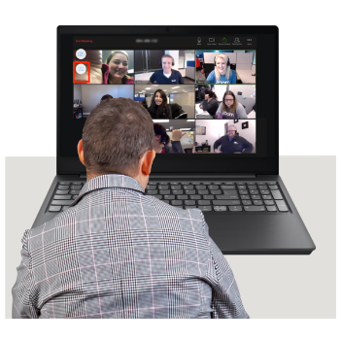
Sport NZ also hosted a group meeting called Disability Sector Virtual Connects 4 times each year.

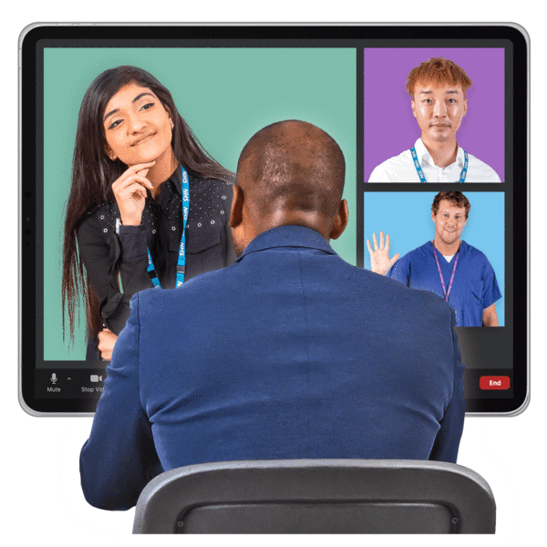
The Disability Sector Virtual Connects supported
people / organisations in the active sector to:
connect with each other
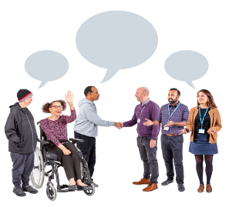
learn from each other
share with each other good ways of working.

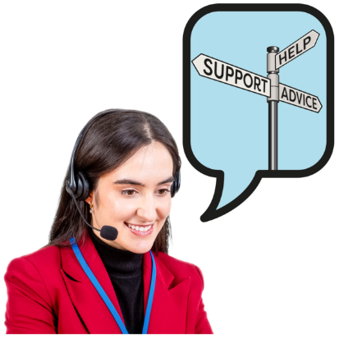
From 2021 to 2024 Sport NZ put together the Inclusivity Hub to guide other organisations how to be inclusive of disability.

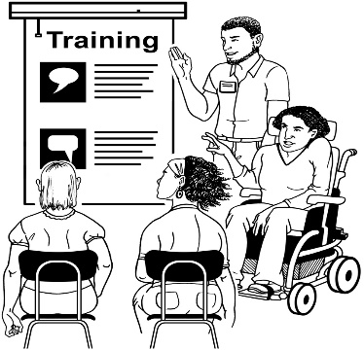
From 2021 to 2024 Sport NZ also supported 21 people to go to the International Symposium of Adaptive Physical Activity in 2023.

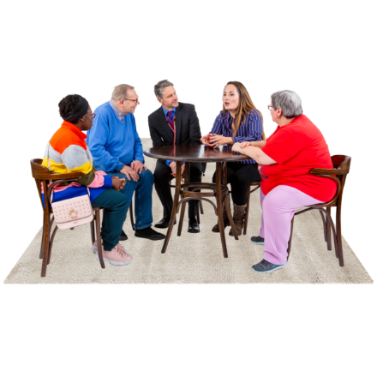
The International Symposium supported them to learn about how to get disabled tamariki / children and
rangatahi / young people to be active.

Outcomes


Outcomes means things that have happened because of work that has been done.
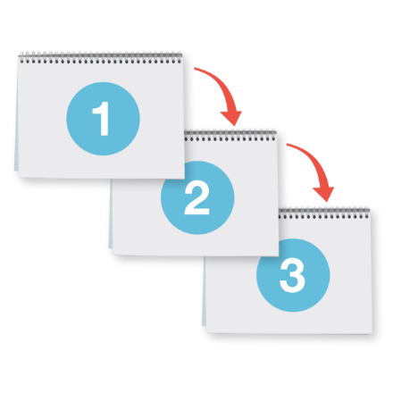

The Sport NZ Disability Plan includes an outcomes framework.

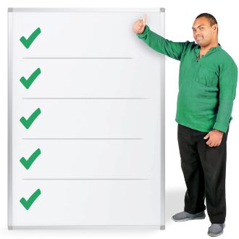
The outcomes framework sets out what things Sport NZ will do.

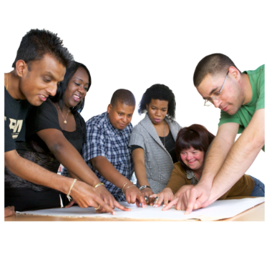
The outcomes match those in the
New Zealand Disability Strategy.



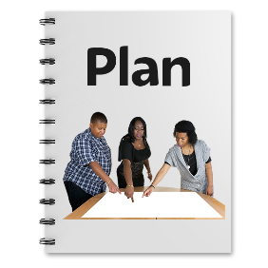
The New Zealand Disability Strategy is a 10 year plan that guides government agencies to work well on issues about disability.

You can read more about the New Zealand Disability Strategy on the Office for Disability Issues website at:

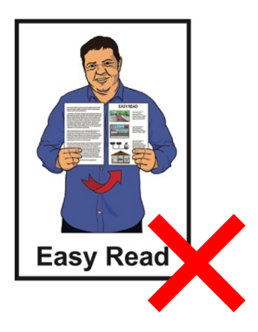
www.odi.govt.nz/nz-disability-strategy/

This website is not in Easy Read.

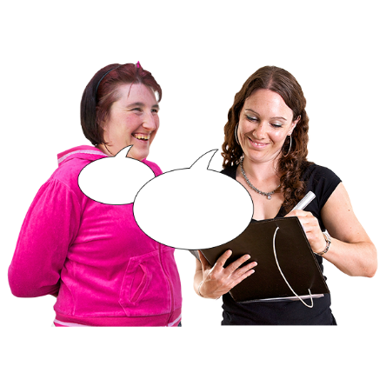
The information on pages 28 to 35 was found out in surveys done by Sport NZ.

A survey is when you ask lots of people what they think about something.

The surveys have not yet shown how things Sport NZ and the active sector have done might improve things.


It might take many years for things to improve.

This is because it takes time for:
improvements to happen because of changes
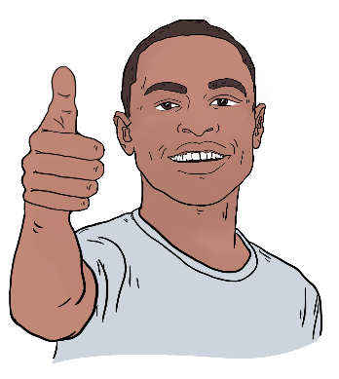
changes to be seen in things like:
- surveys
- other feedback

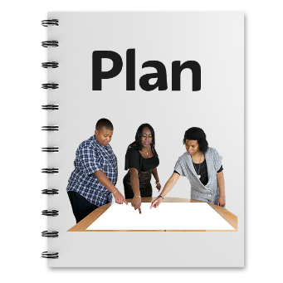
The information shows some of the outcomes that have happened since Sport NZ started the Disability Plan.

Overall experiences of disabled people

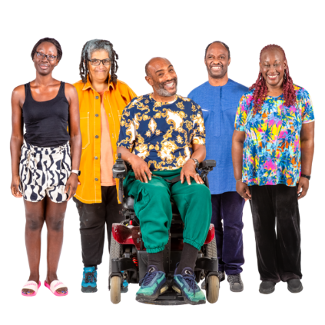
Here overall means most disabled people who took part in the surveys had these experiences.

Not all disabled people experienced the same things.
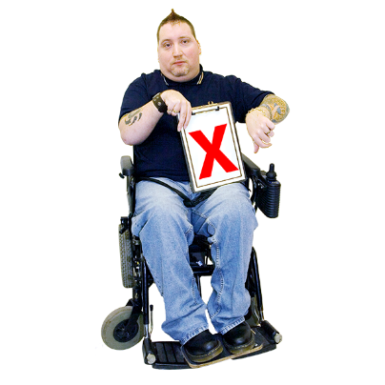

Disabled people overall do not have as good experiences doing physical activities as non-disabled people.
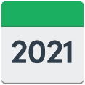

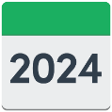

This has got worse in some activities since 2021.

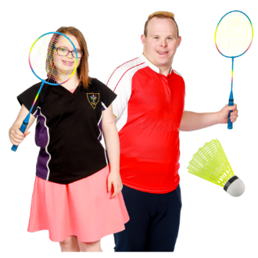
Some physical activities get better for disabled people when opportunities meet their needs.

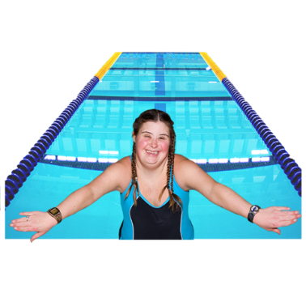
This happens when:
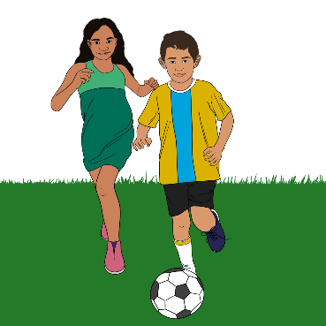
the activity is changed in a way so everyone can do it
disabled people can do activities with friends / people of their own age.

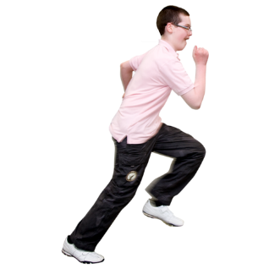
Fewer disabled people overall enjoy being active than non-disabled people.

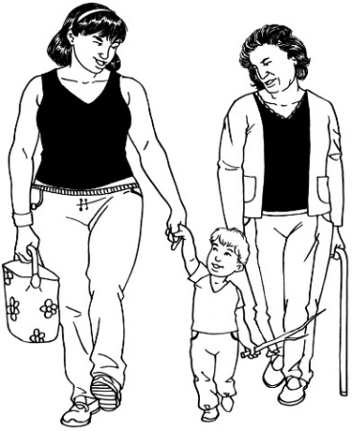
There has been an increase in the number of disabled adults who enjoy being active since 2021.

This is also true for non-disabled adults.

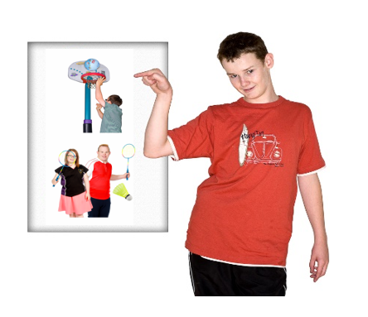
Disabled young people said that the physical activities / opportunities offered to them in 2023 were not as good as those offered in 2022.

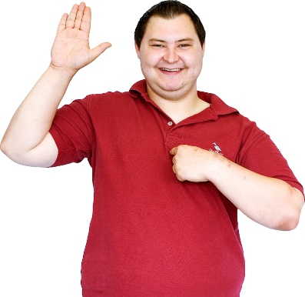
Feeling able to take part in physical activities

Disabled people overall do not feel as confident as non-disabled people to do physical activities.

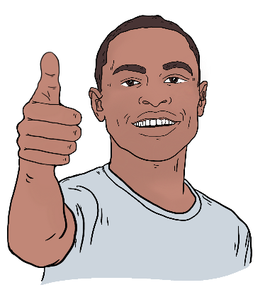
Confident means you feel like you can do something.
Disabled people are also less likely to:
think they are good at physical activities
be motivated to do physical activities.
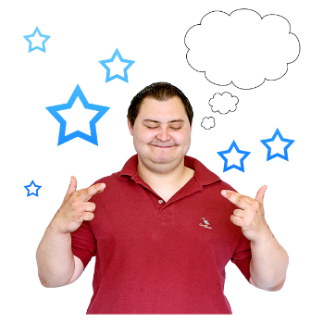

Motivated means wanting to do something.

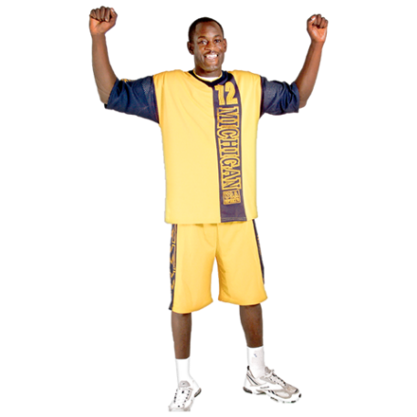
Information from 2021 to 2023 shows that more disabled adults have felt able to take part in physical activities.

This is also true for non-disabled adults.

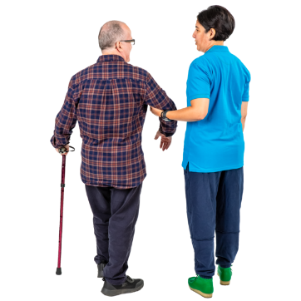
Support for disabled people to do physical activities from people around them

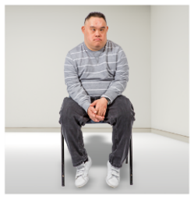
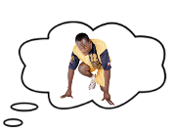
Disabled people feel like they do not get as much support to take part in physical activities as non-disabled people.

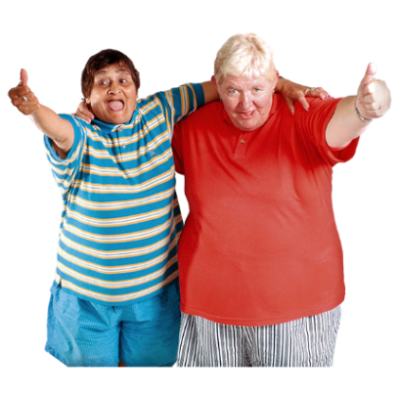
Information from 2021 to 2023 shows there was an increase in support for disabled adults doing physical activities.

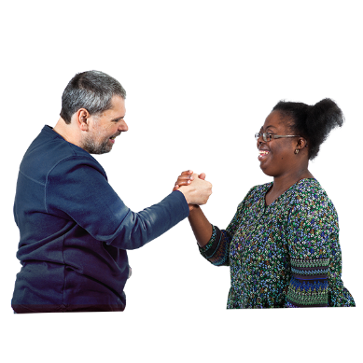
The information shows there was also an increase in support for
non-disabled adults.
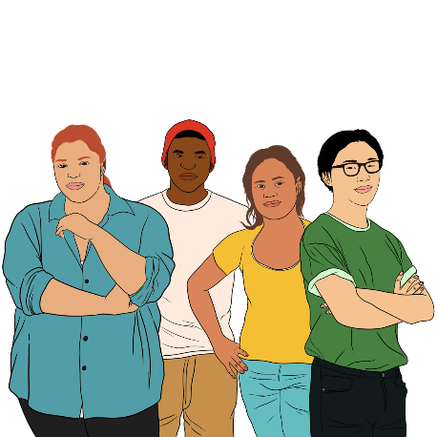

There has been much more support for young disabled people to do physical activities.
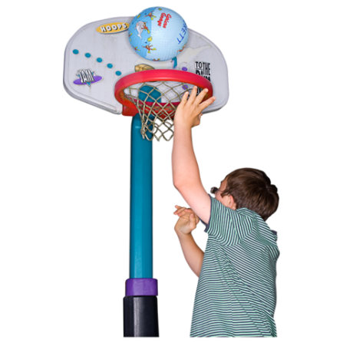
Young disabled people said they thought they had more support from their communities to do physical activities than non-disabled young people.

Sport organisations knowing how to include disabled people

Some regional sports clubs are doing well at making sure they include disabled people.

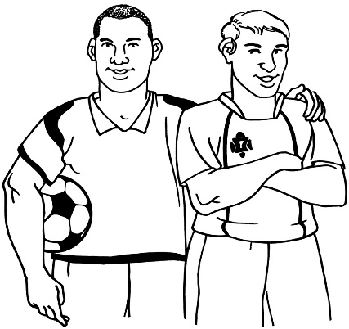
More work is still needed to include disabled people better in areas like:
making sure coaching / training is good for everybody
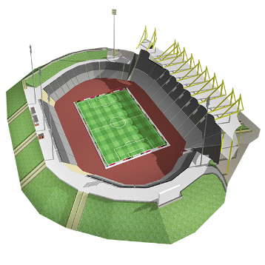
how activities are set up
how organisations are run.
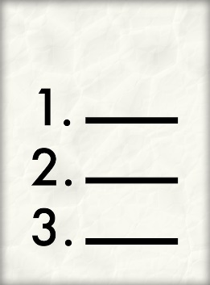
Only 1 in 3 community sport clubs in Aotearoa New Zealand feel sure that their organisation leaders could meet the needs of disabled people.

Less than 1 in 5 sport clubs say it is very important to make physical activities better for disabled people in their community.
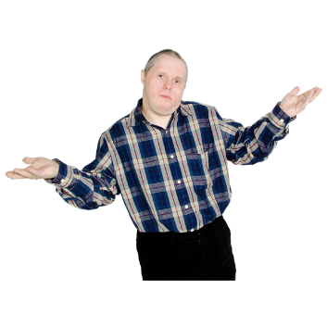

Most club leaders do not talk about things to do with disability in sport at all.

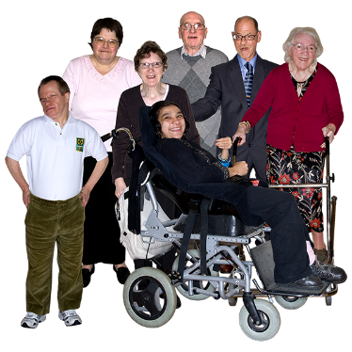
Disabled people in the sport sector

Less than 4 in every 100 people who work in the active sector in 2024 are disabled.

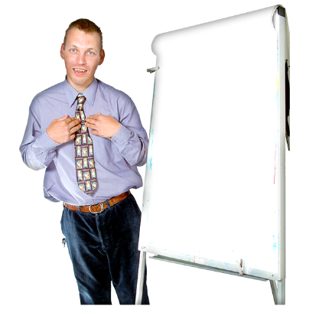
There are slightly more disabled people working in leadership roles than other parts of the active sector.

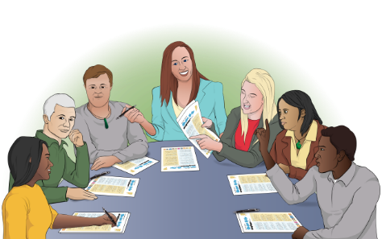
Leadership roles are jobs where someone leads / supports others.

Summing up

Lots more work needs to be done over time so improvements keep happening into the future.

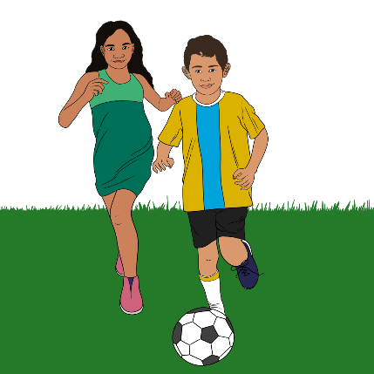
Sport NZ has made a promise to make opportunities better for
tamariki / children and
rangatahi / young people to be physically active.

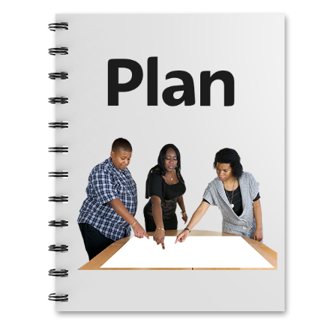
This promise is part of the
Sport NZ 2024 to 2028 strategy.

A strategy is a plan for how to do something.

This information has been written by Sport NZ.

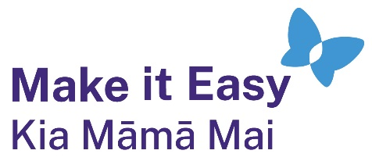
It has been translated into Easy Read by the Make it Easy Kia Māmā Mai service of People First New Zealand Ngā Tāngata Tuatahi.
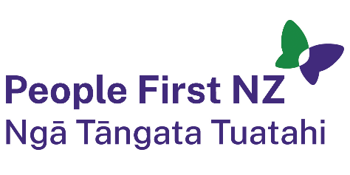
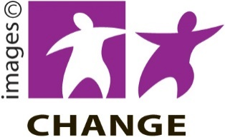
The ideas in this document are not the ideas of People First New Zealand Ngā Tāngata Tuatahi.

Make it Easy uses images from:


- Changepeople.org


            - Photosymbols.com

- SGC Image Works
- Huriana Kopeke-Te Aho

- T. Wood.

All images used in this Easy Read document are subject to copyright rules and cannot be used without permission.

