He Oranga Poutama

2022-2024

Investment Guidelines
February 2023

No part of this publication can be published in any form or by any means without permission in writing from the publisher – Sport NZ, PO Box 2251, Wellington 6011

Mihi

Tutawa mai i runga
Tutawa mai i raro
Tutawa mai i roto
Tutawa mai i waho
Kia tau ai te mauri tū
Kia tau ai te mauri ora
Tūturu whakamaua ki a tina
Haumi e! Hui e! Taiki e!

Kei te rere tonu ngā mihi
ki a rātou kua wehe atu ki te pō,
haere, haere, okioki atu
Rātou te hunga wairua ki a rātou
Tātou te hunga ora ki a tātou
Tēnā koutou, tēnā koutou, tēnā koutou!

Contents

Mihi 2
Our commitment to Te Tiriti o Waitangi 4
Our commitment enacted Treaty Principles 4
Sport NZ Ihi Aotearoa Strategic Direction 2020-2032 5
Sport NZ Ihi Aotearoa Strategic Plan 2020-2024 7
He Oranga Poutama 8
He Oranga Poutama Investment period 8
He Oranga Poutama Guiding Frameworks 9
He Oranga Poutama Outcomes Framework 9
Te Whetū Rehua eligibility criteria 9
Application Timeline 12
Application Process 13
Questions 13

Our commitment to Te Tiriti o Waitangi

Te Tiriti o Waitangi is Aotearoa New Zealand’s founding document. Sport NZ Ihi Aotearoa (herein referred to as “Ihi Aotearoa”) is committed to upholding the mana of Te Tiriti o Waitangi and the principles of Partnership, Protection and Participation.
We are committed to partnership with tangata whenua and the protection of Māori culture and taonga. We value the distinctiveness that tangata whenua bring to physical activity and our success on the world stage. We believe a strong bi-cultural foundation is critical to our national identity and wellbeing.
Aotearoa New Zealand will realise its full potential in play, active recreation and sport when tangata whenua and all New Zealanders are able to participate and succeed as themselves.

Our commitment enacted Treaty Principles

Partnership – Ihi Aotearoa is committed to partnership with tangata whenua. We will through joint action, agree on a partnership approach and kaupapa that mutually benefit the partnership, to improve the wellbeing of tangata whenua and all New Zealanders.
Protection – Ihi Aotearoa is committed to the active protection of tikanga Māori, te reo, taonga, and mātauranga Māori. Through our partnerships and relationships with tangata whenua, we will support the realisation of tangata whenua tino rangatiratanga.
Participation – Ihi Aotearoa is committed to equitable and accessible opportunities for tangata whenua and all New Zealanders. We value the need for culturally distinctive pathways that enable tangata whenua and all New Zealanders to participate and succeed as themselves.

*Ihi Aotearoa expect all He Oranga Poutama providers to demonstrate their commitment to Te Tiriti o Waitangi.

Sport NZ Ihi Aotearoa Strategic Direction 2020-2032

Our Purpose
To contribute to the wellbeing of everybody in Aotearoa New Zealand by leading an enriching and inspiring play, active recreation and sport system.

Our Vision
“Every Body Active”. Every Body Active means:
- All tamariki, rangatahi and adults being physically active through play, active recreation and sport.
- No one missing out on the benefits of play, active recreation and sport, regardless of factors such as gender, ethnicity, sexual orientation or where in Aotearoa New Zealand they live.
- Every New Zealander is able to access a quality experience at home, within their neighbourhood and across the community.
- Communities are collaborating, generating ideas, and owning the creation and promotion of opportunities for all New Zealanders to be active.

To aspire toward our bold vision Ihi Aotearoa has established two outcomes frameworks with Long Term Outcomes that align to the Government’s Wellbeing Framework. Both Frameworks have mana ōrite, same status in our organisation.

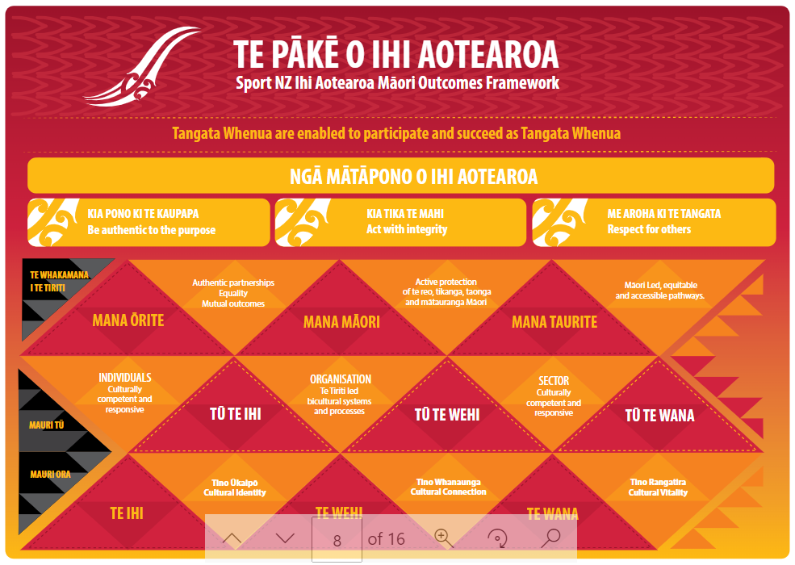
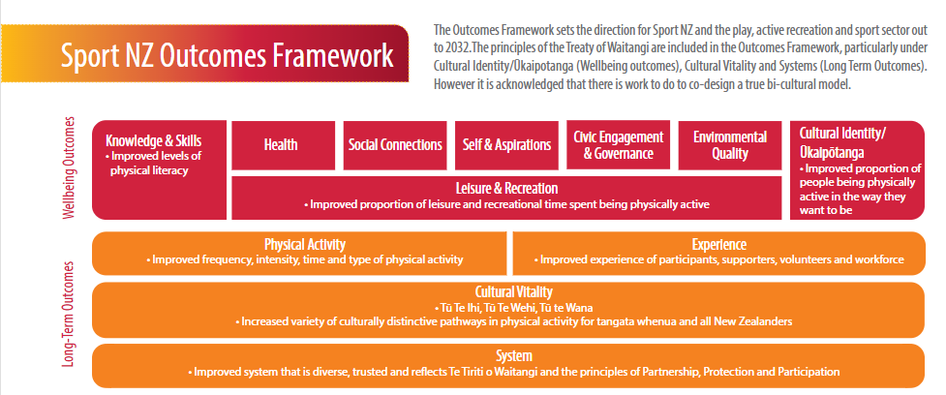

Sport NZ Ihi Aotearoa Outcomes Framework

- Physical Activity – improved frequency, intensity, time and type of physical activity
- Experience – improved experiences of participants, supporters, volunteers and workforce
- Cultural Vitality – increased variety of culturally distinctive pathways in physical activity for tangata whenua and all New Zealanders
- System – improved system that is diverse, trusted and reflects Te Tiriti o Waitangi and the principles of Partnership, Protection and Participation

Sport NZ Ihi Aotearoa Strategic Plan 2020-2024

Ihi Aotearoa 2020-2024 Strategic Plan outlines our focus for the first four years. In this strategic period we will focus on tamariki (5-11 year olds) and rangatahi (12-18 year olds).
With tamariki, these are key formative years for the development of the skills that encourage being active for life. With rangatahi, our prime interest is improving the quality of experiences, opportunities and support offered to keep them being active.
Ihi Aotearoa seek to achieve three Key Result Areas (KRAs) that positively impact their activity levels:
KRA1
- Improve activity levels for tamariki and rangatahi (5-18 year olds)
- For KRA1, we will balance targeted initiatives with longer term system change.
KRA2
- Improve the activity levels of tamariki and rangatahi who are less active
- For KRA2, we will prioritise communities that are facing greater levels of deprivation.
KRA3
- Identify and embed good quality and principled behaviour at all levels of the play, active recreation and sport system to support achievement of KRA1 and KRA2
- As Kaitiaki of the system, ensure its strength and sustainability focussing on whole-of-system like integrity, diversity and inclusion, research, reporting, and reflecting Te Tiriti o Waitangi through embedding Treaty principles.
*Ihi Aotearoa expect all He Oranga Poutama Providers to understand the Ihi Aotearoa Strategic Direction 2020-2032, the Ihi Aotearoa Strategic Plan 2020-2024, and the Key Result Areas. Find these documents at https://sportnz.org.nz/about/publications/strategic-direction.

He Oranga Poutama

The strategic goal of He Oranga Poutama is to increase participation and leadership as Māori in sport and traditional physical recreation at community level.
The outcome gives effect to our commitment to Te Tiriti o Waitangi and the principles of Partnership, Protection and Participation. It is also strategically aligned to Te Pākē o Ihi Aotearoa and Sport NZ Outcomes Framework.
The focus on participation as Māori is a key distinction of this investment. It prioritises the value of culturally distinctive elements in leadership and delivery. He Oranga Poutama provides Ihi Aotearoa with the unique opportunity to work with providers to connect and align with our strategic focus on Māori wellbeing outcomes through play, active recreation and sport.
Within this commitment Ihi Aotearoa acknowledges:
- He Oranga Poutama is a strength-based approach
- the importance of creating accessible pathways that are for and by Māori to enable delivery as Māori that contributes to all New Zealanders being active.
*Ihi Aotearoa expect all He Oranga Poutama providers to affirm the validity and legitimacy of Māori knowledge and culture that enables Māori to participate as Māori.

He Oranga Poutama Investment period
The He Oranga Poutama investment period will be from 1 April 2023 to 30 June 2024. There may be opportunities for continued He Oranga Poutama investment beyond the investment period. Providers will be given 6 months notice of the investment period.
Ihi Aotearoa emphasis for this investment period is on quality initiatives that meet the short and medium-term outcomes of the He Oranga Poutama strategic outcomes of Leadership, Participation and System Build as Māori.

He Oranga Poutama Guiding Frameworks

Māori frameworks are critical in addressing Māori wellbeing. Ihi Aotearoa has codesigned with Māori, in particular the He Oranga Poutama Kaiwhakahaere, the He Oranga Poutama Outcomes Framework and a Māori wellbeing taonga named Te Whetū Rehua. Both were developed in 2010 and reviewed in 2021 to ensure the ongoing relevancy to Te Ao Hurihuri, Te Ao Māori and the alignment of “as Māori” to the Strategic Direction of Ihi Aotearoa.

He Oranga Poutama Outcomes Framework

The He Oranga Poutama outcomes framework:

- specifies and makes explicit the results He Oranga Poutama aims to achieve
- provides a basis for shared understanding between Ihi Aotearoa and He Oranga Poutama providers about how investment is intended to make a difference in the short, medium and longer term
- provides the parameters for assessing performance against the stated goals and outcomes.

Te Whetū Rehua eligibility criteria

Te Whetū Rehua was developed by Māori for Māori and is the framework that defines as Māori in the sport and recreation context.
We are using Te Whetū Rehua to guide our criteria and application process.

Te Whetū  Dimension | Whakamārama – Outline
By Māori  (Organisational Profile) | Primarily, this element refers to the degree that initiatives are governed, managed and delivered by Māori within your organisation. This element supports the principles of rangatiratanga / self-determination.  All applicant organisations must:  - Be a legally constituted body.  - Have, or be working towards Māori representation at governance, management and delivery levels (with a focus on governance).  - Have evidence of strong and active partnerships, relationships with whānau, hapū, iwi, Māori.  - Have competent staff in the organisation capable of operating effectively in Te Ao Māori outside of the He Oranga Poutama investment.  - Additionally, it would be beneficial if your organisation has a strategic Māori plan.
With Māori language and custom central to unique Māori identity - the practice and teaching | Te Reo me ōna Tikanga – Māori language and culture are central to survival and expression of a unique Māori identity. He Oranga Poutama initiatives have a role to contribute to the promotion, maintenance and strengthening of all peoples’ experience of te reo Māori and Māori customs.  It is recommended your organisation has a:  - Strong understanding of Te Whetū Rehua.  - Strong understanding of the He Oranga Poutama Outcomes Framework.  - Strong understanding of Kaupapa Māori principles.  - A strategic organisational approach or plan in relation to cultural capability, te reo and tikanga Māori.
In/On Guardianship and/or connection to places of whakapapa significance | Places, spaces and/or venues of whakapapa significance (marae, awa, maunga) are associated with as Māori participation. They provide access to possibilities of growing, enhancing and maintaining cultural identity.  This element includes:  - Partnering with local hapū, iwi, Māori on local projects.  - Previous experience of providing support or advice to local Māori groups and organisations including Kōhanga Reo, Kura Kaupapa Māori, Marae or Māori sports organisations.  - Supported or currently supporting any Te Taiao (environmental) initiatives.
Through  Customary activities handed down | He Oranga Poutama places an emphasis on the development and advancement of traditional sports and games but is also inclusive of contemporary sport and recreation initiatives, leadership initiatives and organisational capability.  These are termed as:  - Ngā Taonga Tākaro (Traditional Māori Sports)  - Ngā Mahi a te Rēhia (Traditional Māori Active Performance Arts)  - Ngā Hākinakina Auraki (Contemporary Play, Active Recreation and Sport)  - Hautūtanga me te Whakawhanake Whare (Leadership and Organisational Capability).  There is an expectation your organisation will have the ability to support the development of the above activity types as Māori.
For  Whānau, hapū, iwi, Māori. Emphasis is to support whakapapa and kaupapa Māori groups | The concept of whānau is highly valued in te ao Māori and includes an emphasis on tamariki and rangatahi in the context of whānau.  Participating as Māori in modern times links to both traditional  whakapapa (genealogical), whānau (whānau, hapū, iwi, waka) and more recent Kaupapa Māori whānau collectives (e.g. kōhanga reo, Aotea Māori netball). He Oranga Poutama initiatives emphasise supporting leadership and participation in sport and recreation for whānau groupings in both contexts. The principle of whanaungatanga is affirmed through this element.  Applicants must have an understanding of the Māori demographic in their area of work. This includes insights regarding rangatahi, tamariki and kaumātua.
Outcomes Focus | Providers are expected to work across all three He Oranga Poutama Outcome Framework Domains:  - Leaders for the Future  - Developing Participation Opportunities  - Strengthening Infrastructure  This is expected throughout the investment period with a focus on the He Oranga Poutama short and medium-term outcomes.

Collaborative Applications

Collaborative applications are welcomed and encouraged. Collaborative applications can involve two or more organisations.
Please ensure to include details of the organisations involved, and the details of one lead organisation to take primary responsibility for the investment agreement with Ihi Aotearoa.
*Ihi Aotearoa expect all He Oranga Poutama applicants to have a strong understanding of the He Oranga Poutama Outcomes framework and the Te Whetū Rehua framework.

Application Timeline

Date | Action
Dec 2022 | Early notification of the Investment announced
14 February 2023 | He Oranga Poutama online applications open February 2023
16 February 2023 | Webinar explaining He Oranga Poutama and the application process.
07 March 2023 | Applications close. Late applications will not be accepted
March 2023 | Shortlising  Appointments made with successful applicants

Application Process

The application process for He Oranga Poutama investment consists of four stages.

Stage 1 – Read the Information Documents
- Read the Investment Guidelines, application form (in Word) and other important documents you are sent prior to submitting your application.
Stage 2 – Complete and submit your application form online
- We recommend you use the Word version of the application form to prepare your application. You can then cut and paste your answers into the online form when applications open.
- Ihi Aotearoa will only accept applications through the online application form.
- Applications must be submitted by close date and time. Applications received after this time will not be accepted.
- Ihi Aotearoa will acknowledge each application immediately upon receipt. Acknowledgement of the application receipt does not imply any commitment by Ihi Aotearoa to invest in the proposal.
Stage 3 – Interview/Presentations
- An interview time and method will be confirmed with shortlisted applicants. Please note interviews will take place March 2023.
- During the interview (see timeline above), each applicant is to provide a 20 minute presentation that will give Ihi Aotearoa confidence they understand the He Oranga Poutama outcomes and Te Whetū Rehua. Examples of strategic alliance and mahi are ideal.
- All parties to the Collective Applications must be present at the interview.
Stage 4 – Investment Agreement
- Ihi Aotearoa will discuss with Providers contractual terms and conditions, contractual requirements, investment level and monitoring and reporting.

Questions

If you have any questions throughout the process please don’t hesitate to email hopaotearoa@sportnz.org.nz or contact Wiremu Mato, He Oranga Poutama Lead on
027 2405 276.

